HARDTACK
Indianapolis Civil War Round Table Newsletter
http://indianapoliscwrt.org/

September 11, 2006 at 7:30 p.m.
Please note we are meeting at the Indiana War Memorial this month.

The Plan of the Day

On Gender and Military Relief Work: How I Wrote Women at the Front
Presented by Jane Schultz
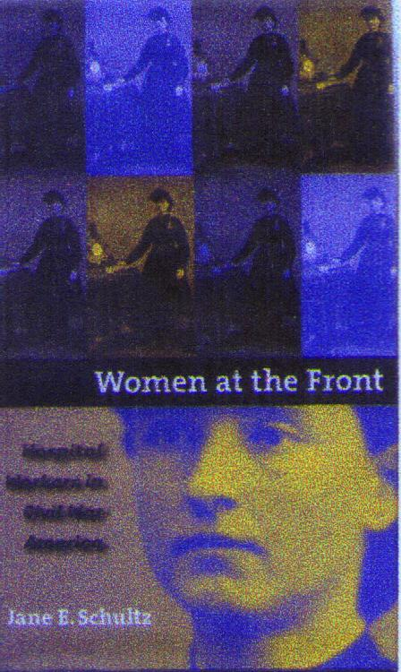
During the Civil War, as many as 20,000 women worked in Union and Confederate hospitals serving as nurses, administrators, matrons, seamstresses, cooks, laundresses, and custodial workers. Jane Schultz, in her book Women at the Front, used government records, private manuscripts and published sources to provide the first history of these female relief workers. In this month’s illustrated lecture, Dr. Schultz will discuss how she arrived at the number of these women and will address the conflicts that arose due to racial and class diversity and their subordinate status in military hospitals. She will also analyze the pensioning of hospital workers in the 1890s.

Our Guest Speaker

Jane Schultz
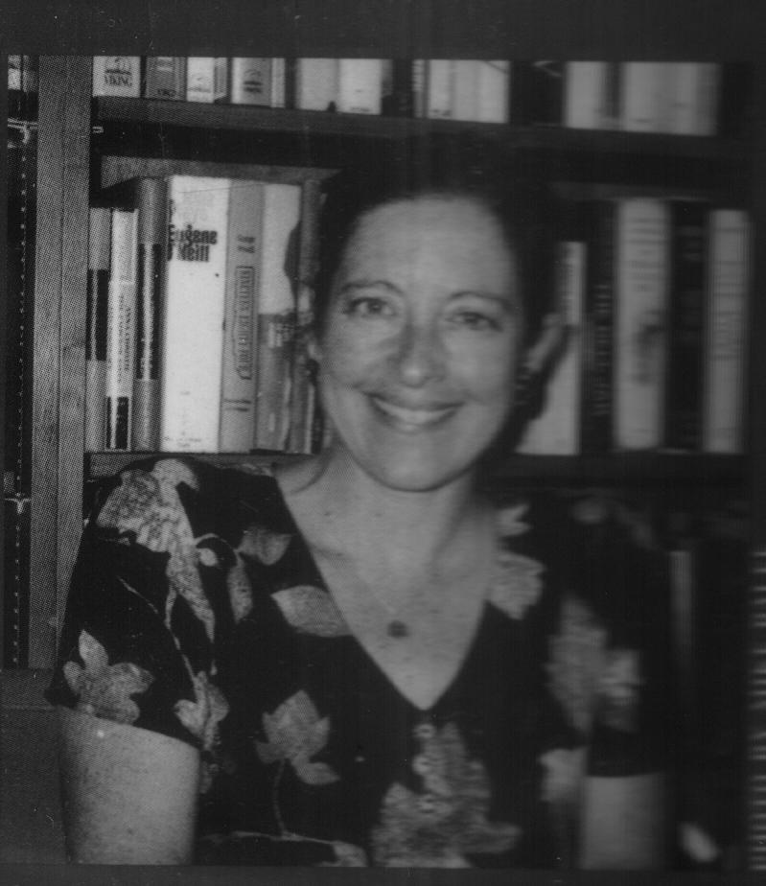
Jane Schultz earned her B.A. degree from Stanford University and her M.A. and Ph.D. from the University of Michigan. She is currently on sabbatical from her position as professor of English, American studies, and women’s studies at Indiana University-Purdue University-Indianapolis. She has also served on a number of committees at IUPUI. She has been nominated for several national awards for Women at the Front and is currently completing another book.

Roster of Officers and Committees for the 2006-2007 Campaign
Officers:
President: Dave Klinestiver Secretary:
Vice President: Dave Sutherland Treasurer: Peg Bertelli
Committee Chairs:
Programs: Dave Sutherland Preservation: Andy O’Donnell
Membership: Nikki Schofield Publicity: Dave Buchanan & Tony Roscetti
Quiz Master: Summer Campaign:
Tony Trimble Nikki Schofield
HARDTACK Newsletter:
Editor: Jenny Thompson
Distribution: Dave Klinestiver (email) & Tony Roscetti (U.S. mail)

2006-2007 Campaign Plans
Unless otherwise noted, we meet at the Indiana History Center, 450 West Ohio Street.
October 9, 2006* Restoration of CSS H.L. Hunley Chris Amer
November 13, 2006 Helen Douglass Speaks Nikki Schofield
December 11, 2006 Grant & Lincoln: A Unique Partnership Robert Vane
January 8, 2006 Cross Keys & Port Republic Tony Trimble
February 12, 2007 Topic to be Announced Peter Carmichael
March 12, 2007 “Stovepipe” Johnson’s Raid on Newburgh Ray Mulesky
April 9, 2007 The USS Monitor Center Craig Symonds
May 14, 2007 A New Look at Civil War Photography Dave Klinestiver
June 11, 2007 Vicksburg Terry Winschel

* The October meeting will be held at the Indiana War Memorial.

Other Camp Activities
September 15, 2006 (9:30 a.m. – 4:30 p.m.) Workshop
A workshop will be held with Richard McMurry at Saginaw Valley State University (Wickes Hall) in Saginaw, Michigan. He will address the inner details of the Civil War with some new looks at old ideas. There will be a book signing after lunch and at the close of the workshop. The cost is $96, which includes a buffet lunch. To register, call Saginaw Valley State University at (989) 964-4475. For more information, please contact Dan Marino at (989) 799-0044.

October 1, 2006 (2-4 p.m.) Crown Hill tour of Civil War Generals
There are 17 Civil War generals buried in Crown Hill Cemetery, which was founded during the Civil War. These generals include Benjamin Harrison, Jefferson C. Davis, and Richard Canby. Nikki Schofield will lead this tour, which will meet at the Gothic Chapel. No reservations are needed. Cost: Adults $5; Seniors $4; and Students $3.

Special Orders
Publication notice: Simon & Schuster will publish The Gettysburg Gospel: The Lincoln Speech Nobody Knows by Gabor Boritt on November 19. This book is being nominated for the National Book Award and the Pulitzer Prize.

Bounty offered: $1,000 Reward for information leading to the return of his great-grandfather’s Civil War Springfield rifle, which was stolen in northern Illinois in the 70’s. The butt plate has the following engraving: “32nd Wisconsin Volunteers, N.W.”
He will also pay twice the value to the present owner. Please contact Pat.
Work: 816-241-6411; Home 816-537-6030; and Cell: 816-289-1416

Official Records
After Action Report: The annual trip went well, with good NPS and local speakers and guides. Corinth is an interesting CW town, well worth visiting. Dr. Tim Smith, author of three books, was an excellent guide at Shiloh. Morris Penny and Danny Fullenwider did an exceptional job as all day tour guides on Gen. Abel Streight’s Raid. It was a busy, memorable week. Plan to join us next year, when we go to Vicksburg.
- Submitted by Nikki Schofield, Tour Director

Test Your Civil War Knowledge (with Trimble’s Trivia)
- Shelby Foote said, “There were only two true geniuses in the Civil War.” Name them.

- For what invention was William F. Ketchum known?

- By what nickname was Jackson’s 33rd Virginia known?

- What did the Memphis Novelty Works manufacture for the Confederate Army?

- One observer described men who resembled, “creatures compounded of the sentinel crab, the frog, the grasshopper, and the sand-hill crane.” What was he watching?

The Civilians and Soldiers Speak

THE WAR’S EFFECT ON THE WOMEN
(Quoted from Catherine Clinton’s Life in Civil War America,)

The reaction of Mary Williamson, an Alabama bride, to her husband’s departure to the army:
“This great sorrow makes me forget I ever had such a feeling as patriotism.”

From a woman’s diary:
“The real sorrows of war, like those of drunkenness, always fall most heavily upon women. They may not bear arms. They may not even share the triumphs which compensate their brethren for toil and suffering and danger. They must sit still and endure.”

From the memoir of Septima M. Collis:
“I never fully realized the fratricidal character of the conflict until I lost my idolized brother Dave of the Southern army one day, and was nursing my Northern husband back to life the next.”

THE SOLDIER’S REACTION TO NURSES
(Quoted from John H. Worsham’s One of Jackson’s Foot Cavalry,)

“I heard numerous soldiers say they were glad they were wounded, as the careful attention received from those women more than repaid them for the suffering they endured! Here is a little incident told me after the war, by one of the fashionable young ladies, who lived on one of the fashionable streets of Richmond during the war. She was one of the young ladies who composed one of the hospital committees. In one of the hospitals which she attended, there was a soldier from one of the southern states who was desperately wounded, whom devoted nursing saved. He appreciated it and showed his obligation as well as a man could by thanks. When he was well and was ordered to his command in the field, he asked this young lady if he might call at her home. She told him she would be glad to see him at any time, and gave him the number of her residence. A day or two afterwards he called, and after conversing a short while, he told her he knew that the care given him by the ladies had saved his life, and he had asked to call in order that he might thank her and at the same time he wished to make her a little present. This had given him a great deal of thought, as his means were very limited, but he had bought her what he considered the best thing in the world, and he presented her with a small package of “goobers” (peanuts), saying he wished he were able to give her a bushel! She said to me that she considered that the most valuable present she ever received, and prized it as such, because it came from the man’s heart; and she thinks it took every cent of money he had to purchase it!”

(Quoted from The Columbia Book of Civil War Poetry, edited by Richard Marius)
Hospital Duties
Author Unknown

Fold away all your bright-tinted dresses,
Turn the key on your jewels today,
And the wealth of your tendril-like tresses
Braid back in a serious way;
No more delicate gloves, no more laces,
No more trifling in boudoir or bower,
But come with your souls in your faces
To meet the stern wants of the hour.

Look around! By the torchlight unsteady
The dead and the dying seem one –
What! trembling and paling already,
Before your dear mission’s begun?
These wounds are more precious than ghastly –
Time presses her lips to each scar,
While she chants of that glory which vastly
Transcends all the horrors of war.

Pause here by this bedside. How mellow
The light showers down on that brow!
Such a brave, brawny visage, poor fellow!
Some homestead is missing him now.
Some wife shades her eyes in the clearing,
Some mother sits moaning distressed,
While the loved one lies faint but unfearing,
With the enemy’s ball in his breast.

Here’s another – a lad – a mere stripling,
Picked up in the field almost dead,
With the blood through his sunny hair rippling
From the horrible gash in the head.
They say he was first in the action;
Gay-hearted, quick-headed, and witty:
He fought till he dropped with exhaustion
At the gates of our fair Southern city.

Fought and fell ‘neath the guns of that city,
With a spirit transcending his years –
Lift him up in your large-hearted pity,
And wet his pale lips with your tears.
Touch him gently; most sacred the duty
Of dressing that poor shattered hand!
God spare him to rise in his beauty,
And battle once more for his land!

Pass on! it is useless to linger
While others are calling your care;
There is need for your delicate finger,
For your womanly sympathy there.
There are sick ones athirst for caressing,
There are dying ones raving at home,
There are wounds to be bound with a blessing,
And shrouds to make ready for some.

They have gathered about you the harvest
Of death in its ghastliest view;
The nearest as well as the furthest
Is there with the traitor and true.
And crowned with your beautiful patience,
Made sunny with love at the heart,
You must balsam the wounds of the nations,
Nor falter nor shrink from your part.

And the lips of the mother will bless you,
And angels, sweet-visaged and pale,
And the little ones run to caress you,
And the wives and the sisters cry hail!
But e’en if you drop down unheeded,
What matter? God’s ways are the best;
You have poured out your life where ‘twas needed,
And He will take care of the rest.

Civilian of the Month

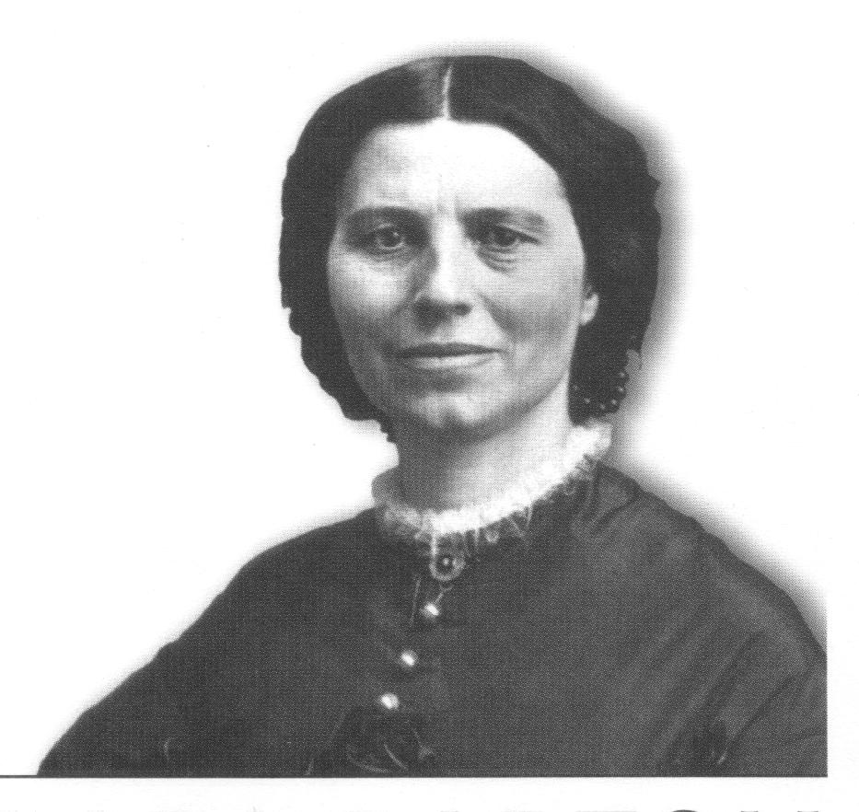

Clara Barton
Clara was born Clarissa Harlow Barton on December 25, 1821, in North Oxford, Massachusetts. She taught school in Oxford for ten years and in a female academy (Clinton Liberal Institute) in Clinton, New York. She led one of the first “Free” schools in Bordentown, New Jersey for two years, then resigned and accepted a position of Clerk in the Patent Office in Washington D.C.
The Civil War began while Clara was working as a clerk. She immediately saw the needs of the enlisted men, asked for supplies to help them, and was granted permission to join Burnside’s Division at the front. This marked the beginning of her remarkable service of providing supplies and food to the wounded and medicines to the Surgeons. She continued this service throughout the war. As the war was ending, she turned her attention to finding missing soldiers and received official permission from Abraham Lincoln to publish monthly lists of these missing men in the newspapers. Secretary of War Stanton gave her official permission to travel with Captain J.M. Moore and his party to visit Andersonville in July 1865. Clara requested Andersonville be turned into a national cemetery. The cemetery was dedicated on August 17, and Clara was given the honor of raising the flag. She worked for four years to bring information to over 22,000 families about their missing soldiers. She traveled to Europe to rest and learned about the Red Cross. In 1881,Clara founded the American Red Cross, helping with disaster relief throughout the country and providing supplies during the Spanish-American War. She was forced to resign in 1904. In 1905, she invented the first aid kit, similar to those used by the military today. She died April 12, 1912 in her home and was buried in North Cemetery in Oxford, Massachusetts.

Historic Site of the Month
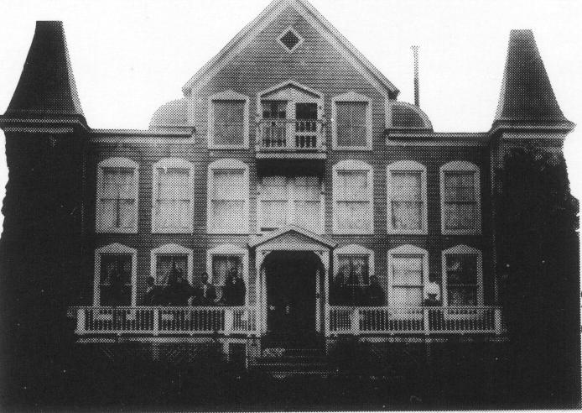 1898 photo
Clara Barton Home
The stone home was built in 1891 and was originally used as a Red Cross warehouse. In 1897, the exterior of the house was remodeled to resemble a Red Cross Hotel using wood (from earlier disaster area Red Cross hotels), which had been stored in the warehouse. The interior was also modified for living quarters and offices for Clara and her staff. Clara used every available interior wall for closets to store supplies. Bandages were made of muslin; Clara also used muslin to suspend an interior hallway light from the second floor to the first floor and to cover and insulate her ceilings. When she was told to resign because of her age, she had the back of her chair cut off to prove she was not too old to sit at her desk. The home was located at the end of the Trolley Line. Clara placed candles in the upstairs windows (which had Red Crosses on them) to show that travelers were welcome to stay for the night. The home was used as the American Red Cross national headquarters until 1904.
The Clara Barton National Historic Site is located at 5801 Oxford Road in Glen Echo, Maryland. The home is open 10-5 daily. It is closed Jan. 1, Thanksgiving and Dec. 25. Admission is free.

(Quoted from http://womenshistory.about.com/library/etext/poem1/blp_barton_fields.htm)
The Women Who Went to the Fields
By Clara Barton

The women who went to the field, you say,
The women who went to the field; and pray
What did they go for? Just to be in the way!--
They’d not know the difference betwixt work and play,
What did they know about war anyway?
What could they do? of what use could they be?
They would scream at the sight of a gun, don’t you see?
Just fancy them round where the bugle notes play,
And the long roll is bidding us on to the fray.
Imagine their skirts ‘mong artillery wheels,
And watch for their flutter as they flee ‘cross the fields
When the charge is rammed home and the fire belches not;
They never will wait for the answering shot.
They would faint at the first drop of blood, in their sight.
What fun for us boys, -- (ere we enter the fight;)
They might pick some lint, and tear up some sheets,
And make us some jellies, and send on their sweets,
And knit some soft socks for Uncle Sam’s shoes,
And write us some letters, and tell us the news.
And thus it was settled by common consent,
That husbands, or brothers, or whoever went,
That the place for the women was in their own homes,
There to patiently wait until victory comes.
But later, it chanced, just how no one knew,
That the lines slipped a bit, and some began to crowd through;
And they went, where did they go? Ah; where did they not?
Show us the battle, the field, or the spot
Where the groans of the wounded rang out on the air
That her ear caught it not, and her hand was not there,
Who wiped the death sweat from the cold clammy brow,
And sent home the message; -“ ‘T is well with him now”?
Who watched in the tents, whilst the fever fires burned,
And the pain-tossing limbs in agony turned,
And wet the parched tongue, calmed delirium’s strife
Till the dying lips murmured, “My Mother,” “My Wife”!
And who were they all? They were many, my men:
Their record was kept by no tabular pen:
They exist in traditions from father to son.
Who recalls, in dim memory, now here and there one.
A few names were writ, and by chance live to-day;
But’s a perishing record fast fading away.
Of those we recall, there are scarcely a score,
Dix, Dame, Bickerdyke, -- Edson, Harvey, and Moore,
Fales, Wittenmyer, Gilson, Safford and Lee,
And poor Cutter dead in the sands of the sea;
And Frances D. Gage, our “Aunt Fanny” of old,
Whose voice rang for freedom when freedom was sold.
And Husband, and Etheridge, and Harlan and Case,
Livermore, Alcott, Hancock, and Chase,
And Turner, and Hawley, and Potter, and Hall.
Ah! The list grows apace, as they come at the call:
Did these women quail at the sight of a gun?
Will some soldier tell us of one he saw run?
Will he glance at the boats on the great western flood,
At Pittsburgh and Shiloh, did they faint at the blood?
And the brave wife of Grant stood there with them then,
And her calm, stately presence gave strength to his men.
And Marie of Logan; she went with them too;
A bride, scarcely more than a sweetheart, tis true.
Her young cheek grows pale when the bold troopers ride.
Where the “Black Eagle” soars, she is close at his side,
She staunches his blood, cools the fever-burnt breath,
And the wave of her hand stays the Angel of Death;
She nurses him back, and restores once again
To both army and state the brave leader of men.
She has smoothed his black plumes and laid them to sleep,
Whilst the angels above them their high vigils keep;
And she sits here alone, with the snow on her brow
Your cheers for her comrades! Three cheers for her now.
And these were the women who went to the war;
The women of question; what did they go for?
Because in their hearts God had planted the seed
Of pity for woe, and help for its need;
They saw, in high purpose, a duty to do,
And the armor of right broke the barriers through.
Uninvited, unaided, unsanctioned oft times,
With pass, or without it, they pressed on the lines;
They pressed, they implored, till they ran the lines through,
And this was the “running” the men saw them do.
‘Twas a hampered work, its worth largely lost;
‘Twas hindrance, and pain, and effort, and cost:
But through these came knowledge, knowledge is power.
And never again in the deadliest hour
Of war or of peace, shall we be so beset
To accomplish the purpose our spirits have met.
And what would they do if war came again?
The scarlet cross floats where all was black then.
They would bind on their “brassards” and march to the fray,
And the man liveth not who could say to them nay;
They would stand with you now, as they stood with you then,
The nurses, consolers, and saviors of men.

If you have a short article, book review, or some other item that may be of interest to our members, please submit it via email to the editor at jkt60@earthlink.net by the tenth day following the preceding month’s meeting. Please list HARDTACK in the subject line and include your email address in case I need to contact you.

Please complete, detach and include with your check

ICWRT Call for Enlistment

Make your check payable to “Indianapolis Civil War Round Table”

Name_____________________________________ Date __________________
Address ________________________________________________
_________________________________________________
Phone ______________________ Email ________________________________
PLEASE NOTE: We must have a correct email address if you wish to receive
the HARDTACK newsletter electronically at no charge!

The year you joined the ICWRT __________________

Enlistment Status for July 2006 through June 2007 (please specify):
$25 Individual ________ $30 Family _________ $10 Student ___________
_________ $12.00 (in addition to dues) if you wish to have the HARDTACK newsletter mailed to you via U.S. Postal Service

In addition to my membership dues, please accept my generous gift of $ __________
to the ICWRT general operating account (this donation is not tax deductible)

