HARDTACK
Indianapolis Civil War Round Table Newsletter
October 9, 2006 at 7:30 p.m.
Please note we are meeting at the Indiana War Memorial this month.

The Plan of the Day

The H.L. Hunley Project: Dedication During Three Centuries
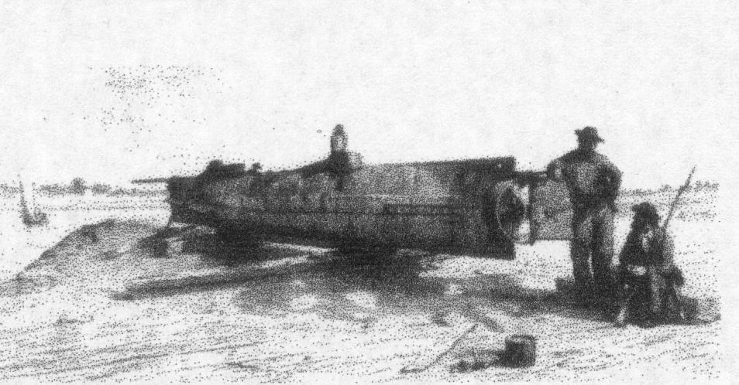
The idea of an underwater vehicle was not a new idea. In B.C. 332, Alexander the Great used a primitive diving bell. In the early 1500s, Leonardo da Vinci drew a design for a primitive submersible, but feared that evil men would use it for destruction. During the Revolutionary War, David Bushnell invented the first workable military submarine, the Turtle, but was unable to attach a mine onto the copper siding of a British ship.
The H.L. Hunley, however, was the first submarine to sink a warship. The Hunley was built in Mobile, Alabama in 1863 and was moved to Charleston, South Carolina. This boat required eight men to turn the hand-cranked propeller. The commander controlled the rudders to dive and surface. Two conning towers contained glass portholes and the hatches. A mercury gauge indicated depth, and a candle indicated the need to surface when its light went out. Each end of this Confederate submarine was equipped with ballast tanks, which could be flooded by opening valves or pumped dry by using hand pumps. The cast-iron keel, which provided extra ballast, could be disconnected to allow the boat to surface quickly. Because the water-ballast tanks were open on the top, flooding of the ship was a constant potential problem.
On August 29, the wake of a passing ship sent water into the open hatch on a training mission. The crew panicked to get out, causing the submarine to tip over and sink. Only four men survived; they never set foot in her again. The boat was raised ten days later. When the new commander George Dixon was absent on October 15, Horace Hunley (the submarine’s financial backer and namesake) took the next crew on another training mission to dive under the CSS Indian Chief. The boat dived too quickly and went straight to the bottom; the entire crew was lost. The boat was found October 18 and raised November 7. Dixon trained his final crew and waited for the perfect opportunity to attack. The USS Housatonic, anchored in Charleston Harbor, had followed Rear Admiral Dahlgren’s submarine defensive instructions of installing chain netting along the hull, not anchoring in deep water, changing anchorage occasionally, and training guns on the water at all times; however, it was rammed by the Hunley’s spar torpedo in a late night attack on February 17, 1864. The explosion sank the Housatonic with five of its crew. Dixon had promised to flash a blue phosphorus lamp when the mission was complete, so the Confederates on the beach could light a fire to guide them back to shore. One Union sailor and the Confederates on shore saw this light, but the Hunley never arrived. Over the years, many have searched for the Hunley. In the late 1870’s, P.T. Barnum even offered a $100,000 reward to the finder.

Our Guest Speaker

Chris Amer
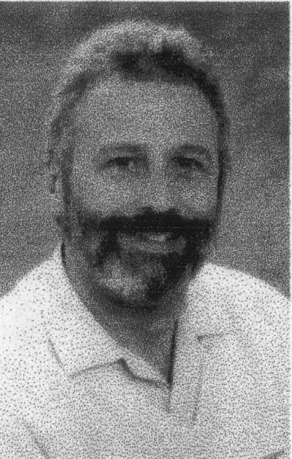
After a 14-year search, Clive Cussler and his team from the National Underwater and Marine Agency (NUMA) found the Hunley just outside the Charleston Harbor near Sullivan’s Island in 1995. The Hunley was lifted from its watery grave on August 8, 2000. It is currently undergoing conservation in the Warren Lasch Conservation Center.
Chris Amer is South Carolina’s State Underwater Archaeologist and the Head of the Maritime Research Division of the South Carolina Institute of Archaeology and Anthropology at the University of South Carolina. He was an investigator on the 1996 H.L. Hunley Assessment Project and the 1999 U.S.S. Housatonic Survey. He was a diving member of the H.L. Hunley Recovery Team. He also served as historical consultant for the TV movie, The Hunley.
Chris will present a slide presentation and lecture about the results of the two surveys, the recovery of the crew’s remains, the preservation of the submarine, new knowledge about engineering and mechanical mysteries in H.L. Hunley, and the current status and future plans for the submarine.

Roster of Officers and Committees for the 2006-2007 Campaign
Officers:
President: Dave Klinestiver Secretary: vacant
Vice President: Dave Sutherland Treasurer: Peg Bertelli
Librarian: Marilyn Hoffman
Committee Chairs:
Programs: Dave Sutherland Preservation: Andy O’Donnell
Membership: Nikki Schofield Publicity: Dave Buchanan & Tony Roscetti
Quiz Master: Summer Campaign:
Tony Trimble Nikki Schofield
HARDTACK Newsletter:
Editor: Jenny Thompson
Distribution: Jenny Thompson (email) & Tony Roscetti (U.S. mail)

2006-2007 Campaign Plans
Unless otherwise noted, we meet at the Indiana History Center, 450 West Ohio Street.
November 13, 2006 Helen Douglass Speaks Nikki Schofield
December 11, 2006 Grant & Lincoln: A Unique Partnership Robert Vane
January 8, 2006 Cross Keys & Port Republic Tony Trimble
February 12, 2007 Hoosier Soldiers at Fredericksburg Peter Carmichael
March 12, 2007 “Stovepipe” Johnson’s Raid on Newburgh Ray Mulesky
April 9, 2007 The USS Monitor Center Craig Symonds
May 14, 2007 A New Look at Civil War Photography Dave Klinestiver
June 11, 2007 Vicksburg Terry Winschel

Other Camp Activities

October 13-15, 2006 Hartford City Civil War Days
The 12th annual Student Discovery Day will be held on Friday, October 13th. The 17th annual Anniversary of Hartford City Civil War Days will be held on Saturday, October 14th and Sunday, October 15th. There will be a dedication of a bronze statue of a Civil War soldier at the Blackford County Court House on Saturday at 8:30 a.m. Nikki Schofield will be speaking as Clara Barton and Laura Keene on Saturday at 11:15 a.m. and 3:00 p.m. For directions and a schedule, please visit: http://www.angelfire.com/in3/34IN/

October 16, 2006 (7 p.m.) “A Journey Through Time: The Civil War”
The Wabash County Historical Museum presents Edwin Cole Bearss presenting “A Journey Through Time: The Civil War”, at the Honeywell Center, 275 W. Market Street, Wabash, Indiana. Tickets are $12 Adults, $5 Students through college. To purchase tickets, visit the website: http://www.honeywellcenter.org or call the box office at (260) 563-1102. For more information, please contact Beth Driscoll at (260) 750-3916.

October 18, 2006 (7:00 – 8:30 p.m.) “Well Done, Indiana” DVD reception
The Indianapolis Civil War Round Table, Indiana Historical Society, and WFYI are hosting a reception and viewing at the Indiana History Center. You are all cordially invited to see the new DVD on Indiana in the Civil War, “Well Done, Indiana”. This 30-minute story consists of four segments: The Iron Brigade; Lew Wallace; 28th US Colored Troop; and Morgan’s Raid in Indiana. Round Table members who are seen in the film or who make comments during the film include: Alan Nolan, Tony Trimble, Richard Skidmore and former member Wayne Sanford. The reception begins at 7:00 and the viewing will be at 7:45.

Special Orders

Publication notice: Kent State University Press has published another book in the Civil War in the North Series, entitled August Willich’s Gallant Dutchmen: Civil War Letters from the 32nd Indiana Infantry edited by Joseph R. Reinhart. Colonel August Willich, a former Prussian army officer, led this German regiment in battles in Kentucky (Rowlett’s Station), Tennessee (Shiloh, Stones River and Missionary Ridge) and Georgia (Chickamauga and Pickett’s Mill). These letters originally appeared in German American newspapers during the war and provide an interesting insight into the patriotic immigrant soldier and his regiment.

Sesquicentennial of the Civil War (2011 – 2015): Tom Krasean has been asked to serve as a representative of the ICWRT on a statewide committee to plan for the commemoration of the Sesquicentennial of the Civil War (2011 – 2015) and Indiana’s Role in the War.

A letter home from South Carolina: Elbert Watson, who operates on our Southern Front, recently spoke to an overflow crowd of WWII veterans and history buffs at the Pickens County (South Carolina) History Museum on the subject “The Flight of the Enola Gay and the End of World War II.” In October, Elbert will speak to a chapter of the United Daughters of the Confederacy on “Confederate General Stand Watie.” After an absence of several years, Elbert re-enlisted in the Round Table in June. He is thrilled to be part of such an outstanding group, whose dynamic energy evokes for him many pleasant and happy memories of his Hoosier years. Welcome back, Elbert!

Test Your Civil War Knowledge (with Trimble’s Trivia)

- What battle saw a larger proportion of Confederate troops killed or wounded than any other major engagement of the war?

- Name the Confederate warship whose surrender was the last of the war.

- Name the highest placed Union spy of the war. Where did she work?

- What sarcastic name did enlisted men give to their officer’s swords?

- Who were the “Immortal 600?”

Answers to the September Quiz
- Abraham Lincoln and Nathan Bedford Forrest
- The Ketchum Grenade
- Lousy 33rd
- The Leech and Rigdon revolver
- A bayonet exercise

The Soldiers Speak

THE RECOVERY OF THE FIRST CREW:
Brian Hicks & Schuyler Kropf’s book Raising the Hunley: The Remarkable History and Recovery of the Lost Confederate Submarine stated that within a week, Horace Hunley attempted to clean the smell of death from the submarine:

“… the bodies of the first crew having become so bloated, they had to be chopped in pieces to be removed. It was a grisly sight and a worse smell. But the scent – and image – of death would linger on the Hunley. Soldiers becoming wary of the submarine called it an ‘iron coffin.’”

THE RECOVERY OF THE SECOND CREW:
(quoted from R. Thomas Campbell’s book The CSS H.L. Hunley: Confederate Submarine)

General Beauregard:
“When the boat was discovered, raised and opened, the spectacle was indescribably ghastly; the unfortunate men were contorted into all kinds of horrible attitudes; some clutching candles, evidently endeavoring to force open the man-holes; others lying in the bottom tightly grappled together, and the blackened faces of all presented the expression of their despair and agony.”

DIXON’S PLANS FOR THE HUNLEY:
(quoted from his letter to Mr. Henry Willey of Mobile, Alabama, found at http://www.hunley.org/main_index.asp?content=DIXON)

“… I shall keep trying until I do some thing. I have been out-side several times but for various reasons I have not yet met with success. I am out-side every night in a small boat… I have my boat lying between Sullivan’s and Long Islands and think that when the night does come that I will surprise the Yankees completely. The Fleet offshore have drawings of the sub-marine and of course they have taken all precautions that it is possible for Yankee ingenuity to invent, but I hope to Flank them yet.”

DESCRIPTIONS OF THE HUNLEY FROM SAILORS ON THE HOUSATONIC:
(quoted in Brian Hicks & Schuyler Kropf’s book Raising the Hunley: The Remarkable History and Recovery of the Lost Confederate Submarine)

Robert Flemming, a black sailor on starboard watch, thought he saw a big log:
“moving across the tide”

John Crosby, acting master on the quarterdeck, first thought it looked:
“like a porpoise, coming up to the surface to blow.”

(quoted from R. Thomas Campbell’s book The CSS H.L. Hunley: Confederate Submarine)
Lieutenant F.J. Higginson, the ship’s executive officer, saw:
“It had the appearance of a plank sharp at both ends…it was entirely on awash with the water, and there was a glimmer of light through the top of it”

Captain Charles W. Pickering, the commanding officer, saw something:
“shaped like a large whale boat, about two feet, more or less, under water”

Mr. Mayer, the ship’s Assistant Engineer, heard:
“the explosion, accompanied by a sound of rushing water and crashing timbers and metal. Immediately the engine went with great velocity as if the propeller had broken off. I then throttled her down, but with little effect. I then jumped up the hatch, saw the ship was sinking and gave the order for all hands to go on deck.”

WHAT HAPPENED TO THE HUNLEY:
(quoted from R. Thomas Campbell’s book The CSS H.L. Hunley: Confederate Submarine)

Robert Flemming while in the fore rigging of the Housatonic, saw:
“a blue light on the water just ahead of the Canandaigua, and on the starboard quarter of the Housatonic.”

Lt. Col. O.M. Dantzler, CSN, reported that:
“The signals agreed upon to be given in case the boat wished a light to be exposed at this post as a guide for its return were observed and answered.”

(quoted from http://www.history.navy.mil/branches/org12-7b.htm)

McClintock’s opinion, recorded in 1872:
“I would here state that I do not believe that the Sub Marine Boat was lost in the operation of destroying the Housatonic, but was lost in a storm which occurred a few hours after. I am aware that the Federals has made diligent search for her, and have made three different reports of having found her, yet no descriptions that I have ever heard are correct.”

Soldier of the Month

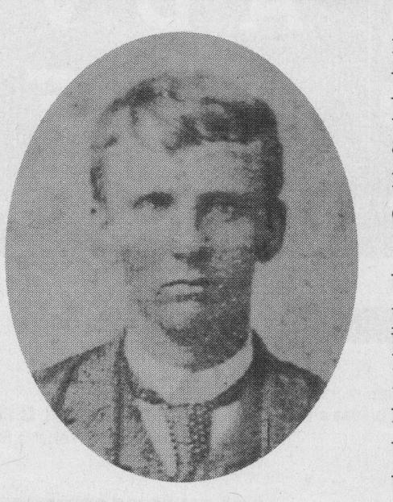
2nd Lt. George E. Dixon
Dixon enlisted in the 21st Alabama Infantry in October of 1861. Legend states that a young lady, Queenie Bennett, gave him a gold coin as a good luck charm before he left Mobile. A bullet struck the coin in the pocket of his trousers during the Battle of Shiloh. Because this coin saved his life by taking the major impact of the bullet, Dixon inscribed the following on the coin: “Shiloh / April 6, 1862 / My life Preserver / G.E.D.” After recovering in Mobile, Dixon became involved in the test runs of the H.L. Hunley in Mobile Bay.
Dixon became commander of the submarine after the first sinking in Charleston Harbor. Beauregard felt the submarine was too dangerous after the second sinking of the Hunley, so he grounded it. Dixon and Alexander demanded another chance. They agreed to inform the next crew about the possible dangers and to add a twenty-foot spar for the copper torpedo. Dixon organized the first submariner’s school at Mount Pleasant on Sullivan’s Island. For three months, the crew learned about the structure and characteristics of the boat in the morning and performed practice runs in the afternoon. Dixon and his crew successfully sank the USS Housatonic; however, the Hunley never returned to shore.
The legend of the gold coin proved true when the remains of Dixon were found in the Hunley; a $20 gold piece, minted in 1860, was found next to him bearing that same inscription. On April 17, 2004, Dixon and his crew were buried in Magnolia Cemetery next to the others who had lost their lives on the earlier test missions of the H.L. Hunley.

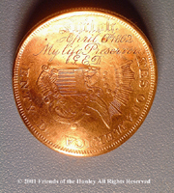
Historic Site of the Month

Charleston Museum

An iron replica of the Hunley, built by college students in the 1960s, lies outside the Charleston Museum. This museum was established in 1773 by the Charleston Library Society and is considered the America’s first museum. Many collections were destroyed in a fire in 1778. Operations were suspended during the American Revolution. The museum opened to the public in 1824. Operations were also suspended during the Civil War.
The museum is located at 360 Meeting Street in Charleston. It is open year-round Monday – Saturday, 9-5 and Sunday 1-5. It is closed on New Year’s Day, Easter, Thanksgiving, Christmas Eve (at noon) and Christmas Day. Admission is $10.00 Adults (13+); $4.00 Children (3-12); and free for Children 2 and under. For more information, visit: http://www.charlestonmuseum.org/

The Charleston he Charleston Museum he Charleston Museum was established in 1773the Museum was established in 1773 by the Charleston Library Society and is commonly
If you have a short article, book review, or some other item that may be of interest to our members, please submit it via email to the editor at jkt60@earthlink.net by the tenth day following the preceding the month’s meeting. Please list HARDTACK in the subject line and include your email address in case I need to contact you.

Please complete, detach and include with your check

ICWRT Call for Enlistment

Make your check payable to “Indianapolis Civil War Round Table”

Name_____________________________________ Date __________________
Address ________________________________________________
_________________________________________________
Phone ______________________ Email ________________________________
PLEASE NOTE: We must have a correct email address if you wish to receive
the HARDTACK newsletter electronically at no charge!

The year you joined the ICWRT __________________

Enlistment Status for July 2006 through June 2007 (please specify):
$25 Individual ________ $30 Family _________ $10 Student ___________
_________ $12.00 (in addition to dues) if you wish to have the HARDTACK newsletter mailed to you via U.S. Postal Service

In addition to my membership dues, please accept my generous gift of $ __________
to the ICWRT general operating account (this donation is not tax deductible)
Mail to:
Margaret Bertelli
11827 Corbin Dr.
Fishers, IN 46038

