HARDTACK
Indianapolis Civil War Round Table Newsletter
November 13, 2006 at 7:30 p.m.
Meeting at Indiana History Center
450 West Ohio Street
Indianapolis, Indiana

The Plan of the Day

The Second Mrs. Frederick Douglass Remembers Her Famous Husband

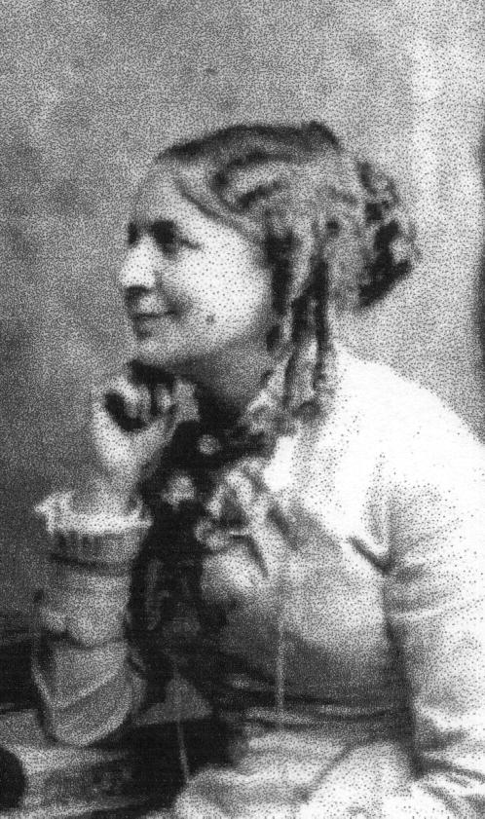
Helen Pitts Douglass was born (in 1838) and raised in Honeoye, NY. She graduated from Genessee Wesleyan Seminary in Lima, NY and from Mount Holyoke Seminary in Massachusetts. For several years, she taught Negro children at the Hampton Institute in Norfolk, Virginia. Local residents insulted and abused her students, so Helen caused them to be arrested. Tensions and poor health forced her to return home. After recovering, she joined her sister and taught school in Huntington, Indiana. In 1882, she went to Washington, D.C. to live with her uncle. In June, she became secretary for Frederick Douglass, who was recorder of deeds.
Frederick escaped from slavery at the age of 20, married his first wife Anna Murray (a black woman, who died in 1882), edited a newspaper, campaigned for Negro men to serve as soldiers in the Civil War, served in government offices, and became the most famous orator of the 19th century.
Helen, a white woman, and Frederick were married on January 24, 1884. Her family and his children did not approve of this marriage. Many Negroes felt betrayed. Helen and Frederick shared intellectual interests and a commitment to women’s suffrage. Frederick died suddenly of a heart attack in February of 1895. At the funeral, in Washington, D.C., five days later, Helen received hundreds of condolence messages. A memorial service was also held in Rochester, New York.
Helen bought their home, Cedar Hill, as a memorial to Frederick. She also established the Frederick Douglass Memorial and Historical Association. Helen died in 1903. Both were buried at Mount Hope Cemetery in Rochester, New York. The National Association of Colored Women bought the home after her death. The home is now owned and operated by the National Park Service.

Our Guest Speaker

Nikki Scofield

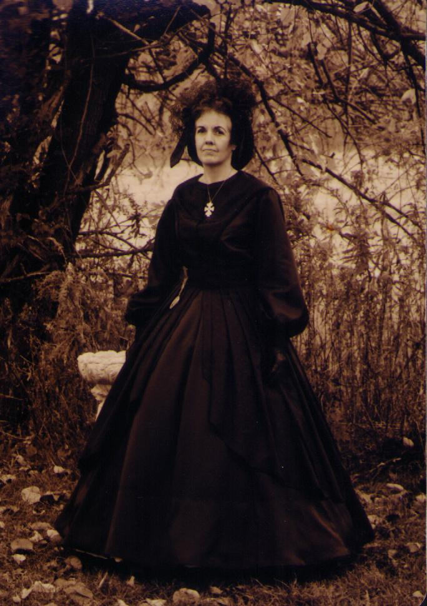
Nikki Schofield, a living history presenter, has portrayed Mrs. Stonewall Jackson, Anzolette Page Pendleton (wife of Gen. William Nelson Pendleton and the mother of Sandi Pendleton), Susan Pendleton Lee (wife of Brig. Gen. Edwin Gray Lee, head of the CSA Secret Service in Canada), Mary Jenkins Surratt (Lincoln conspirator), Belle Boyd (most famous Confederate Spy), Mrs. Lucinda Burbank Morton (wife of Indiana’s great war governor), Clara Barton (Civil War nurse), Laura Keene (actress at Ford’s Theater when Lincoln was shot, and Mrs. Helen Pitts Douglass (second wife of Frederick Douglass).
Nikki is past president of the ICWRT (1996-1997) and has served as secretary for many years, newsletter editor, co-chairman of the 2000 Mid-West Civil War Conference, and is currently director of the ICWRT annual trip. Since 1974, Nikki has been director of the law library at Bingham McHale LLP, the fourth largest law firm in Indiana. She is a deacon, Sunday School teacher, and business meeting moderator at Speedway Baptist Church. She has two sons (one of whom is a Civil War buff), five grandchildren and one great-grandson.
Nikki will portray Helen Douglass, who will talk about her famous husband, while looking through condolence messages from friends and enemies. She will tell not only about his stormy public life, but also about his private life, including stories of the other white ladies who created scandals.

JOIN US BEFORE THE MEETING AT SHAPIRO’S DELI! All ICWRT members and guests are invited to join us at 5:30 P.M. at Shapiro’s Delicatessen, 808 S. Meridian St. (just south of McCarty Street) before the meeting to enjoy dinner and fellowship.

Roster of Officers and Committees for the 2006-2007 Campaign
Officers:
President: Dave Klinestiver Secretary: vacant
Vice President: Dave Sutherland Treasurer: Peg Bertelli
Librarian: Marilyn Hoffman
Committee Chairs:
Programs: Dave Sutherland Preservation: Andy O’Donnell
Membership: Nikki Schofield Publicity: Dave Buchanan & Tony Roscetti
Quiz Master: Summer Campaign:
Tony Trimble Nikki Schofield
HARDTACK Newsletter:
Editor: Jenny Thompson
Distribution: Jenny Thompson (email) & Tony Roscetti (U.S. mail)
2006-2007 Campaign Plans
Unless otherwise noted, we meet at the Indiana History Center, 450 West Ohio Street.
December 11, 2006 Grant & Lincoln: A Unique Partnership Robert Vane
January 8, 2006 Cross Keys & Port Republic Tony Trimble
February 12, 2007 Hoosier Soldiers at Fredericksburg Peter Carmichael
March 12, 2007 “Stovepipe” Johnson’s Raid on Newburgh Ray Mulesky
April 9, 2007 The USS Monitor Center Craig Symonds
May 14, 2007 A New Look at Civil War Photography Dave Klinestiver
June 11, 2007 Vicksburg Terry Winschel

Test Your Civil War Knowledge (with Trimble’s Trivia)

- In one 20-minute stretch, 7,000 Union soldiers fell during an assault on Confederate fortifications. Name the battle where this occurred.

- Relative to the Civil War, what do the following men have in common: Andrew Carnegie, J.P. Morgan, John D. Rockefeller, Charles Pillsbury, George Pullman, Jay Gould, and Marshall Field?

- Name the president whose name was given to regulation Federal footwear.

- What is a “razorback”?

- Who was known as, “Old Jack’s Commissary General”?

Answers to the October Quiz:
- Battle of Franklin
- CSS Shenandoah
- Mary Elizabeth Bowser; Confederate White House
- Cheese Knife
- Confederate POWs deliberately placed in the line of fire in retaliation for similar treatment of Union prisoners

Official Records
Casualty report:
Margie Riddle Bearss, the beloved wife of Edwin Cole Bearss, passed away on October 7, 2006, just two weeks shy of her 81st birthday. She was also his partner in history. When he raised the Union ironclad, Cairo, from the bottom of the Yazoo River in 1964, she cleaned, identified and catalogued every artifact he found. She edited his written works. She was also an author. She wrote Sherman’s Forgotten Campaign: The Meridian Expedition and co-authored several other books, including My Dear Wife: Letters to Matilda. A chapter about her life can be found in Jack Waugh’s biography of Ed Bearss, which can be found at http://www.cr.nps.gov/history/online_books/bearss/bearss.pdf on pages 31-35. She will be deeply missed.

The Soldiers Speak

THE COMMANDER-IN-CHIEF (LINCOLN) TALKS ABOUT SLAVERY

(Quoted from Famous Statements, Speeches & Stories of Abraham Lincoln, edited by J. Donald Hawkins)

“I hold that if the Almighty had ever made a set of men that should do all the eating and none of the work, He would have made them with mouths only and no hands; and if He had ever made another class that He intended should do all the work and no eating, He would have made them with hands only and no mouths.”

“Slavery is founded in the selfishness of man’s nature – opposition to it in his love of justice.”

REACTIONS ABOUT ARMING SLAVES
(Quoted from James McPherson’s The Negro’s Civil War)

Report, dated January 2, 1864, from group of rebel officers headed by General Patrick R. Cleburne:
“… to meet the causes which are now threatening ruin to our country, we propose…that we immediately commence training a large reserve of the most courageous of our slaves, and further that we guarantee freedom within a reasonable time to every slave in the South who shall remain true to the Confederacy in this war…. Apart from all other aspects of the question, the necessity for more fighting men is upon us. We can only get a sufficiency by making the negro share the danger and hardships of the war.”

Letter, dated December 21, 1864, from Confederate Secretary of War, Judah P. Benjamin, to Fred A. Porter:
“The negroes will certainly be made to fight against us if not armed for our defense…. It is well known that General Lee, who commands so largely the confidence of the people, is strongly in favor of our using the negroes for defense, and emancipating them, if necessary, for that purpose.”

Written January 8, 1865 by General Howell Cobb:
“You cannot make soldiers of slaves, nor slaves of soldiers…. The day you make soldiers of them is the beginning of the end of the revolution.”

Letter, dated January 11, 1865, from General Robert E. Lee to a Confederate senator:
“I think, therefore, we must decide whether slavery shall be extinguished by our enemies and the slaves be used against us, or use them ourselves at the risk of the effects which may be produced upon our social institutions…. We should employ them without delay.”

THE REACTION OF UNION TROOPS TO NEGRO SOLDIERS

(Quoted from T. J. Morgan’s Negroes in the Civil War)
Note: Morgan was colonel of the 14th USCT.

“When the question was first broached of enlisting Negro soldiers there was a strong prejudice against it among both officers and men. The general opinion seemed to be that slaves were disqualified for efficient service as soldiers by reason of their ignorance and the servile spirit begotten by bondage…. there was also a strong objection to arming the slaves and using them as soldiers to fight their old masters on the ground that it savored a little of dishonor; and, further, that it would necessarily intensify the bitterness of the Southern soldiers and people against the Union army and the North.
“On the other hand, those among the officers and soldiers who favored their enlistment argued that one of the probable results of the war was to be the destruction of slavery, that consequently the slaves had more at stake than any other class of persons, and hence, that they should share the burden of the war and aid in the suppression of the rebellion. Then too, if they were to be free, their experience as soldiers would prepare them for freedom as no other experience possibly could…. The certainty of their severe treatment if captured in battle would be an added stimulus to desperate courage…. at length the opinion of the army came to be that Negro soldiers, organized and disciplined, could at least perform, as has been said, invaluable service in the construction of fortifications and the guarding of the forts, thus liberating for service in the field an equal number of veteran white troops.”

SOME OF THOSE OPINIONS CHANGED

(Quoted from T. J. Morgan’s Negroes in the Civil War)

“The most common expression to be heard among the visitors after witnessing a parade was, ‘Those men will fight.’”

[Nashville, fall of 1863] “At a public reception given by General Ward, an officer of a Negro regiment meeting an acquaintance, the lieutenant-colonel of an Ohio regiment, offered him his hand, which the latter declined, remarking as he turned away, that he ‘did not recognize Negro officers.’…the offending officer was promptly dismissed from the service.
“After my soldiers had charged and taken a battery at Decatur, Ala., in October, 1864, and had shown great gallantry the following day under fire, they received an ovation from the white troops, who by thousands sprang upon the parapets and cheered the regiment as it re-entered the lines.”

“When it was over it was recognized by common consent that the Negroes had been an influential factor in preserving the integrity of the Union…”

(Quoted from. All for the Union: The Civil War Diary and Letters of Elisha Hunt Rhodes, edited by Robert Hunt Rhodes)

Elisha Hunt Rhodes, writing near Petersburg, VA, June 19, 1864

“A division of colored soldiers charged over the same ground but were driven back. They fought well and left many dead on the field…. I have not been much in favor of colored soldiers, but yesterday’s work convinced me that they will fight. So Hurrah for the colored troops!”

(Quoted from Thomas Wentworth Higginson’s Army Life in a Black Regiment)
Note: Higginson commanded the 1st SC Volunteers: “the first black regiment that ever bore arms in defence of freedom on the continent of America.”

“Till the blacks were armed, there was no guaranty of their freedom. It was their demeanor under arms that shamed the nation into recognizing them as men.”

THE REACTION OF CONFEDERATE TROOPS TO NEGRO SOLDIERS AND THEIR WHITE OFFICERS

(Quoted from Warren Wilkinson’s Mother, May You Never See The Sights I Have Seen: The Fifty-Seventh Massachusetts Veteran Volunteers in the Army of the Potomac 1864-1865)

“The Southerners were incensed beyond all reason at the North’s use of black soldiers against them. It was simply beyond comprehension to those men that the Federal government would stoop to the mustering of their former property as soldiers. It was insulting, mortifying, and outrageous to each and every officer and enlisted man in the Army of Northern Virginia, be he in civilian life an aristocratic slaveholding Virginia planter, a poor Georgia dirt farmer, or a West Texas plainsman. In fact, a few of the Texans quite probably never had even seen a black man until they came east to the war. To be shot by a former slave, a human of an inferior race in their eyes, would be the acme of humiliation, and the Rebels, to a man, vented their unabashed hatred of the black soldiers with ferocity at every opportunity.”
“The Confederate government had passed a law by which Southerners could execute white Union officers commanding Negro troops, and those officers were not anxious to be taken prisoner. Men of any rank who were taken that day were treated far worse than usual for having fought with the blacks. The Southerners clearly were venting their rage.”

Civilian of the Month
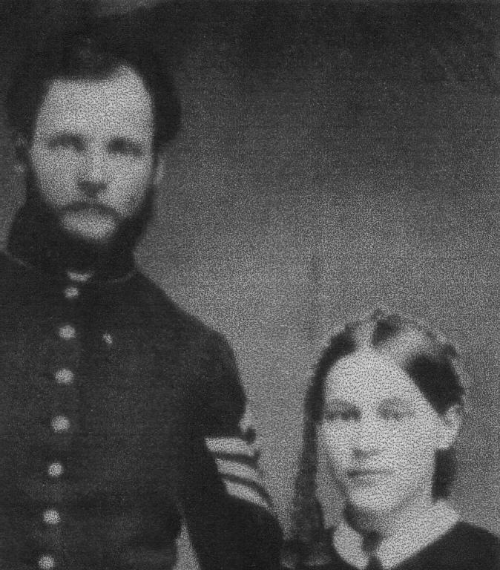

Kate Fribley
Katherine Ault married Charles Wesley Fribley on December 10, 1861. Charles grew up on a farm in Pennsylvania and attended Dickinson Seminary in Williamsport. He moved to the West in 1857 to seek his fortune as a ferry boatman, schoolteacher, Overland Mail conductor, and fighter between “bleeding Kansas” and border ruffians. Charles returned to Pennsylvania and became a teacher. A few days after the attack on Fort Sumter, Charles answered Lincoln’s call for volunteers and joined a three-month regiment – the Woodward Guards (Company A of the 11th PA infantry). In October 1861, Charles enlisted in Company F of the 84th Pennsylvania Infantry. He was made 2nd Lieutenant in May 1862, commissioned Captain of his company in October 1862, and was made Adjutant of the 84th in February 1863. During this time, he was engaged in the following battles: Winchester, Cedar Mountain, Manassas and Haymarket, Second Bull Run, Fredericksburg, and Chancellorsville. Kate accompanied Charles to camp whenever it was convenient.
In 1863, Charles made two major decisions, changing his life forever. Realizing that death could be soon, Charles settled his account with God in April 1863: “Read…‘How to Turn a Christian’. Did me much good. I this day choose to be and resolve to be a Christian.” (Quoted from Charles’ diary) On July 8, 1863, Charles applied to the War Department for command of a colored troop. He appeared before a Board of Examiners for the examination of field office and passed the examination with ease. He was promoted to the rank of Colonel on November 23 and was assigned to the command of the 8th Regiment, U.S. Colored Troops at Camp William Penn. The 8th USCT moved into wooden army barracks in December 1863. Fribley purchased musical instruments and two howitzers, organized companies, and continued drills throughout December. Lieutenant Oliver Norton commented that “Colonel Fribley had applied time and time again for permission to practice his regiment in target firing, and been always refused.” (Quoted from William H. Nulty’s Confederate Florida: The Road to Olustee) This may have led to the conflict with Lieutenant Colonel Louis Wagner, who charged Colonel Fribley with disobedience of orders and conduct unbecoming an officer and a gentleman for his response to the original charges: “tell Col. Wagner to attend to his own business and he / Col. F. / would attend to his.” (Noted on the Military Service File for Charles Wesley Fribley) The Acting Judge Advocate did not feel the charges important enough to warrant a trial before him.
In January 1864, the 8th Regiment, USCT, was ordered into battle. They departed Camp William Penn for New York City and embarked for Hilton Head, South Carolina. Kate accompanied her husband to Hilton Head and stayed with them until the regiment left for Florida on February 6. Kate returned to Fort Monroe, Virginia. From Jacksonville, the regiment traveled inland under the command of General Seymour to a settlement designated as Olustee, and there on February 20, 1864, were engaged in battle with a large number of Confederate skirmishers. The Confederates charged the left flank of the 8th USCT. As he ordered his men to continue firing as they slowly fell back, Fribley was shot in the chest. He told his men to carry him to the rear. He died a few moments later. His body was placed on the footboard of one of Hamilton’s limbers. The regimental colors were carried to the rear. Three color sergeants and five corporals of the color guard fell saving their national colors. Lieutenant Lewis carried the national colors to a battery on the left. A fragment of the regiment rallied around the flag. The horses started to the rear and were soon stopped. Enemy fire forced the men to retreat and unfortunately, in the confusion the colors were left behind. Captain Hamilton ordered Fribley’s body removed from the limber, so one of his guns could be moved. The Confederates stripped the dead of their clothing. Seymour requested Fribley’s grave be marked for later reburial; however, Finegan denied his request. Seymour also requested that Fribley’s effects be given to his widow. Finegan felt compassion for the widow and returned an ambrotype, his watch, a letter and Fribley’s diary. Colonel Fribley was probably buried in a mass grave with his men. A letter published March 30, 1864 in the Savannah Daily News (quoted in Confederate Florida: The Road to Olustee) showed no compassion: “The black-hearted Frieble had a dog’s burial. A leader of a horde of infuriated negroes, on a mission of murder, robbery and rape, ought he not have been left to rot on the plain, to the obscene birds to fatten on his vitals, and the great wolves to gnaw on his bones?” This letter also questioned the color of Fribley’s wife, whether she was white or black. A photo of the couple (a portion of which is seen above) showed they were both white.
Fribley’s death was a great loss to the regiment. The regiment did not blame their colonel for their losses. They named their next principle fort outside of Jacksonville ‘Redoubt Fribley’ in his honor. Kate received many letters of condolence from the various officers connected to the Florida expedition. Fribley’s name can be found today on the African American Civil War Memorial in Washington, D.C. and on the soldier’s monument in the Muncy cemetery in Pennsylvania. Pennsylvania also named the GAR post in Williamsport, Lycoming County in his honor – Col. Chas. W. Fribley Post No. 390.
After the war, “the North sent ‘Yankee schoolmarms’ to the South to educate the newly freed slaves.”(Quoted from William A. Gladstone’s Men of Color) Kate honored Charles by becoming a “Yankee schoolmarm” in Tennessee. She married Jesse Snyder in 1868 and died in 1882. [Editor’s note: Charles and Kate are my distant relatives. My great-grandmother was a Fribley.]

Historic Site of the Month

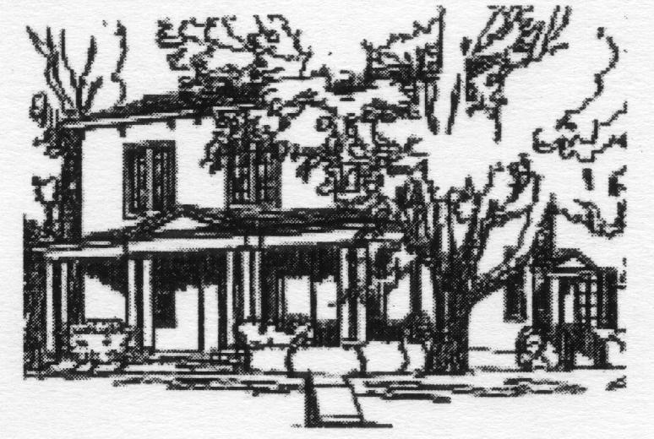

The Harriet Beecher Stowe House was originally the residence of the president of Lane Seminary. Harriet’s father, Reverend Dr. Lyman Beecher, was the first president of the seminary. Harriet lived here from 1833 – 1836, until her marriage to the recently widowed Calvin Stowe, a professor at Lane Seminary. In May of that year, Harriet moved back into the home, when her husband left for Europe to investigate old world school systems and to secure books for the seminary. Harriet wrote stories and songs to supplement her husband’s income, which was not sufficient to provide for their growing family. Two of her songs, “Knocking, Knocking, Who Is There?” and “Well, Well With Thee,” can be found in some Methodist hymnbooks today.
Harriet visited a slave plantation in Kentucky in 1833.Lane Seminary became divided in 1834 over the issue of slavery. Harriet was also greatly influenced by the opposition against abolitionism occurring in Cincinnati. In 1839, her family took in a colored girl from Kentucky as a servant. They soon learned she was a fugitive slave and helped to move her to a place of safety. All these events influenced the writing of Uncle Tom’s Cabin, which was published in 1852. This book became the all-time best seller of the nineteenth century. It has never been out of print.
The House is located at 2950 Gilbert Avenue in Cincinnati, Ohio. It is open 10 a.m. – 3 p.m. Tuesday, Wednesday, Thursday and Saturday from May 1 – Labor Day; 11 a.m. – 3 p.m. Tuesday, Wednesday, and the first Saturday of each month from September – November; and 11 a.m. – 3 p.m. on Saturdays from December – April. Admission is free; donations are appreciated. The home is at the corner of Martin Luther King Drive and Gilbert Avenue. Directions to the house from I-71S: Taft Road Exit #3; right onto William Howard Taft Road; right onto Reading Road / US-42; right onto Martin Luther King Drive; right onto Gilbert Ave.; immediate left onto Foraker. Parking is available behind the house, off Foraker and across the street at the African-American Chamber of Commerce. For more information, please call (513) 751-0651; contact FriendsHarrietBeecherStowe@gmail.com; or visit www.harrietbeecherstowehouse.org.

If you have a short article, book review, or some other item that may be of interest to our members, please submit it via email to the editor at jkt60@earthlink.net by the tenth day following the preceding month’s meeting. Please list HARDTACK in the subject line and include your email address in case I need to contact you.

A TRIBUTE TO FREDERICK DOUGLASS:

(Quoted from The Columbia Book of Civil War Poetry, edited by Richard Marius)

Frederick Douglass
Paul Laurence Dunbar (1872-1906)

A hush is over all the teeming lists,
And there is pause, a breath-space in the strife;
A spirit brave has passed beyond the mists
And vapors that obscure the sun of life.
And Ethiopia, with bosom torn,
Laments the passing of her noblest born.

She weeps for him a mother’s burning tears –
She loved him with a mother’s deepest love.
He was her champion thro’ direful years,
And held her weal all other ends above.
When Bondage held her bleeding in the dust,
He raised her up and whispered, “Hope and Trust.”

For her his voice, a fearless clarion, rung
That broke in warning on the ears of men;
For her the strong bow of his power he strung,
And sent his arrows to the very den
Where grim Oppression held his bloody place
And gloated o’er the mis’ries of a race.

And he was no soft-tongued apologist;
He spoke straightforward, fearlessly uncowed;
The sunlight of his truth dispelled the mist,
And set in bold relief each dark-hued cloud;
To sin and crime he gave their proper hue,
And hurled at evil what was evil’s due.

Through good and ill report he cleaved his way
Right onward, with his face set toward the heights,
Nor feared to face the foeman’s dread array, -
The lash of scorn, the sting of petty spites.
He dared the lightning in the lightning’s track,
And answered thunder with his thunder back.

Please complete, detach and include with your check
ICWRT Call for Enlistment

Make your check payable to “Indianapolis Civil War Round Table”

Name_____________________________________ Date __________________
Address ________________________________________________
_________________________________________________
Phone ______________________ Email ________________________________
The year you joined the ICWRT __________________
Enlistment Status for July 2006 through June 2007 (please specify):
$25 Individual ________ $30 Family _________ $10 Student ___________
In addition to my membership dues, please accept my generous gift of $ __________
to the ICWRT general operating account (this donation is not tax deductible)
Mail to:
Peg Bertelli
11827 Corbin Dr.
Fishers, IN 46038

