HARDTACK
Indianapolis Civil War Round Table Newsletter
http://indianapoliscwrt.org/

March 12, 2007 at 7:30 p.m.
Meeting at Indiana History Center

The Plan of the Day

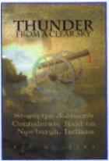
Thunder from a Clear Sky
This book tells the story of the first Confederate raid to cross the Mason-Dixon line, the capture of Newburgh, Indiana in July 1862. In twenty minutes, Stovepipe Johnson and his men captured 85 Union soldiers in two army hospitals and the commander of the Indiana Legion. They also gained enough muskets and pistols to outfit three Kentucky Rebel companies. In less than one hour, Evansville mobilized 1,000 men, but they arrived too late. Boatloads of guns and goods had already crossed into Kentucky. Within 72 hours of receiving the news, Indiana Governor Oliver Morton unleashed an overwhelming counter-offensive of 1500 soldiers and sailors in response to this raid.

Our Guest Speaker
Ray Mulesky

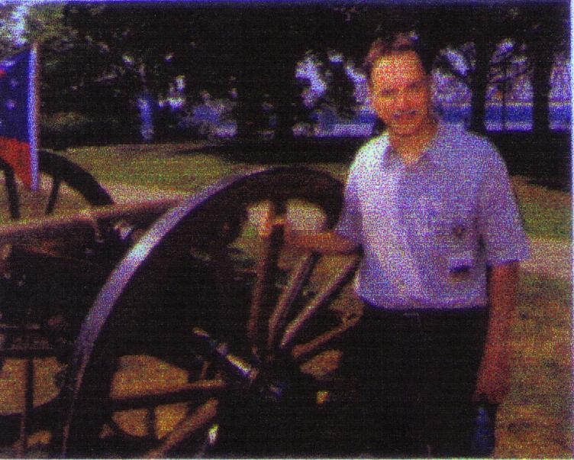
Ray Mulesky is an ardent student of Indiana history. He lives in Evansville, Indiana. His book was written to support a number of charities: James Larmouth Family Resource Center – Madisonville, KY (November 2005 Tornado Relief Fund); Tri-State Genealogical Society; Warrick County Museum, Boonville, IN; Historic Newburgh, Inc. Scholarship Fund, Newburgh, IN; Mollie Morehead Chapter of the United Daughters of the Confederacy, Calhoun, KY; and the Vincennes Civil War Monument Restoration Fund. Information about these charities and the Newburgh Home Guard can be found on his website at www.thunderfromaclearsky.com.

Roster of Officers and Committees for the 2006-2007 Campaign
Officers:
President: Dave Klinestiver Secretary: Robert Vane
Vice President: Dave Sutherland Treasurer: Peg Bertelli
Librarian: Marilyn Hoffman
Committee Chairs:
Programs: Dave Sutherland Preservation: Andy O’Donnell
Membership: Nikki Schofield Publicity: Dave Buchanan & Tony Roscetti
Quiz Master: Summer Campaign:
Tony Trimble Nikki Schofield
HARDTACK Newsletter:
Editor: Jenny Thompson
Distribution: Jenny Thompson (email) & Tony Roscetti (U.S. mail)

2006-2007 Campaign Plans

Unless otherwise noted, we meet at the Indiana History Center, 450 West Ohio Street.
April 9, 2007 The USS Monitor Center Craig Symonds
May 14, 2007 A New Look at Civil War Photography Dave Klinestiver
June 11, 2007 Vicksburg Terry Winschel

JOIN US BEFORE THE MEETING AT SHAPIRO’S DELI!
All ICWRT members and guests are invited to join us at 5:30 P.M. at Shapiro’s Delicatessen, 808 S. Meridian St. (just south of McCarty Street) before the meeting to enjoy dinner and fellowship.

Other Camp Activities

The Monitor’s new home: In Newport News, Virginia, on the weekend of March 9, 2007, The Mariner’s Museum will become the Monitor’s new home. For more information or to request a brochure, please call toll free at 888-493-7386 and speak with the experienced Travel Counselors or visit www.newport_news.org. [More information about this historic event and the USS Monitor Center will be in the April Hardtack.]

Civil War Talk Radio: The webmaster for the Louisville CWRT informs us that Civil War Talk Radio is available on the internet. Gerald Prokopowicz of East Carolina University interviews Civil War historians and authors for one hour on this program. A listing of past programs can be found on: www.worldtalkradio.com/show.asp?sid=150

Annual Nashville Area Civil War Conference: The Third Annual Nashville Civil War Conference will be held at Travellers Rest Plantation and Museum on Saturday, March 10, 2007. The all day affair begins at 9 AM and will end at 4 PM. A lunch and tour of the ante-bellum home is included in the $38 conference fee. The theme is Cavalry Operations of the Western Theater. Speakers and subjects include: Eric Wittenberg – “Union Cavalry in the West;” Myers Brown – “Joe Wheeler and Confederate Cavalry in the West;” Brian Wills – “Nathan Bedford Forrest;” and Greg Biggs – “Turning the Tide: The Union Cavalry At the Battle of Shelbyville.” For more information and an online registration form, please visit www.travellersrestplantation.org. Other programs of interest at this location include Hidden Histories: The Lives of Women in Nineteenth Century Nashville (March 30 – June 15, 2007) and Civil War Refugee: Historic Role-Playing Activities for the Family (April 21, 2007).

Special Orders

Civil War battle flag returned to Indiana War Memorial: A flag carried by the 25th Indiana Volunteer Regiment that went missing from the Indiana War Memorial a decade ago and was illegally sold to a collector in 2000 was returned on January 29, 2007. The flag was found hung on a ceiling in the Waterloo branch of the First National Bank of Fremont.

Another letter home from South Carolina: Elbert Watson, who patrols our Southern front in South Carolina, recently had two full-page articles about General Robert E. Lee’s 200th Birthday Anniversary published in two of the area’s local newspapers. One paper [The Pickens Sentinel] carried an impressive picture of Lee in full military uniform. [Editor’s Note: The article “General Robert E. Lee’s Noble Character Shown Brightly in War and Peace,” which was published January 24, 2007, can be viewed by searching on www.timesexaminer.com.]

Camp Morton Medals: On October 25, 2003, Sons of Confederate Veterans and the Ben Harrison Camp of the Sons of the Union Veterans dedicated four markers to designate the boundaries of Camp Morton. These markers are located at the corners of 19th and Central; 21st and Central; 21st and Talbott; and 19th and Talbott. The Ben Harrison Camp made Camp Morton Medals using the design found on the markers. The camp still has medals available for sale, at the cost of $10. For those who have expressed an interest in purchasing one of these medals, Jerry or Jenny Thompson will be down at the front with your medals.

Official Records

Upcoming Summer Campaign: Reserve the dates of June 16-23, 2007 for the annual trip to Vicksburg. We will be staying for three nights at the brand new Hampton Inn in Vicksburg. It is located across from the entrance to the National Military Park. You can take a tour of our hotel by going to: www.vicksburghamptoninn.com. Some of the other stops will be the Old Courthouse in St. Louis, where the first Dred Scott decision was rendered; Mud Island in Memphis, which has five galleries about war on the river; and the Natchez Trace. If you have not been on one of our trips, please contact tour director, Nikki Schofield, so she can send you information. Her telephone is: 328-8782 and her email is Nikki1942@sbcglobal.net. If you have been on a trip, she will mail you the schedule and cost as soon as it is finalized.

Re-enlist this Month and Beat the Dues Increase: In view of rising operational expenses, including the rental fees we pay for our meeting space and transportation costs for outside speakers, the ICWRT Executive Board has deemed it prudent to increase our standard dues rates by $5.00 for each membership level. Accordingly, annual membership dues for the 2007-2008 campaign will be $30 per individual, $35 per family and $15 for students. The good news, however, is that you don't have to pay the increase! By re-enlisting for next year now-- or anytime prior to July 1, 2007-- you will receive a $5.00 discount that effectively offsets the dues increase entirely. We are offering this "early bird" discount to encourage more members to re-enlist before the end of this campaign. This will allow us to better plan and budget for the coming year. A re-enlistment form is included at the end of this newsletter. Please deliver or mail your completed form and dues payment to Treasurer Peg Bertelli.

Dr. Peter Carmichael: Due to the Winter storm, we unfortunately had to cancel our February 12 meeting on very short notice. We regret any inconvenience this may have caused any of our members. We hope to reschedule our February speaker, Dr. Peter Carmichael, for another meeting sometime next year.

Officer election: Since the weather cancelled our February meeting, we will be electing officers for the 2007-2008 campaign at the March meeting. Please plan to attend to cast your vote.

Test Your Civil War Knowledge (with Trimble’s Trivia)

Due to the cancellation of the February meeting, we are using the same trivia questions again this month.

- Name the Texas general killed at Pea Ridge.

- What general nickname was given to southern soldiers from Georgia?

- Who or what was “Don MacGregor?

- On what battlefield would you find the “Devil’s Pulpit”?

- “______________________ supplemented each other, and together, with any fair opportunity, they were absolutely invincible.” Who are they?

Answers to the January Quiz:
1. What distinction is held by Confederate General Joseph Shelby?
He never surrendered after the war ended.
2. Name the Federal cavalry unit that is reputed to have suffered more men killed than any other according to its commander. Who was the commander?
Michigan Cavalry Brigade; George Armstrong Custer
3. Name the Federal cavalry unit that actually lost more men killed than any other. What was the unit’s nickname?
1st Maine Cavalry; Puritans
4. Maj. James A. Connolly, U.S.A. wrote to his wife, “I have seen the promised land. The domes and minarets and spires of ___________ are glittering in the sunlight before us and only 8 miles distant.” What southern city was he describing?
Atlanta
5. Name the Union commander who once rode a horse named “Fox”.
U.S. Grant

The Soldiers Speak

(Quoted from Indiana in the War of the Rebellion: Report of the Adjutant General, prepared by W.H.H. Terrell)
The reason for choosing Newburgh:
“Although Newburgh was not a military post, a hospital had been established there which contained eighty or ninety sick and wounded Union soldiers, with a considerable amount of commissary and hospital stores. The muskets, accoutrements and ammunition of the two Newburgh companies of the Legion, which had been collected in some months previously, were also deposited in the hospital building; while in a warehouse, not far distant, seventy-five sabers and one hundred and thirty holsters and pistols were stored in the boxes in which they had been shipped. There being no indications of danger, no guard was stationed for the protection of the patients in the hospital or the public property.”

The raid on Newburgh:
“Accordingly, at noon, when most of the citizens were at dinner, JOHNSON appeared on the bank of the river opposite Newburgh, placed his men on a large ferry boat, concealed them as well as possible, and rowed rapidly to the Indiana shore. As soon as the boat touched the landing a dash was made for the hospital, and the warehouse and the arms stored therein were at once secured…. The soldiers in the hospital, to the number of eighty-five, were required to sign paroles of honor, in which the leader of the marauders was styled “A.R. JOHNSON, C.S.A.” These paroles were never claimed as valid by the Confederate authorities and were held as null and void by those who signed them. While JOHNSON was personally engaged in paroling the sick and wounded soldiers, his men, guided by some of the citizens, commenced the genial business of pillage. Houses were broken open and ransacked; horses were taken from the stables, and coffee, sugar and other articles, that could readily be transported, were stolen in large quantities…. After remaining four or five hours, during which time the boat was kept busy in transporting their plunder, the commander ordered his men to embark and they were speedily transferred to the other shore.”

The reactions of Indiana and her governor:
“A courier arrived in Evansville early in the afternoon with intelligence that the Newburgh hospital was being sacked by a large band of Kentucky guerrillas. The signal of danger was given and in less than an hour one thousand men were under arms.”

“The Governor, therefore, immediately, in receipt of news of the Newburgh outrage, determined to assume the offensive, organize an expedition sufficiently strong to penetrate the heart of the infected territory, and drive the rebels out, whereby he hoped to break up their recruiting stations, restore order in Kentucky, and secure our own border from the dangers that threatened and alarmed it…. on the morning of the 19th, a call was made by the Governor for volunteers, and the Legion on the border was ordered on duty.”

“The Newburgh raid had aroused the indignation of the people of the whole State, and disposition to inflict immediate punishment upon the rebels was manifest in every locality…”

The reactions of Kentucky:
“…Governor MORTON was, more directly than any other man, the Guardian of Kentucky. Through him she received, for a time, most of the arms that enabled her loyal men to protect themselves…. He was informed of every movement as promptly, and his assistance requested as confidently as if he had been their own Governor. If dangerous points needed to be guarded, they were pointed out to him. If invasions were to be met, he was appealed to.”

(Governor Morton proclamation, quoted in Indiana in the Civil War, researched by Melissa Rose)
The reason behind Governor Morton’s response:
“There is no curse like that of a lingering war. If, with the immense superiority in wealth, population and resources of the loyal States, their power was promptly exerted in anything like an equal ratio with the efforts made in the seceding States, this rebellion would be speedily extinguished. Let Indiana set the glorious example of doing her whole duty, and show to the world how much can be accomplished by the brave and loyal people of a single State.
To this we are prompted by every consideration of hope, interest, and affection. All that we are, all that we hope to be, is in issue. Our cause is the holiest for which arms were ever taken, involving, as it does, the existence of our government, and all that is valuable and dear to a free people.”

(Governor Oliver P. Morton quoted in Theodore Stempfel’s Artist Life – Rudolf Schwarz and Karl Bitter)
“Let us honor the dead, cherish the living, and preserve in immortal memory the deeds and virtues of all, as an inspiration for countless generations to come.”

Governor of the Month

Oliver P. Morton
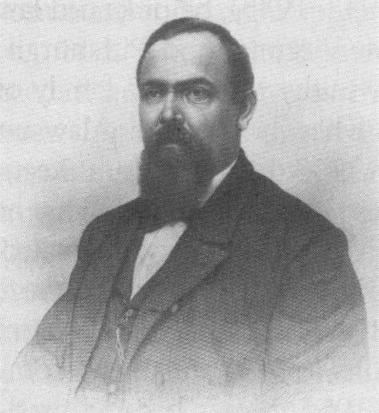
Oliver P. Morton helped launch the Indiana Republican party. He won election as lieutenant governor in 1860 and soon became governor in early 1861 when Governor Henry Lane resigned to enter the U.S. Senate. After the fall of Fort Sumter, he quickly offered 10,000 troops to serve in the Union. He worked tirelessly to fill Indiana’s quotas and took a deep interest in the welfare of Hoosier troops. He devised ingenious ways to supply their needs, including establishing an arsenal at Indianapolis to supply Hoosier troops and to sell to the federal government. He approved of the suppression of opposition newspapers and the arrest and trial of those who criticized the government. Some of Governor Morton’s telegraph books have been scanned and are available at http://indiamond6.ulib.iupui.edu/Telegraph/. He was re-elected as governor in 1864 and three years later was elected U.S. senator. He sought and lost the 1876 presidential nomination in the convention to Rutherford B. Hayes.

Historic Sites of the Month
Soldiers and Sailors Monument

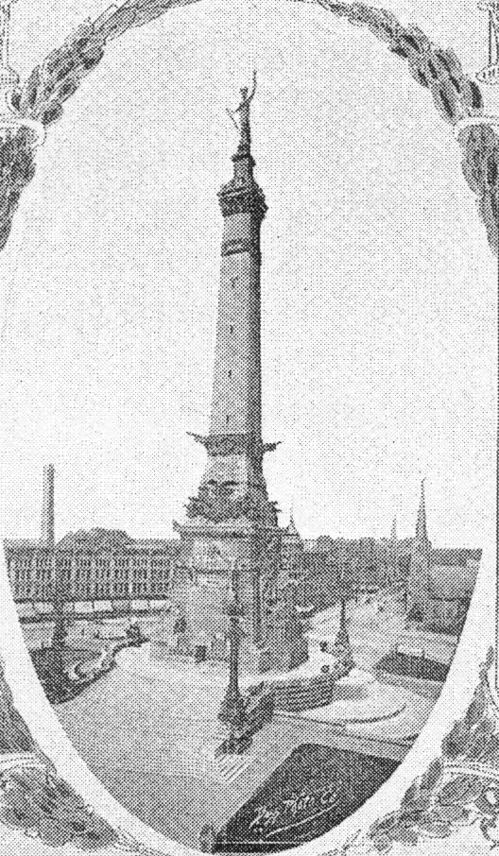
Within a week of the firing at Fort Sumter, thousands of Hoosier volunteers answered the call to enlist. Nearly 75 percent of eligible Hoosier men served during the war. Nearly 200,000 Hoosier Union veterans returned from the Civil War in 1865; more than 24,000 Hoosiers died in the war. Hoosiers hold the distinction of firing the first and last infantry volleys, making the first and last charges and losing the first and last soldier in the Civil War. The Soldiers and Sailors Monument, located on Monument Circle in downtown Indianapolis, is the only Civil War Monument in America dedicated to ordinary soldiers and sailors.
The Grand Army of the Republic (GAR), the Union Civil War group, was founded in 1866. Indianapolis was the site of their first and last encampments. GAR members were devoted to protecting survivors, making sure pensions and other benefits were distributed, and remembering their fallen comrades. Hoosier GAR veterans raised money to build a number of monuments to honor their fallen Hoosier comrades. “In 1862, a letter to the editor in the Indianapolis Daily Journal suggested that the state ‘erect a monument…to the memory of all the dead of Indiana who have fallen in defense of the Union.’” (Quoted from Theodore Stempfel’s Artist Life – Rudolf Schwarz and Karl Bitter) Governor Oliver P. Morton supported the building of this Monument. Construction began in 1888, and the Monument was dedicated May 15, 1902. Lew Wallace was master of ceremonies. James Whitcomb Riley composed a poem and John Philip Sousa composed a march for this event. John W. Foster, Benjamin Harrison’s secretary of state, delivered the address.
Today, visitors to the Monument can also visit the Colonel Eli Lilly Civil War Museum, located in the monument’s lower level. Exhibits display Hoosier life during the Civil War: recruitment, camp life, drills, battles, medical treatment and life back at home. The Museum is open Wednesday – Sunday, 9 a.m. – 6 p.m. Admission to the Museum is free. For more information about the Museum, please visit www.indianacivilwar.org or call (317) 232-7615.

(Quoted from The Complete Poetical Works of James Whitcomb Riley)
The Soldier
[The Dedication of the Soldiers’ and Sailors’ Monument, Indianapolis, May 15, 1902]

The Soldier! – meek the title, yet divine:
Therefore, with reverence, as with wild acclaim,
We fain would honor in exalted line
The glorious lineage of the glorious name:
The Soldier. – Lo, he ever was and is,
Our Country’s high custodian, by right
Of patriot blood that brims that heart of his
With fiercest love, yet honor infinite.

The Soldier – within whose inviolate care
The Nation takes repose, – her inmost fane
Of Freedom ever has its guardian there,
As have her forts and fleets on land and main:
The Heavenward Banner, as its ripples stream
In happy winds, or float in languid flow,
Through silken meshes ever sifts the gleam
Of sunshine on its Sentinel below.

The Soldier! – Why, the very utterance
Is music – as of rallying bugles, blent
With blur of drums and cymbals and the chants
Of battle-hymns that shake the continent! –
The thunder-chorus of a world is stirred
To awful, universal jubilee, –
Yet ever through it, pure and sweet, are heard
The prayers of Womanhood, and Infancy.

Even as a fateful tempest sudden loosed
Upon our senses, so our thoughts are blown
Back where The Soldier battled, nor refused
A grave all nameless in a clime unknown. –
The Soldier – though, perchance, worn, old and gray;
The Soldier – though, perchance, the merest lad, –
The Soldier – though he gave his life away,
Hearing the shout of “Victory,” was glad;

Ay, glad and grateful, that in such a cause
His veins were drained at Freedom’s holy shrine –
Rechristening the land – as first it was, –
His blood poured thus in sacramental sign
Of new baptism of the hallowed name
“My Country” – now on every lip once more
And blest of God with still enduring fame. –
This thought even though The Soldier gloried o’er.

The dying eyes upraised in rapture there, –
As, haply, he remembered how a breeze
Once swept his boyish brow and tossed his hair,
Under the fresh bloom of the orchard-trees –
When his heart hurried, in some wistful haste
Of ecstasy, and his quick breath was wild
And balmy-sharp and chilly-sweet to taste, –
And he towered godlike, though a trembling child!

Again, through luminous mists, he saw the skies’
Far fields white-tented; and in gray and blue
And dazzling gold, he saw vast armies rise
And fuse in fire – from which, in swiftest view,
The Old Flag soared, and friend and foe as one
Blent in an instant’s vivid mirage. …Then
The eyes closed smiling on the smiling sun
That changed the seer to a child again. –

And, even so, The Soldier slept. – Our own! –
The Soldier of our plaudits, flowers and tears, –
O this memorial of bronze and stone –
His love shall outlast this a thousand years!
Yet, as the towering symbol bids us do, –
With soul saluting, as salutes the hand,
We answer as The Soldier answered to
The Captain’s high command.
If you have a short article, book review, or some other item that may be of interest to our members, please submit it via email to the editor at jkt60@earthlink.net by the tenth day following the preceding month’s meeting. Please list HARDTACK in the subject line and include your email address in case I need to contact you.

Re-enlist NOW for the 2007-2008 Campaign and save 5.00!!

Membership dues for the 2007-2008 campaign of The Indianapolis Civil War Round Table
will increase by $5.00 effective July 1, 2007
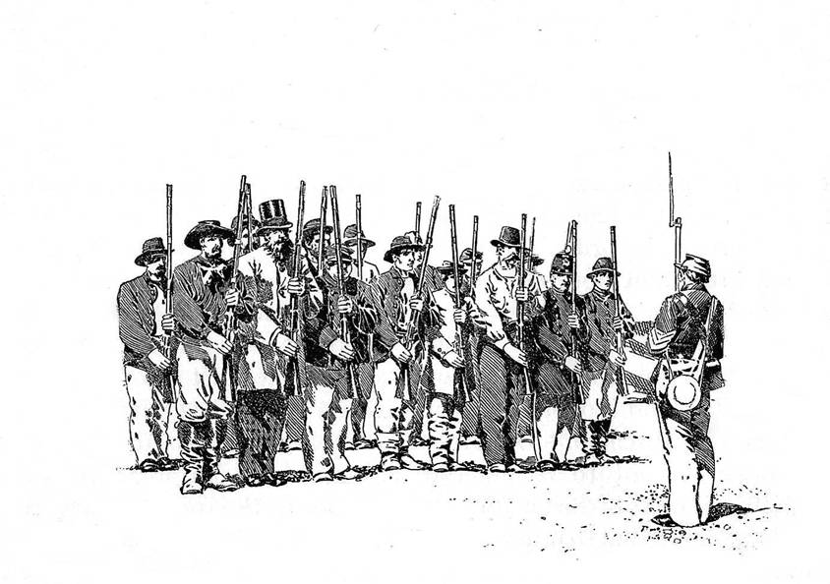
Beat the dues increase by re-enlisting NOW at current rates!

To encourage early re-enlistments, the ICWRT is extending a $5.00 discount on all new or renewal memberships for next year that are received by the end of June. This discount will effectively offset a $5.00 dues increase applicable to all membership levels for next season.

All ICWRT members may continue to receive the monthly newsletter, HARDTACK, via email at no additional charge. Members who prefer to receive the HARDTACK by U.S. Mail are asked to pay an additional $12.00 to help cover printing and mailing costs.

Please bring your completed re-enlistment form (below) together with your payment to Peg Bertelli, ICWRT Treasurer, at the next Round Table meeting, or mail your re-enlistment form and payment to:

Peg Bertelli
11827 Corbin Drive Phone: (317) 596-9193
Fishers, Indiana 46038 Email: pbbertelli@insightbb.com

Please complete and detach the form below and include with your check:
-------------------------------------------------------------------------------------------------------

ICWRT Membership Enlistment for July 2007 thru June 2008
Please print legibly!

Name…………………………………………………….…. Date ………………..

Address……………………………………………………………………….

……………………………………………………………………….

Phone: (………) …………………… Email Address: ……………………..………..

We must have a valid email address if you wish to receive the HARDTACK newsletter free of charge!

Discounted Dues for the 2007-2008 must be paid by June 30, 2007* (please specify Membership Level):

_____ $25 Individual (reg. $30) _____$30 Family (reg. $35) _____ $10 Student (reg. $15)

* If paying after June 30, 2007, please pay the regular dues amount as shown above

______ I wish to receive the newsletter via U.S. Mail for an additional $12

In addition to my membership dues, please accept my generous gift of $ _________
to the ICWRT general operating account (This donation is not tax deductible)

