HARDTACK
Indianapolis Civil War Round Table Newsletter
http://indianapoliscwrt.org/

January 8, 2007 at 7:30 p.m.
Meeting at Indiana History Center

The Plan of the Day

Cross Keys and Port Republic
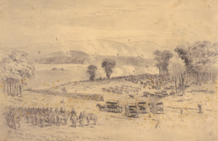
The battle of Cross Keys
Forbes, Edwin, artist, June 7, 1862.
Image from wickipedia.org

By early June, a weary Stonewall Jackson and his army were at the lower end of the Shenandoah Valley in and about Cross Keys and Port Republic. For a month he had fought one engagement after another – Winchester, Kernstown, McDowell and Front Royal. Now Jackson again faced a potentially strong Federal army and a loss would be disastrous. The valley was an important source of food and supplies for the Confederacy.
Fremont’s army encountered Ewell’s division near Cross Keys Tavern on June 8, 1862. A surprise volley from Trimble’s command drove back Stahel’s brigade, who was attacking the Union left. The next day, Trimble and Patton’s brigades held Fremont at bay, while the rest of Ewell’s division crossed the river to assist Jackson at Port Republic. The Union army repulsed Confederate assaults until a flanking column turned the Union left flank. Union counterattacks failed, and Tyler was forced to retreat. When Ewell’s division crossed the river, they burned the North River Bridge behind them. Arriving too late to help Tyler and Carroll, Fremont’s army watched helplessly from across the rain-swollen river. Our speaker will tell the story of the battles of Cross Keys and Port Republic – how the Federals had a chance to win but failed to take advantage of Jackson’s uncharacteristic mistakes, and how Jackson ultimately won the day. These two battles were the decisive victories in Jackson’s Valley Campaign. They forced the Union armies to retreat and enabled Jackson to reinforce Lee for the Seven Days Battles.

Our Guest Speaker
Tony Trimble

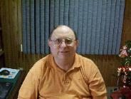
Dr. Tony Trimble is a resident of Plainfield, Indiana. He earned his B.S. and M.S. degrees in history and political science from Indiana State University and an Ed.S. in school psychology from Butler University. He is employed as a psychologist, supervising the Federal Drug Aftercare Program. He also supervises interns for the Psychology Department at the University of Indianapolis.
Dr. Trimble is a member of the Indiana Historical Society, currently serving as a member of the Honors Committee, Indiana Association of Historians and Organization of American Historians. He has served as Vice President and President of the ICWRT and is a winner of its Harmon Award for Civil War Scholarship and the Bates Award for contributions to the administration of the affairs of the roundtable. Dr. Trimble is a member of the Phi Alpha Theta – National Honorary Fraternity for Historians. He is also an active member of the Civil War Roundtable of West Central Indiana, The National Congress of Civil War Roundtables and Society of Civil War Historians. Dr. Trimble is listed in the 1990-1991 edition of Who’s Who in the Midwest and the 1992-1993 edition of Who’s Who in American Education. He has published articles in Civil War Times Illustrated, Indiana Military Historical Journal, Civil War, Gettysburg-Historical Articles of Lasting Interest, Governors of Indiana, Michigan History, The Encyclopedia of Indianapolis, and was seen on the DVD Well Done Indiana: Tales of the Triumphs and Tragedies of Indiana in the Civil War.

Roster of Officers and Committees for the 2006-2007 Campaign
Officers:
President: Dave Klinestiver Secretary: Robert Vane
Vice President: Dave Sutherland Treasurer: Peg Bertelli
Librarian: Marilyn Hoffman
Committee Chairs:
Programs: Dave Sutherland Preservation: Andy O’Donnell
Membership: Nikki Schofield Publicity: Dave Buchanan & Tony Roscetti
Quiz Master: Summer Campaign:
Tony Trimble Nikki Schofield
HARDTACK Newsletter:
Editor: Jenny Thompson
Distribution: Jenny Thompson (email) & Tony Roscetti (U.S. mail)

2006-2007 Campaign Plans

Unless otherwise noted, we meet at the Indiana History Center, 450 West Ohio Street.
February 12, 2007 Hoosier Soldiers at Fredericksburg Peter Carmichael
March 12, 2007 “Stovepipe” Johnson’s Raid on Newburgh Ray Mulesky
April 9, 2007 The USS Monitor Center Craig Symonds
May 14, 2007 A New Look at Civil War Photography Dave Klinestiver
June 11, 2007 Vicksburg Terry Winschel

JOIN US BEFORE THE MEETING AT SHAPIRO’S DELI!
All ICWRT members and guests are invited to join us at 5:30 P.M. at Shapiro’s Delicatessen, 808 S. Meridian St. (just south of McCarty Street) before the meeting to enjoy dinner and fellowship.

Other Camp Activities

Master of Arts in Military History – Civil War: As we begin 2007, many people will make resolutions of things they hope to do in the coming year. For those of you who are interested in a deeper pursuit of Civil War History, I invite you to investigate pursuing a Master’s Degree in Military History – Civil War at American Military University, an online university. AMU is a member institution of the American Public University System (APUS), which is regionally accredited by the Higher Learning Commission of the North Central Association and nationally accredited by the Accrediting Commission, Distance Education Training Council. Visit their website at http://www.amu.apus.edu for more information on this degree. [Note from the editor: I graduated with my Master’s in Military Studies – Civil War from AMU in May of 2006. I highly recommend this school and their outstanding professors.]

Special Orders
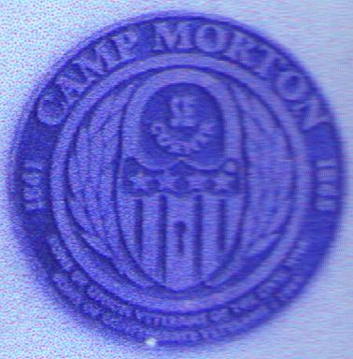
Camp Morton Medals: On October 25, 2003, Sons of Confederate Veterans and the Ben Harrison Camp of the Sons of the Union Veterans dedicated four markers to designate the boundaries of Camp Morton. These markers are located at the corners of 19th and Central; 21st and Central; 21st and Talbott; and 19th and Talbott. The Ben Harrison Camp made Camp Morton Medals using the design found on the markers. The camp still has medals available for sale, at the cost of $10. If you are interested in purchasing one, please see Jerry or Jenny Thompson during our next meeting. Jerry is an officer in the Ben Harrison Camp and Jenny is the ICWRT Hardtack editor.

Medal of Honor Gravesites: The editor recently found the following website, which provides the location of Medal of Honor gravesites with photos of the gravestones. Please visit www.homeofheroes.com/gravesites to learn more about these heroes.

Final Roll Call: A member of the ICWRT has answered the final roll call. The post office recently informed us that Betty Brown, a member since 2003, has passed away. We will miss her.

Test Your Civil War Knowledge (with Trimble’s Trivia)

- What distinction is held by Confederate General Joseph Shelby?

- Name the Federal cavalry unit that is reputed to have suffered more men killed than any other according to its commander. Who was the commander?

- Name the Federal cavalry unit that actually lost more men killed than any other. What was the unit’s nickname?

- Maj. James A. Connolly, U.S.A. wrote to his wife, “I have seen the promised land. The domes and minarets and spires of ___________ are glittering in the sunlight before us and only 8 miles distant.” What southern city was he describing?

- Name the Union commander who once rode a horse named “Fox”.

Answers to the December Quiz:
Identify the Civil War figure associated with each of these nicknames.
1. “Bull” (1 USA; 1 CSA)
Maj. Gen. William Nelson, USA; Brig. Gen. Elisha Paxton, CSA
2. “Old Lop Ear”
Gen. Jubal Early, CSA
3. “Porte Crayon”
David Hunter Strother, Illustrator for Harper’s
4. “Spoons” or “Beast”
Maj. Gen. Benjamin Butler, USA
5. “Polecat”
Prince Camille Armand Jules Marie de Polignac, Maj. Gen. CSA

The Soldiers Speak

ABOUT CROSS KEYS AND PORT REPUBLIC:
(Quoted from Henry Kyd Douglas’ I Rode With Stonewall)
“Ewell’s position was a good one, and he did not hesitate because of Fremont’s superior force. He fought his battle well and with his small division defeated Fremont with heavy loss to him. General Fremont did not fight his battle so well, or his troops were not equal to it….It was another Sunday fight, which ended with the day, and the moon that shone over the Valley that night threw her rays upon the wounded soldiers and not far off upon their mothers and sisters going to church to pray for them. The result of the battle confirmed the wholesome belief of the old soldiers that the side that inaugurated a battle on Sunday, lost it…. [next day] The result was a hot fight continued for several hours with great vigor and varying success, as was announced by alternate “Rebel yells” and “Yankee cheers….” The fight was a very different one from that of the day before, and Jackson found that he had met men of like mettle to his own….The fact is, Jackson went into the fight impetuously and was disappointed. Had he waited to get his troops up and into formation, his victory would have been easier and his loss less….The campaign just ended was Jackson’s masterpiece. The more it is studied and its difficulties comprehended, the greater will be its rank among military successes. The battle of McDowell was fought on the 8th of May, the battle of Port Republic on the 9th of June. In this one month Jackson and his little army became immortal in military history….In thirty days his army had marched nearly four hundred miles, skirmishing almost daily, fought five battles, defeated four armies, two of which were completely routed, captured about twenty pieces of artillery, some four thousand prisoners, and immense quantity of stores of all kinds, and had done all this with a loss of less than one thousand killed, wounded, and missing. Such a more brilliant record cannot be found in the history of the world, and General Jackson might well say this was accomplished ‘through God’s blessing.’”

(Quoted from Gerald F. Linderman’s Embattled Courage: The Experience of Combat in the American Civil War)
“At the battle of Port Republic [June 9, 1862] an officer commanding a regiment of Federal soldiers and riding a snowwhite horse was very conspicuous for his gallantry. He frequently exposed himself to the fire of our men in the most reckless way. So splendid was this man’s courage that General Ewell, one of the most chivalrous gentlemen…at some risk to his own life, rode down the line and called to his men not to shoot the man on the white horse. After a while, however, the officer and the white horse went down. A day or two after, when General Jackson learned of the incident, he sent for General Ewell and told him not to do such a thing again; that this was no ordinary war, and the brave and gallant Federal officers were the very kind that must be killed. ‘Shoot the brave officers and the cowards will run away and take the men with them.’”

ABOUT JACKSON:
(Quoted from Henry Kyd Douglas’ I Rode With Stonewall)
“He regulated his conduct, personal and military, in accordance with his own ideas of right and wrong; he acknowledged accountability to no one but God and his superior officers.”
“In face and figure Jackson was not striking. Above the average height, with a frame angular, muscular, and fleshless, he was, in all his movements from riding a horse to handling a pen, the most awkward man in the army. His expression was thoughtful, and, as a result I fancy of his long ill health, was generally clouded with an air of fatigue. His eye was small, blue, and in repose as gentle as a young girl’s. With high, broad, forehead, small sharp nose, thin, pallid lips generally tightly shut, deep-set eyes, dark, rusty beard, he was certainly not a handsome man….The enemy believed he never slept. In fact he slept a great deal. Give him five minutes to rest, he could sleep three of them. Whenever he had nothing else to do he went to sleep, especially in church. He could sleep in any position, in a chair, under fire, or on horseback….He was quiet…Swiftness of execution was his most popular virtue…Jackson was a man of strategy…”

(Quoted from Faith in God and Generals, edited by Ted Baehr and Susan Wales) Jackson told another officer how he could remain calm under fire:
“Captain, my religious belief teaches me to feel as safe in battle as in bed. God has fixed the time for my death. I do not concern myself about that, but to always be ready, no matter when it may overtake me….Captain, that is the way all men should live, and then all would be equally brave.”

(Quoted from John D. Imboden’s “Stonewall Jackson in the Shenandoah,” found in Battles and Leaders of the Civil War: Grant-Lee Edition, Volume II, Part 1)
The winter of 1861-1862:
“In that terrible winter’s march and exposure, Jackson endured all that any private was exposed to. One morning, near Bath, some of his men, having crawled out from their snow-laden blankets, half-frozen, were cursing him as the cause of their sufferings. He lay close by under a tree, also snowed under, and heard all this; and, without noticing it, presently crawled out, too, and, shaking the snow off, made some jocular remark to the nearest men, who had no idea he had ridden up in the night and lain down amongst them. The incident ran through the little army in a few hours, and reconciled his followers to all the hardships of the expedition, and fully reestablished his popularity.”

(Quoted from Roy Bird Cook’s Thomas J. Jackson: A God-Fearing Soldier of the CSA)
Some of Jackson’s mottos:
“Sacrifice your life rather than your word.”
“Resolve to perform what you ought.”
“You may be what you resolve to be.”
“Do your duty and leave the rest to God.”

Officer of the Month

Stonewall Jackson
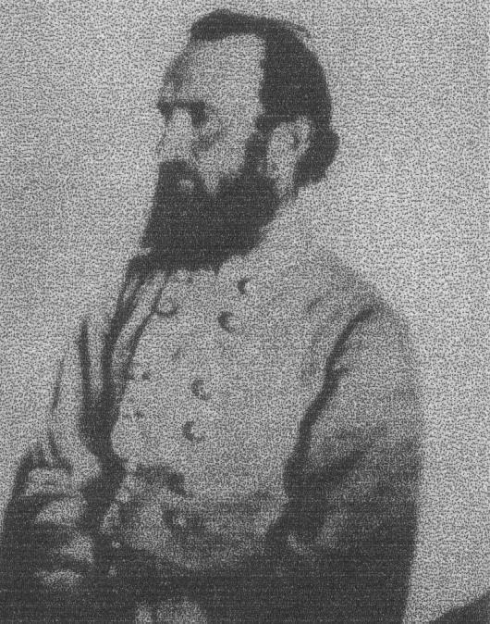
Thomas Jonathan Jackson was born January 21, 1824 at Clarksburg, [West] Virginia. Two years later, his father and six-year-old sister, Elizabeth, died of typhoid fever and his mother gave birth to another sister. Shortly after his mother remarried, Thomas and his younger sister, Laura, were sent to live with relatives. His younger brother, Warren, was sent to live with another relative. His mother died in 1831 from childbirth complications. Warren died of tuberculosis in 1841.
Jackson attended the US Military Academy at West Point and graduated 17th in his class of 59 graduates in 1846. He served during the Mexican War and in the military until 1851, when he resigned to take a teaching position at the Virginia Military Institute in Lexington, Virginia. In 1853, he married Elinor Junkin, daughter of the president of Washington College. In 1854, Elinor and her stillborn son died in childbirth. In 1857, Jackson married Mary Anna Morrison, the daughter of the retired president of Davidson College. Their first daughter, Mary, died less than a month after her birth. Their second daughter, Julia, was born in 1862.
Thomas Jonathan Jackson was an unknown major in the Virginia Militia when he sent to Richmond to become a colonel in the Confederate Infantry in 1861. In June, he became Brigadier General. In July, he became Major General and had gained the nickname of “Stonewall” from the Battle of Bull Run. He was a model Christian gentleman and soon became a hero, respected by the Confederates and feared by the Federals.
Jackson was a master of tactics and strategy, and his ideas, especially during the Shenandoah Valley Campaign, dramatically altered the methods of warfare for the remainder of the Civil War. His attack at Chancellorsville was one of the most striking victories of the war. Unfortunately, that night he was also accidentally wounded by his own troops in the dim light of sunset. His left arm was amputated, but he died of pneumonia May 10, 1863. Lee had lost his “right hand man.” He was buried in Lexington, Virginia. His wife never remarried and was known as the “Widow of the Confederacy”, devoting much of her time to the United Daughters of the Confederacy. She died in 1915 in Charlotte, North Carolina and was buried beside Jackson in Lexington, Virginia.

Historic Sites of the Month

Stonewall Jackson Headquarters Museum

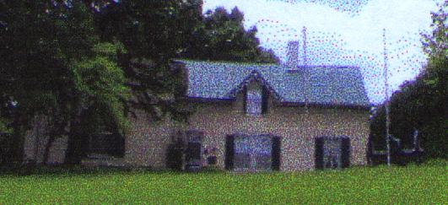

Mary Tyler Moore’s great grandfather, Lt. Col. Lewis T. Moore, provided this home to Jackson and his wife during their stay in Winchester. This Hudson River Gothic Revival-style house was built in 1854. The home briefly served as Stonewall Jackson’s headquarters during the Valley Campaign from 1861 to 1862. Jackson, Turner Ashby, and cartographer, Jed Hotchkiss organized their battle plans in these rooms.
The home is located at 415 Braddock Street in Winchester, Virginia. It has been restored and furnished much like it was when Jackson was there. It is open Monday – Saturday 10 a.m. to 4 p.m. and Sunday 12 to 4 p.m. from April 1 – October 31. Admission is charged. Parking is available on the street. For more information, please call the museum at (540) 667-3242 or contact the Winchester – Frederick County Historical Society at www.winchesterhistory.org or by phone at (540) 662-6550.
[Editor’s note: When we visited here in May 2006, we were told that school groups no longer visit the museum. It is not considered politically correct to visit this historical site. How sad it is that these students are restricted in what they can now learn about Civil War history.]

(Quoted from The Columbia Book of Civil War Poetry, edited by Richard Marius)
Stonewall Jackson’s Way
By John Williamson Palmer
[Note: this poem was also set to music]

Come, stack arms, men. Pile on the rails,
Stir up the camp-fire bright;
No matter if the canteen fails,
We’ll make a roaring night.
Here Shenandoah brawls along,
There burly Blue Ridge echoes strong
To swell the brigade’s rousing song
Of “Stonewall Jackson’s way.”

We see him now – the old slouched hat
Cocked o’er his eye askew –
The shrewd, dry smile – the speech so pat –
So calm, so blunt, so true.
The “Blue-Light Elder” knowns ‘em well –
Says he, “That’s Banks; he’s fond of shell –
Lord save his soul! we'll give him” well,
That’s “Stonewall Jackson’s way.”

Silence! ground arms! kneel all! caps off!
Old Blue Light’s going to pray;
Strangle the fool that dares to scoff;
Attention; it’s his way!
Appealing from his native sod,
In forma pauperis to God –
“Lay bare thine arm; stretch forth thy rod;
Amen.” That’s “Stonewall’s way.”

He’s in the saddle now! Fall in!
Steady, the whole brigade!
Hill’s at the ford, cut off! He’ll win
His way out, ball and blade.
What matter if our shoes are worn?
What matter if our feet are torn?
“Quick step – we’re with him ere the dawn!”
That’s “Stonewall Jackson’s way.”

The sun’s bright glances rout the mists
Of morning, and, by George!
There’s Longstreet struggling in the lists,
Hemmed in an ugly gorge –
Pope and his Yankees whipped before –
“Bayonet and grape!” hear Stonewall roar,
“Charge, Stuart! Pay off Ashby’s score
In Stonewall Jackson’s way.”

Ah, maiden! wait and watch and yearn
For news of Stonewall’s band!
Ah, widow! read with eyes that burn
That ring upon thy hand!
Ah, wife! sew on, pray on, hope on,
Thy life shall not be all forlorn –
The foe had better ne’er been born,
That gets in Stonewall’s way.
If you have a short article, book review, or some other item that may be of interest to our members, please submit it via email to the editor at jkt60@earthlink.net by the tenth day following the preceding month’s meeting. Please list HARDTACK in the subject line and include your email address in case I need to contact you.

