HARDTACK
Indianapolis Civil War Round Table Newsletter
http://indianapoliscwrt.org/

February 12, 2007 at 7:30 p.m.
Meeting at Indiana History Center

The Plan of the Day

Finding Meaning in Defeat: Hoosier Soldiers at the Battle of Fredericksburg

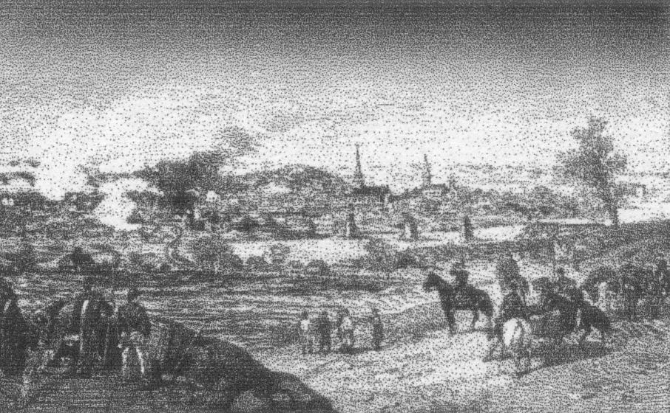

On November 14, 1862, Burnside sent a corps to occupy Falmouth near Fredericksburg. The rest of the Army of the Potomac soon followed. Lee entrenched his army on the heights behind Fredericksburg. While under fire, Union engineers laid five pontoon bridges on December 11, which allowed the army to cross the Rappahannock on December 12. Union soldiers looted and vandalized homes and shops in Fredericksburg. Burnside began a series of futile frontal assaults on December 13, but ultimately called off the offensive and re-crossed the river on December 15. Burnside tried another offensive in January 1863, but troops became bogged down in the winter mud (the “Mud March”). Fredericksburg would be the scene of another battle in May of 1863.

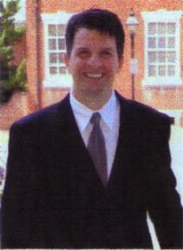
Our Guest Speaker
Dr. Peter S. Carmichael
Dr. Carmichael is from Indiana and earned his Bachelor’s Degree from Indiana University at Indianapolis. He earned his Master’s and Doctorate Degrees from Pennsylvania State University. He is currently an Associate Professor of History at the University of North Carolina at Greensboro. He is the author of Lee’s Young Artillerist: William R.J. Pegram and The Last Generation: Young Virginians in Peace, War, and Reunion and is currently working on his next book about “Black Rebels.” He is also the editor of the Voices of the Civil War series, published by the University of Tennessee Press.

Roster of Officers and Committees for the 2006-2007 Campaign
Officers:
President: Dave Klinestiver Secretary: Robert Vane
Vice President: Dave Sutherland Treasurer: Peg Bertelli
Librarian: Marilyn Hoffman
Committee Chairs:
Programs: Dave Sutherland Preservation: Andy O’Donnell
Membership: Nikki Schofield Publicity: Dave Buchanan & Tony Roscetti
Quiz Master: Summer Campaign:
Tony Trimble Nikki Schofield
HARDTACK Newsletter:
Editor: Jenny Thompson
Distribution: Jenny Thompson (email) & Tony Roscetti (U.S. mail)

2006-2007 Campaign Plans

Unless otherwise noted, we meet at the Indiana History Center, 450 West Ohio Street.
March 12, 2007 “Stovepipe” Johnson’s Raid on Newburgh Ray Mulesky
April 9, 2007 The USS Monitor Center Craig Symonds
May 14, 2007 A New Look at Civil War Photography Dave Klinestiver
June 11, 2007 Vicksburg Terry Winschel

JOIN US BEFORE THE MEETING AT SHAPIRO’S DELI!
All ICWRT members and guests are invited to join us at 5:30 P.M. at Shapiro’s Delicatessen, 808 S. Meridian St. (just south of McCarty Street) before the meeting to enjoy dinner and fellowship.

Other Camp Activities
Civil War Museum: Dan Gibbord, of the Chicago Tribune, in his article dated January 14, 2007, discussed the changes to the city of Kenosha, Wisconsin. When the factories closed, the city of Kenosha turned to developing museums to attract tourists to the area. The Public Museum opened five years ago. The Dinosaur Discovery Museum opened last August. The city now plans a Civil War Museum, which will open in the spring of 2008. Guests will journey into history with the local debate in 1850 over slavery and prepare for the coming war. They will travel with the soldiers to the front lines and into battle. They will also see how the war affected the towns back home in the Midwest.

Margie Bearss Memorial: History America reports that Rebecca Drake will unveil a monument to her friend and co-author, Margie Bearss, who passed away October 5, 2006. Friends and admirers of Margie are invited to attend the unveiling at Champion Hill, Mississippi on May 5, 2007.

Special Orders
Camp Morton Medals: On October 25, 2003, Sons of Confederate Veterans and the Ben Harrison Camp of the Sons of the Union Veterans dedicated four markers to designate the boundaries of Camp Morton. These markers are located at the corners of 19th and Central; 21st and Central; 21st and Talbott; and 19th and Talbott. The Ben Harrison Camp made Camp Morton Medals using the design found on the markers. The camp still has medals available for sale, at the cost of $10. For those who have expressed an interest in purchasing one of these medals, Jerry or Jenny Thompson will be down at the front with your medals.

Official Records

Gettysburg update: Gettysburg has won the battle over the casinos. The Pennsylvania gambling regulators have rejected the proposal for a slot-machine casino near Gettysburg. Preservationists and historians rejoice at this great victory.

Perryville update: The Perryville park manager has approved the first interpretative sign, the wording of which was published in the December Hardtack.

Upcoming Summer Campaign: Reserve the dates June 16-23, 2007 for the annual trip to Vicksburg. Some of the other stops will be the Old Courthouse in St. Louis, where the first Dred Scott decision was rendered; Mud Island in Memphis, which has five galleries about war on the river; and the Natchez Trace. If you have not been on one of our trips, please advise tour director, Nikki Schofield, so she can send you information. Her email is: Nikki1942@sbcglobal.net, and telephone is: 328-8782. If you have been on a trip, she will mail you the schedule and cost as soon as it is finalized.

Dues reminder: If you have not paid your 2006-2007 campaign dues, half dues can be paid January through March. Please see Peg to re-enlist for this campaign.

Officer election: We will be electing officers for the 2007-2008 campaign at the February meeting. Please plan to attend to cast your vote.

Test Your Civil War Knowledge (with Trimble’s Trivia)

- Name the Texas general killed at Pea Ridge.

- What general nickname was given to southern soldiers from Georgia?

- Who or what was “Don MacGregor?

- On what battlefield would you find the “Devil’s Pulpit”?

- “______________________ supplemented each other, and together, with any fair opportunity, they were absolutely invincible.” Who are they?

Answers to the January Quiz:
1. What distinction is held by Confederate General Joseph Shelby?
He never surrendered after the war ended.
2. Name the Federal cavalry unit that is reputed to have suffered more men killed than any other according to its commander. Who was the commander?
Michigan Cavalry Brigade; George Armstrong Custer
3. Name the Federal cavalry unit that actually lost more men killed than any other. What was the unit’s nickname?
1st Maine Cavalry; Puritans
4. Maj. James A. Connolly, U.S.A. wrote to his wife, “I have seen the promised land. The domes and minarets and spires of ___________ are glittering in the sunlight before us and only 8 miles distant.” What southern city was he describing?
Atlanta
5. Name the Union commander who once rode a horse named “Fox”.
U.S. Grant

The Soldiers Speak

ABOUT FREDERICKSBURG:

(Quoted from http://www.nps.gov/frsp/fredhist.htm)
A Connecticut chaplain describing the looting of Fredericksburg:
“I saw men break down the doors to rooms of fine houses, enter, shatter the looking glasses with the blow of the ax, [and] knock the vases and lamps off the mantelpiece with a careless swing…A cavalry man sat down at a fine rosewood Piano…drove his saber through the polished keys, then knocked off the top [and] tore out the strings…”

(Major Frederick Hitchcock of the 132nd Pennsylvania Infantry, quoted in The Civil War Chronicle, edited by J. Matthew Gallman)
“The line was lying prone upon the ground in that open field and trying to maintain a fire against the rebel infantry not more than one hundred and fifty yards in our front behind that stone wall. We were now exposed to the fire of their three lines of infantry, having no shelter whatever. It was like standing upon a raised platform to be shot down by those sheltered behind it. Had we been ordered to fix bayonets and charge those heights we could have understood the movement, though that would have been an impossible undertaking, defended as they were. But to be sent close up to those lines to maintain a firing-line without any intrenchments or other shelter, if that was the purpose, was simply to invite wholesale slaughter without the least compensation…. The ground was soft and spongy from recent rains, and our faces and clothes were bespattered with mud from bullets and fragments of shells striking the ground about us, whilst men were every moment being hit by the storm of projectiles that filled the air.”

(Quoted from Edward J. Hagerty’s Collis’ Zouaves: The 114th Pennsylvania Volunteers in the Civil War)
“Even the darkness provided little refuge from the singing projectiles that whizzed incessantly over their heads. ‘It is a dreadful duty, but we did it,’ wrote Lieutenant Williams. As the stars came out in the clear winter sky, the sounds of battle slowly abated. With the exception of stray shots, the only sound then heard was the groaning of the thousands of wounded men scattered about the field. ‘Poor fellows,’ recalled Williams, ‘we could only listen and suffer with them,’ thanking God for his own escape from a similar fate. Two days after the battle, the still-shaken lieutenant wrote in a letter: ‘Oh Mother if ever a Mortal offered up a sincere prayer of thanks I did it that night. I can only attribute my escape to Providence and a Mothers prayers. Men who have been all through this war say we came in under the hottest fire they had ever seen….God grant that we may never go into another Battle. I dont mind it while I am in but going in and coming out is hard to bear….One of our Lieut was laying alongside of a man who lay with his head on his arm. The enemies sharpshooters began firing on them pretty sharp. The Lieut kept ordering him to lie closer down but he would not mind so he took hold of him and found he was dead.’ Yet Williams, like many others, was so exhausted that he was able to lie down beside his brother Willie and ignore the cries of the wounded that night. ‘I lay down within a few feet of 3 dead men with the wounded screeching in our front…and as soon as the firing ceased I slept as sound as if I had been in bed beside you,’ he wrote to his wife.”

(Quoted from Bruce Catton’s Reflections on the Civil War)
“At the great Battle of Fredericksburg, down at the far end of the line where the fighting was not very heavy, there was a woodland stretch held by the Confederates on one side and the Yankees on the other. The pickets, again, were quite close together, and the skirmish lines not much farther apart. The men got to cat-calling and jeering at each other and making insulting remarks. This went on for quite a while in much the same way that a couple of high school football cheering sections might yell back and forth at each other. Finally, a couple of soldiers, a Confederate and a Yankee, got really angry. They got so angry that they had to have a fight. So all along the line in this particular section of the woodland, the soldiers called an informal truce, and the riled-up Yankee and Southerner got out and had a very fine, soul-satisfying fist fight. I don’t know who came out on top, but at last the fight ended, as all such fights do, and the men went to a nearby stream and washed the blood off their faces and shook hands. Then both sides went back, picked up their weapons, and started shooting at each other again.”

(Quoted from Douglas S. Freeman’s Lee’s Lieutenants: A Study in Command)
“Darkness fell, but not for the undisputed reign of the long December night. Soon from beyond the Confederate left, far up the Rappahannock, there rose a glow. The sky flushed and grew dark again. Now shining white, it reddened and dimmed and blazed once more till it lighted the faces of the marveling soldiers – ‘northern lights’ it must be, the fantastic sky-painting of the aurora borealis. The spectacle awed but it flattered. Wrote one Confederate: ‘Of course, we enthusiastic young fellows felt that the heavens were hanging out banners and streamers and setting off fireworks in honor of our victory.’”

(Samuel Kosciuszko Zook in a letter to his friend E.I. Wade, quoted in Faith in God and Generals, edited by Ted Baehr and Susan Wales)
“I walked over the field, close under the enemy’s picket line, last night about 3 o’clock. The ground was strewn thickly with corpses of the heroes who perished there on Saturday. I never realized before what war was. I never before felt so horribly since I was born. To see men dashed to pieces by shot & torn into shreds by shells during the heat and crash of battle is bad enough God knows, but to walk alone amongst slaughtered brave in the ‘still small hours’ of the night would make the bravest man living ‘blue.’ God grant I may never have to repeat my last night’s experience.”

(Quoted from Haskell of Gettysburg: His Life and Civil War Papers, edited by Frank L. Byrne & Andrew T. Weaver)
April 29, 1863 – anticipating another battle at Fredericksburg
“To-night I heard a Solitary Thrush sing her sweet melancholy song, to the coming darkness, as I have a thousand times when a child – the clouds float fleecy and gently across the face of mild-eyed moon – perfumes from new blossoms come into my tent, upon the soft air, - the poor unpoetical frogs are piping with might and main from every book and puddle, and the Whip-poor-Will complains. – There is not one whisper or hint of battle in all these! No, no, let the army sleep! – sound slumber, and rosy dreams, such as these gentle voices of nature bid. To-morrow battle and blood,- the country, perhaps, saved or lost!”

May 3, 1863 – the battle
“Sedgwick’s men rushed upon the enemy’s right splendidly, - his guns mean time turned upon us. – Up went the stormers. – the rebel rifle pits flashed and puffed their smoke along the crests, terribly – but Sedgwick’s men could not be stopped, - they were for blood. Soon we saw the enemy begin to break upon his right, and run from his earth in utter confusion. – Our men could see it, and they roared in cheers. A determined cheer is a fearful thing to its foes. – The enemy showed signs of fear along his whole line as they heard our roar. – Now was the time for Gibbon’s men. They withdrew from their positions by regiments and rushed up the hillsides with Sedgwick’s at the enemy. At this moment the battle was wild beyond description. Cannon thundered, - shells and shot howled and shrieked, - bullets hissed, - men roared and rushed, - and so amid the smoke of sulphur, the bloody drama went on. The battle rage was on our men, - fear and confusion were upon the enemy. – He fled, shattered and in utter rout. Before ten o’clock A.M. the dread heights were ours, and cheer upon cheer, great shouts of the heroes, rent the sky.”

(Quoted from Gerald F. Linderman’s Embattled Courage: The Experience of Combat in the American Civil War)
“Soldiers pinned name slips on their tunics prior to such battles as Fredericksburg and Cold Harbor. Paxton always carried with him, as identification, one of his wife’s letters. A headquarters circular reaching the Sherman Brigade in mid-1863 recommended that soldiers have their names and regiments printed on the arm – and a brief flurry of business fell to India-ink tattoo artists…. Despite those name papers, only 2,487 of the more than 15,000 bodies buried in the national cemetery at Fredericksburg were identified.”

(Quoted from Bruce Catton’s Reflections on the Civil War)
“One of the most touching stories I know involving this acquaintanceship – friendship, really – between the rival soldiers took place at Fredericksburg, Virginia, along the Rappahannock, a couple of months after the big battle there. The Rappahannock River is not very wide, and the men on the northern bank could easily talk with the men on the southern bank if they raised their voices a little. One winter afternoon when nothing much was going on, a number of the Federal army bands were massed on the hillside overlooking the river valley to give a little informal concert. They played all of the Northern patriotic songs, and the Northern soldiers crowded around to listen. On the opposite shore, the Confederate soldiers gathered to enjoy the concert.
After a while, the band had pretty well run through its repertoire and there was a pause, whereupon some of the Confederates shouted, “Now play some of ours.” So, the band began to play Southern tunes. They played “Dixie” and “Bonnie Blue Flag” and “Yellow Rose of Texas” and I don’t know what all. They played Southern tunes while the Southern and Northern armies sat in the quiet and listened.
It was getting on toward dusk by this time, so the band, to signal the end of the concert, went into “Home, Sweet Home.” Both armies together tried to sing it, and it was a rather sentimental occasion. After all, these boys were a long way from home. They knew perfectly well that a great many of them were never going to see home again; as soon as the warm weather came, they would be fighting each other. The song got to be a little too much for them and pretty soon they choked up and couldn’t sing, and the band finished the music all by itself.”

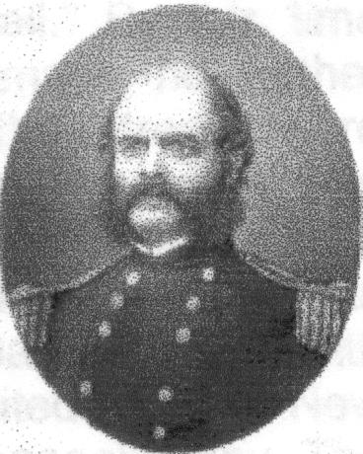

Soldier of the Month

Ambrose E. Burnside

Ambrose E. Burnside, the fourth of nine children, was born in a rude log cabin in Liberty, Indiana on May 23, 1824. After attending the village schools, Burnside was indentured to a merchant tailor. After learning the trade, he returned to Liberty and began business as a partner in Myers & Burnside. He became interested in military affairs and read all the books he could find on the subject. He secured an appointment to West Point and graduated in 1847. He spent six years in the artillery. He was wounded fighting Apache Indians in New Mexico territory in 1849 and spent time on garrison duty in Mexico. In 1852 he married Mary Richmond and resigned his commission after inventing the breech-loading rifle. He manufactured the guns, but failed to receive a government contract and was forced into bankruptcy. He began working for the Illinois Central Railroad and was able to repay his debts. In June 1860, he became Treasurer of the Illinois Central Railroad. Knowing that war was approaching, he accepted command of the Rhode Island First Regiment on April 15, 1861. He was offered command of the Union army several times before he finally accepted. Burnside’s failure at Fredericksburg, his ill-fated “Mud March,” and his General Orders, No. 8 asking for the removal of several officers led to Lincoln relieving him of command of the Union Army. He was transferred to command the Department of Ohio. He successfully defended Knoxville and received the thanks of Congress. He was blamed for the Union disaster at Petersburg and resigned from the army in April 1865. After the war, he worked in railroad construction and management and was elected Governor of Rhode Island in 1866, 1867 and 1868. He visited Europe on business during the Franco-Prussian War and became an envoy between the Prussians and the French. He returned to the U.S. and was elected Rhode Island Senator in 1875 and 1880. He died suddenly from neuralgia of the heart in Bristol, Rhode Island on September 3, 1881.

Historic Site of the Month

Burnside is remembered in his birthplace of Liberty, Indiana on the courthouse lawn with a plaque with the following notation:
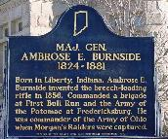
“MAJ. GEN.
AMBROSE E. BURNSIDE
1824 – 1881

Born in Liberty, Indiana, Ambrose E.
Burnside invented the breech-loading
rifle in 1856. Commanded a brigade
at First Bull Run and the Army of
the Potomac at Fredericksburg. He
was commander of the Army of Ohio
when Morgan’s Raiders were captured.”
If you have a short article, book review, or some other item that may be of interest to our members, please submit it via email to the editor at jkt60@earthlink.net by the tenth day following the preceding month’s meeting. Please list HARDTACK in the subject line and include your email address in case I need to contact you.

