HARDTACK
Indianapolis Civil War Round Table Newsletter
December 11, 2006 at 7:30 p.m.
Meeting at Indiana History Center

The Plan of the Day

Grant & Lincoln

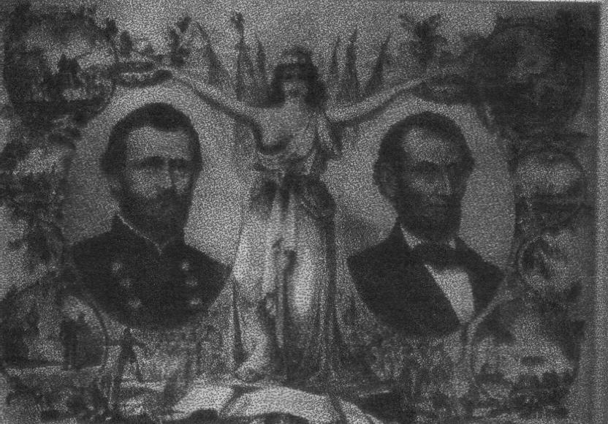
The Preservers of our Union Lithograph by Kimmel and Forster, 1865.

Abraham Lincoln, President and commander-in-chief, was the highest ranked civilian in the Union during the Civil War. Lincoln realized he must preserve the Union. His role as commander-in-chief was to direct war, to establish national security, and to inspire troops to serve willingly. Lincoln took his duty seriously. He borrowed and read military strategy books from the Library of Congress. His superb leadership, strategy and sense of timing enabled Lincoln to deal with things as needed. His use of images and figurative language enabled him to effectively communicate the meaning and purpose of his plans. He sent telegrams to coordinate movements, visited troops and removed incompetent commanders.
Lincoln sought effective commanders. A general-in-chief’s role is to communicate with the President and to use the most effective tactics to achieve the national strategy. McClellan, although a fine organizer and trainer, proved arrogant, disrespectful, slow to fight and constantly begged for reinforcements. Burnside, Butler, Banks, and McClernand proved unable to command large armies. Rosecrans lost his confidence and aggressiveness after the Battle of Stone’s River. Hooker hesitated in a crisis, bad mouthed others, and complained. Meade showed great tactical skill at Gettysburg, but lacked the aggressiveness to follow Lee for total victory. Although the American authority on war, Halleck blamed himself for the loss at Second Manassas and refused to use his authority as general-in-chief to make decisions, choosing instead to only serve as Lincoln’s technical adviser.
Grant showed an aggressive spirit, the ability to make decisions under stress, and instinctive military intelligence. Grant refused to be idle or complain and was willing to use available resources. Lincoln watched Grant for a year and a half to see if he would be a worthy commander. Grant collaborated with the Navy to gain victory at Vicksburg. He showed he was willing to submit to authority and to obey orders without political ambitions. Lincoln had finally found an effective general-in-chief. Grant saw the need for a total war against Confederate resources and took charge of the war effort. Lincoln and Grant complemented each other and worked together to finish the war. Their relationship ushered in the era of total warfare and became a role model for future Presidents and their military commands.


Our Guest Speaker
Robert Vane

Robert Vane is a life-long Hoosier, born and educated on the east side of Indianapolis. After serving in the U.S. Army, he attended IUPUI, where he earned a bachelor’s degree in history and political science and a master’s degree in Medieval History. He and his wife, Kandace, have two children, Andrew Jackson and Anna.
Robert will be discussing the unique relationship between Abraham Lincoln and Ulysses S. Grant. Their partnership allowed the Union military forces to march to ultimate victory. Just as Lincoln rose from prairie lawyer to president, Grant rose from a clerk in the backroom of his family’s tannery to become the most accomplished general in the history of our great Republic.

Roster of Officers and Committees for the 2006-2007 Campaign
Officers:
President: Dave Klinestiver Secretary: Robert Vane
Vice President: Dave Sutherland Treasurer: Peg Bertelli
Librarian: Marilyn Hoffman
Committee Chairs:
Programs: Dave Sutherland Preservation: Andy O’Donnell
Membership: Nikki Schofield Publicity: Dave Buchanan & Tony Roscetti
Quiz Master: Summer Campaign:
Tony Trimble Nikki Schofield
HARDTACK Newsletter:
Editor: Jenny Thompson
Distribution: Jenny Thompson (email) & Tony Roscetti (U.S. mail)

JOIN US BEFORE THE MEETING AT SHAPIRO’S DELI!
All ICWRT members and guests are invited to join us at 5:30 P.M. at Shapiro’s Delicatessen, 808 S. Meridian St. (just south of McCarty Street) before the meeting to enjoy dinner and fellowship.

2006-2007 Campaign Plans
Unless otherwise noted, we meet at the Indiana History Center, 450 West Ohio Street.
January 8, 2007 Cross Keys & Port Republic Tony Trimble
February 12, 2007 Hoosier Soldiers at Fredericksburg Peter Carmichael
March 12, 2007 “Stovepipe” Johnson’s Raid on Newburgh Ray Mulesky
April 9, 2007 The USS Monitor Center Craig Symonds
May 14, 2007 A New Look at Civil War Photography Dave Klinestiver
June 11, 2007 Vicksburg Terry Winschel

Special Orders

Publication notice: Autographed and personalized copies of The Gettysburg Gospel: The Lincoln Speech That Nobody Knows by Gabor Boritt can be purchased for $25.50 with free shipping at www.GettysburgGospel.com. The website can also be visited for a complete schedule of book signings.

Publication notice: The victorious partnership and deep friendship of William Tecumseh Sherman and Ulysses S. Grant is the subject of the new book Grant and Sherman: The Friendship that Won the Civil War by Charles Bracelen Flood. The paperback book is available for $16.95 from Harper Perennial. (www.harperperennial.com)

Official Records

Book Review: In the Team of Rivals – the Political Genius of Abraham Lincoln, Doris Kearns Goodwin explores the political leadership of Abraham Lincoln. It is a biography of five men: Abraham Lincoln, President; William H. Steward, Secretary of State; Salmon P. Chase, Secretary of Treasury; Edward Bates, Attorney General; and Edwin M. Stanton, Secretary of War. Lincoln was more successful choosing his Cabinet than selecting Generals of the Army. Goodwin shows that the Civil War was ignited not by slavery, but by the refusal to expand slavery. She also pays attention to the roles of women, by providing several life stories, giving us insight of the relationships of men and women before and during the Civil War. Goodwin shows that newspapers reported partial news using editorials and fabrication. This wonderful book does not only demonstrate the political genius of Abraham Lincoln, it illustrates his character and leadership and how it influenced his family, friends, Cabinet, military, people of the Union and those in the Confederacy. This book provides a glimpse into everything else that happened off the battlefield during the Civil War.
Submitted by Lee A. Peters

Fort Donelson: On October 30, the properties associated with Fort Heiman in Calloway County, Kentucky (more than 150 acres) were transferred to the National Park Service. The National Park Service is planning events to celebrate the preservation of the site and its inclusion into Fort Donelson National Battlefield. The 145th anniversary of the Battle for Forts Heiman, Henry and Donelson will be held February 6-16, 2007.

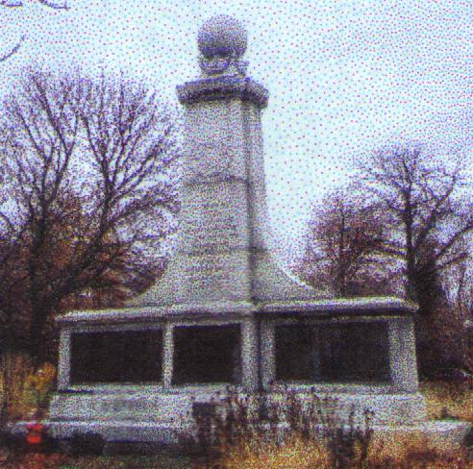
PRESERVATION UPDATES:
Confederate Monument in Garfield Park: The Confederate Monument in Garfield Park was recently cleaned by the Parks Department. It looks much better and they promise to continue to upkeep this historical monument.

Perryville sign: The Kentucky Historical Society has written the text for the first Perryville sign, seen below. Andy invites the ICWRT members to send him any comments or corrections. Andy’s email address is odar1@aol.com.
“For God’s Sake, Save that Battery:”
The 38th Indiana at Perryville

The 436 members of the 38th Indiana Infantry Regiment deployed here, in a cut cornfield, next to the 10th Wisconsin Infantry. These men supported Captain Peter Simonson’s six cannon, which were located to your right. It was a crucial position; along with Simonson’s guns, these infantrymen anchored the center of the Union battle line.

Simonson’s guns roared as an artillery duel opened the Battle of Perryville. The ground shook with the booming cannon, and the Northerners on this ridge readied themselves as Confederate infantry advanced. Union Major General Alexander McCook, the Hoosiers’ corps commander, implored the men to save Simonson’s artillery. “For God’s sake,” he begged, “save that battery.” They paid a heavy price for obeying this order.

Soon, Confederate troops appeared on the ridge in front of you and attacked the Union center. The 38th Indiana fought here for more than two hours. When their ammunition was expended, they prepared to defend the position with their bayonets. “Our ammunition gave out,” John Sipe of the 38th Indiana wrote, “and we had to stand some time and let the Rebels shoot at us without being able to return the fire.” Dozens of casualties were incurred here, and the regimental flag was, an officer wrote, “literally riddled with balls and the staff shot off.”

Union troops to the right broke under the weight of the rebel assault, and Simonson’s battery fell back three hundred yards behind you to the Russell House. When that flank peeled away, the 38th Indiana was left alone—without ammunition—to face the attacking Confederates. Nearly cut off, they fell back toward the Russell House, where they continued to fight.

The 38th Indiana lost 38 killed and 132 wounded, representing nearly forty percent of their strength. After the battle, they buried their dead in the cornfield, where most of their men had fallen. These remains were later moved to Camp Nelson National Cemetery in Jessamine County, Kentucky.

The aftermath was traumatic. Sipe wrote that, “Of all the horrible suffering, I [hope] I may never witness the like again. Union and rebel lying side by side with their limbs blown off or shattered to pieces. One Rebel with [both] his arms blown off told me if he were in his grave he would not suffer so.” Henry Fales Perry of the 38th concurred. He wrote that, “The spectacle presented by the battlefield was enough to make angels weep.”

QUOTES:

“Our loss is very heavy . . . The wonder is that any of us were saved, for we were under a murderous cross fire for hours.”
--Colonel Benjamin F. Scribner, 38th Indiana Infantry Regiment

“The advancing line of rebels had reached a ridge about 200 yards in front of the one occupied by the Thirty-eighth Indiana. The corn which had grown on the ground during the summer, with the exception of perhaps an acre in a sink-hole between the two lines of battle, had been cut, thus leaving an open field for the terrific contest which was to be waged here for two long hours.”
--Henry Fales Perry, 38th Indiana Infantry Regiment

Text provided by the Kentucky Historical Society [LOGO]
Sign sponsored by the Indianapolis Civil War Round Table [LOGO]

Test Your Civil War Knowledge (with Trimble’s Trivia)

Identify the Civil War figure associated with each of these nicknames.
1. “Bull” (1 USA; 1 CSA)

2. “Old Lop Ear”

3. “Porte Crayon”

4. “Spoons” or “Beast”

5. “Polecat”

Answers to the November Quiz:
1. Cold Harbor, 1864
2. They all hired substitutes and made fortunes during the war.
3. The footwear was known as “Jefferson boots.”
4. A prisoner of war who served as an informer.
5. Nathaniel P. Banks

The Commander-in-Chief Speaks

(Lincoln, quoted in Faith in God and Generals, edited by Ted Baehr and Susan Wales)

About his faith:
“When I left Springfield, I asked the people to pray for me; I was not a Christian. When I buried my son – the severest trial of my life – I was not a Christian. But when I went to Gettysburg, and saw the graves of thousands of our soldiers, I then and there consecrated myself to Christ.”

About the war:
“The will of God prevails. In great contests each party claims to act in accordance with the will of God. Both may be, and one must be, wrong. God can not be for and against the same thing at the same time. In the present civil war it is quite possible that God’s purpose is something different from the purpose of either party – and yet the human instrumentalities, working just as they do, are of the best adaptation to effect His purpose. I am almost ready to say this is probably true – that God wills this contest, and wills that is shall not end yet. By His mere quiet power, on the minds of the now contestants, He could have either saved or destroyed the Union without a human contest. Yet the contest began. And having begun He could give the final victory to either side any day. Yet the contest proceeds.”

(Lincoln, quoted in Famous Statements, Speeches & Stories of Abraham Lincoln, edited by J. Donald Hawkins)

About his role:
“God selects his own instruments, and sometimes they are queer ones; for instance, He chose me to steer the ship through a great crisis.”

Abe Lincoln’s Ten Guidelines:
“You cannot bring about prosperity by discouraging thrift.
You cannot help small men by tearing down big men.
You cannot strengthen the weak by weakening the strong.
You cannot lift the wage earner by pulling down the wage payer.
You cannot help the poor man by destroying the rich.
You cannot keep out of trouble by spending more than your income.
You cannot further brotherhood by inciting class hatred.
You cannot establish security by using borrowed money.
You cannot build character and courage by taking away man’s initiative and independence.
You cannot help people permanently by doing for them what they could and should do for themselves.”

The Soldiers Speak

ABOUT LINCOLN:

(Quoted from All for the Union: The Civil War Diary and Letters of Elisha Hunt Rhodes, edited by Robert Hunt Rhodes)

“Today [June 24, 1861] we brushed up and marched into Washington and were reviewed by the President. As we passed the White House I had my first view of Abraham Lincoln. He looks like a good honest man, and I trust that with God’s help he can bring our country safely out of its peril.”

(Quoted from Charles A. Dana’s Recollections of the Civil War)

“He never posed, or put on airs, or attempted to make any particular impression; but he was always conscious of his own ideas and purposes, even in his most unreserved moments…. He was calm, equable, uncomplaining. In the discussion of important questions, whatever he said showed the profoundest thought, even when he was joking. He seemed to see every side of every question. He never was impatient, he never was in a hurry, and he never tried to hurry anybody else. To every one he was pleasant and cordial…. Even physically he was impressive. According to the record measurements, he was six feet four inches in height. That is, he was at least four inches taller than the tall, ordinary man. When he rode out on horseback to review an army, as I have frequently seen him do, he wore usually a high hat, and then he looked like a giant. There was no waste or excess of material about his frame; nevertheless, he was very strong and muscular…. He was a very quick man in his movements when he chose to be, and he had immense physical endurance…. Mr. Lincoln’s face was thin, and his features were large. His hair was black, his eyebrows heavy, his forehead square and well developed. His complexion was dark and quite sallow. His smile was something most lovely…. there was such a charm and beauty about his expression, such good humor and friendly spirit looking from his eyes, that when you were near him you never thought whether he was awkward or graceful; you thought of nothing except, What a kindly character this man has! … Indeed, the expression of his face and of his bearing which impressed one most, after his benevolence and benignity, was his intelligent understanding. You felt that here was a man who saw through things, who understood, and you respected him accordingly…. This unerring judgment, this patience which waited and which knew when the right time had arrived, is an intellectual quality that I do not find exercised upon any such scale and with such absolute precision by any other man in history. It proves Abraham Lincoln to have been intellectually one of the greatest of rulers…. To sum it up, he was a born leader of men. He knew human nature; he knew what chord to strike, and was never afraid to strike it when he believed that the time had arrived.”

ABOUT GRANT:

(Quoted from All for the Union: The Civil War Diary and Letters of Elisha Hunt Rhodes, edited by Robert Hunt Rhodes)

[April 1864]“Yesterday the 18th, the 6th Corps was reviewed by Lieut. Gen. U.S. Grant…General Grant is a short thick set man and rode his horse like a bag of meal. I was a little disappointed in the appearance, but I like the look of his eye. He was more plainly dressed then any other General on the field.”

(Quoted from Joseph T. Glathaar’s Partners in Command: The Relationships Between Leaders in the Civil War)

“Sherman described Grant to his wife as ‘not a brilliant man’ but a ‘good and brave soldier; tried for years; is sober, very industrious and as kind as a child.’”

(Quoted from Charles A. Dana’s Recollections of the Civil War)
Dana was sent to the front to be “the government’s eyes at the front.”

April 29, 1863 near Vicksburg:
“Late in the evening I left Hard Times with Grant to ride across the peninsula to De Shroon’s. The night was pitch dark, and as we rode side by side, Grant’s horse suddenly gave a nasty stumble. I expected to see the general go over the animal’s head, and I watched intently, not to see if he was hurt, but if he would show any anger. I had been with Grant daily now for three weeks, and I had never seen him ruffled or heard him swear. His equanimity was becoming a curious spectacle to me. When I saw his horse lunge my first thought was, ‘Now he will swear.’ For an instant his moral status was on trial; but Grant was a tenacious horseman, and instead of going over the animal’s head, as I imagined he would, he kept his seat. Pulling up his horse, he rode on, and, to my utter amazement, without a word or sign or impatience. And it is a fact that though I was with Grant during the most trying campaigns of the war, I never heard him use an oath.”

During the siege at Vicksburg:
“Grant was an uncommon fellow – the most modest, the most disinterested, and the most honest man I ever knew, with a temper that nothing could disturb, and a judgment that was judicial in its comprehensiveness and wisdom. Not a great man, except morally; not an original or brilliant man, but sincere, thoughtful, deep, and gifted with courage that never faltered; when the time came to risk all, he went in like a simple-hearted, unaffected, unpretending hero, whom no ill omens could deject and no triumph unduly exalt. A social, friendly man, too, fond of a pleasant joke and also ready with one; but liking above all a long chat of an evening, and ready to sit up with you all night, talking in the cool breeze in front of his tent. Not a man of sentimentality, not demonstrative in friendship, but always holding to his friends, and just even to the enemies he hated.”

(Quoted from Famous Statements, Speeches & Stories of Abraham Lincoln, edited by J. Donald Hawkins)

“One night, about eleven o’clock, Colonel A.K. McClure, whose intimacy with President Lincoln was so great that he could obtain admittance to the Executive Mansion at any and all hours, called at the White House to urge Mr. Lincoln to remove General Grant from command.
“After listening patiently for a long time, the President, gathering himself up in his chair, said, with the utmost earnestness: ‘I can’t spare this man; he fights!’”

Commander-in-Chief of the Month

Abraham Lincoln
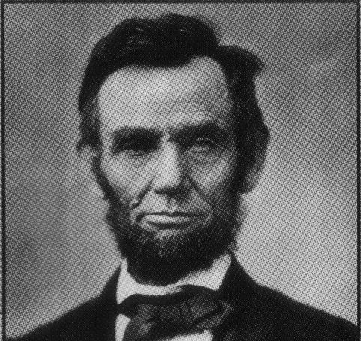
Abraham Lincoln was born February 12, 1809 at the Sinking Spring Farm in Kentucky. When he was two years old, his family moved to the Knob Creek Farm. When he was seven years old, his family moved to Spencer County, Indiana. “We reached our new home about the time the State came into the Union.” His mother, Nancy Hanks Lincoln, died from milk sickness, caused by consuming milk products or the meat of a cow that has grazed on white snakeroot, which contains a deadly toxin tremetol. She was buried here in 1818. Abraham deeply loved his mother: “All that I am or ever hope to be, I owe to my loving angel mother. God bless her.” Within a year, Lincoln’s father married Sarah Bush Johnston, a widow with three children. In 1828, Abraham got a job piloting a flatboat down the Ohio and Mississippi Rivers to New Orleans, where he witnessed a slave auction on the docks, a scene he never forgot. Two years later, the Lincoln family moved to Illinois. Abraham lived in New Salem from 1831 to 1837, working as a clerk, mill hand, soldier, storekeeper, postmaster and surveyor. In the 1840’s, Abraham was a lawyer in Springfield, where he met and married Mary Ann Todd in November 1842. In 1846, Abraham was elected to the U.S. House of Representatives. Abraham was elected President in 1860. During the Civil War, Lincoln faced problems finding an effective commanding officer, until he found Grant, a commander who would fight and not give up until he achieved victory. The Civil War ended April 9, 1865; however, John Wilkes Booth assassinated Lincoln on April 14. Lincoln’s funeral was the most elaborate and expensive state funeral in U.S. history. His body was transported by railroad to Springfield and was buried in Oak Ridge Cemetery on May 4.

Historic Sites of the Month

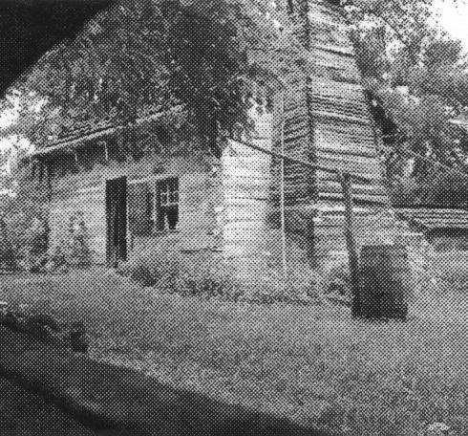

Lincoln Boyhood National Memorial
The Memorial is located just outside Lincoln City, Indiana. From I-64, take exit 57. Go south on U.S. 231 to Gentryville. Turn left (east) on IN162. Go two miles to the park entrance on the left. It is open daily from 8 a.m. to 4:30 p.m. from December through February and from 8 a.m. to 5 p.m. March through November. It is closed on Thanksgiving, Christmas Day and New Year’s Day. The Memorial Visitor Center has an information desk, a brief film, bookstore and exhibits. His mother is buried in the Pioneer Cemetery. A living historical farm recreates the 1820s homestead where Lincoln grew up. The farm is open with park rangers in period clothing from mid-April through September. Admission is $3 for a 7-day pass for adults 17 & older with a maximum charge of $5 per family. If one is interested in visiting several National Parks, he can pay $10 for an annual pass good at all parks for one year. For more information, visit www.nps.gov/libo
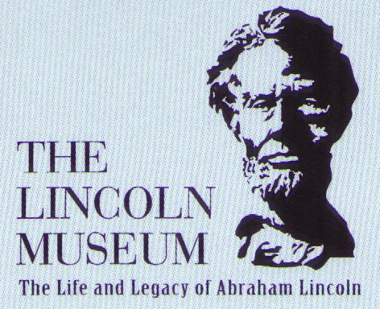
The Lincoln Museum
The Lincoln Museum is located at 200 E. Berry Street in Fort Wayne, Indiana. It is the largest museum dedicated to Abraham Lincoln and features hundreds of artifacts and images. The museum has 4 theaters, 11 exhibit galleries and 18 interactive exhibits. It is open Tuesday – Saturday 10 a.m. – 5 p.m. and Sunday 1 – 5 p.m. It is closed on Mondays and major holidays (New Years Day, Easter, Memorial Day, July 4th, Labor Day, Thanksgiving and Christmas). Admission is $4.99 for Adults; $3.99 Seniors (60 and older), Children (ages 5-12) and groups of 12 or more; and $2.99 for School Groups. Parking is free. For more information, visit www.TheLincolnMuseum.org , email thelincolnmuseum@lnc.com or call (219) 455-3864.

(Quoted from The Columbia Book of Civil War Poetry, edited by Richard Marius)
General Grant – the Hero of the War
By George Moses Horton (1797?-1883?)

Brave Grant, thou hero of the war,
Thou art the emblem of the morning star,
Transpiring from the East to banish fear,
Revolving o’er a servile Hemisphere,
At large thou hast sustained the chief command
And at whose order all must rise and stand,
To hold position in the field is thine,
To sink in darkness or to rise and shine.

Thou art the leader of the Fed’ral band,
To send them at thy pleasure through the land,
Whose martial soldiers never did recoil
Nor fail in any place to take the spoil,
Thus organized was all the army firm,
And led unwavering to their lawful term,
Never repulsed or made to shrink with fear,
Advancing in their cause so truly dear.

The love of Union burned in every heart,
Which led them true and faithful from the start,
Whether upon water or on land,
They all obeyed their marshal’s strict command,
By him the regiments were all surveyed,
His trumpet voice was by the whole obeyed,
His order right was every line to form,
And all be well prepared to front the storm.

Ye Southern gentlemen must grant him praise,
Nor on the flag of Union fail to gaze;
Ye ladies of the South forego the prize,
Our chief commander here to recognize,
From him the stream of general orders flow,
And every chief on him some praise bestow,
The well-known victor of the mighty cause
Demands from every voice a loud applause.

What more has great Napoleon ever done,
Though many battles in his course he won?
What more has Alexander e’er achieved,
Who left depopulated cities grieved?
To him we dedicate the whole in song,
The verses from our pen to him belong,
To him the Union banners are unfurled,
The star of peace the standard of the world.

If you have a short article, book review, or some other item that may be of interest to our members, please submit it via email to the editor at jkt60@earthlink.net by the tenth day following the preceding month’s meeting. Please list HARDTACK in the subject line and include your email address in case I need to contact you.

