HARDTACK
Indianapolis Civil War Round Table Newsletter
http://indianapoliscwrt.org/

April 9, 2007 at 7:30 p.m.
Meeting at Indiana History Center

The Plan of the Day

The USS Monitor Center
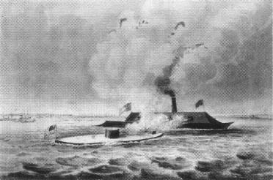
watercolor by Fanny Palmer
published by Currier & Ives in 1862

The CSS Virginia (Merrimac) destroyed the USS Congress and USS Cumberland in the most important naval engagement of the Civil War on March 8, 1862. The USS Monitor engaged the CSS Virginia in a great ironclad duel on March 9. These battles marked the end of the wooden ships and the beginning of the ironclads for navies around the world.
John Ericsson, a mechanical genius, designed and built the Monitor. Armor plating protected the vessel from shell guns, and the armored overhang protected the hull from being rammed. A double piston steam engine, with a jet condenser and two boilers, drove the four-bladed screw propeller. The majority of the 172-foot vessel was submerged, protecting the crew and machinery from harm. A centrifugal blower removed impure air and provided fresh air for the crew, engines and the turret. Periscopes provided a view of surrounding waters. The revolving turret, an idea borrowed from the Greeks, was powered by a small steam engine, operated by one man and allowed the ship to fire its guns in any direction. Heavy iron stoppers closed the gun ports during loading. The crew could escape through the emergency hatch on top of the pilothouse. When asked to name the ship, Ericsson chose Monitor to warn the leaders of the Confederacy against building batteries on the rivers and to reprove the British for their indifference and doubts.
The Monitor carried a crew of 58 men, including thirteen officers. Lieutenant John Worden, a recently released prisoner-of-war, accepted command of the Monitor. Lieutenant Samuel Greene became executive officer. Acting Paymaster William Keeler was pleased with the ship and felt he would be safe on the ship. Coal heaver Davis Ellis was concerned about her seaworthiness. Third assistant engineer Louis Stodder felt the ship had been built too quickly. The Monitor’s mission was to destroy the Virginia at Hampton Roads. A coastal storm delayed their trip until March 6; rough seas almost sunk the Monitor twice on her way to Hampton Roads. During the three and one-half hour ironclad duel, the Virginia had the greater firepower while the Monitor steered better and moved faster. The battle ended as a draw, although both sides claimed a victory. The Monitor suffered no fatalities and only a handful of wounded. The crew received praise and congratulations from many. Peter Williams received the Congressional Medal of Honor for his service as quartermaster. The Virginia was grounded and set afire when the Confederates evacuated Norfolk on May 10. Five days later, the Monitor again faced the crew of the Virginia at Drewry’s Bluff, near Richmond, but could not elevate her guns to reach the batteries. In December, the Monitor sank in 220 feet of water south on Cape Hatteras on her way to blockade duty at Beaufort, North Carolina. The ship was found 16 miles from Cape Hatteras in 1973. Over 1,000 artifacts have been recovered and are currently displayed in the new USS Monitor Center at the Mariners’ Museum in Newport News.

Our Guest Speaker
Craig Symonds

Craig Symonds is a recently retired professor of history from the United States Naval Academy at Annapolis, where he was awarded both the Academy's Excellence in Teaching and Excellence in Research awards. He is now the Chief Historian at the USS Monitor Center. On March 9, 2007, the USS Monitor Center opened at The Mariners’ Museum in Newport News, Virginia. Our speaker will tell us about this world-class attraction, which preserves the memory of the USS Monitor and the CSS Virginia by using full-scale replicas to sense the size of the ironclads, a “battle theater” to experience the historic battle and a walk-through theater to experience the sinking of the Monitor during a storm off Cape Hatteras, NC on December 31, 1862. The USS Monitor Center is also the official repository for the Monitor archives and artifacts.

Special Announcement
Doug Housemeyer, host of radio program, “Indy Arts and Entertainment,” will interview Professor Craig L. Symonds, Professor Emeritus of the U.S. Naval Academy and Chief Historian of the USS Monitor Center at the Mariners’ Museum in Newport News, Virginia, live on air from 9:19 to 9:29 a.m., Wednesday, April 4, 2007, on WICR radio, 88.7 FM in Indianapolis. Professor Symonds will preview his upcoming presentation to the Indianapolis Civil War Round Table that will take place at 7:30 p.m., Monday, April 9, 2007, in the Basile Theater of the Indiana Historical Society at 450 West Ohio Street in Indianapolis.
If you have a short article, book review, or some other item that may be of interest to our members, please submit it via email to the editor at jkt60@earthlink.net by the tenth day following the preceding month’s meeting. Please list HARDTACK in the subject line and include your email address in case I need to contact you.

2006-2007 Campaign Plans

May 14, 2007 A New Look at Civil War Photography Dave Klinestiver
June 11, 2007 Vicksburg Terry Winschel

The May meeting is at the Indiana History Center, 450 West Ohio Street. The June meeting is at Primo. Guests with reservations are welcome. See last page for info and reservation form.

JOIN US BEFORE THE MEETING AT SHAPIRO’S DELI!
All ICWRT members and guests are invited to join us at 5:30 P.M. at Shapiro’s Delicatessen, 808 S. Meridian St. (just south of McCarty Street) before the meeting to enjoy dinner and fellowship.

Roster of Officers and Committees for the 2006-2007 Campaign
Officers:
President: Dave Klinestiver Secretary: Robert Vane
Vice President: Dave Sutherland Treasurer: Peg Bertelli
Librarian: Marilyn Hoffman
Committee Chairs:
Programs: Dave Sutherland Preservation: Andy O’Donnell
Membership: Nikki Schofield Publicity: Dave Buchanan & Tony Roscetti
Quiz Master: Summer Campaign:
Tony Trimble Nikki Schofield
HARDTACK Newsletter:
Editor: Jenny Thompson
Distribution: Jenny Thompson (email) & Tony Roscetti (U.S. mail)
Other Camp Activities

National Trust Historic Site Updates: George Gilmore was a freedman born a slave on James Madison’s Montpelier Estate. In 1810, he built a log cabin on the grounds, where he and his family lived until the late 1920s. The Montpelier Foundation restored this property. In early February 2007, Rebecca Gilmore Coleman, the freedman’s great-granddaughter, presented a deed for a portion of the farm to the Foundation. The Gilmore Cabin and Freedman Farm are open to the public April through October. *** Daniel Webster maintained his family’s farm outside of Concord, New Hampshire as a retreat, model stock farm and meeting place until his death in 1852. In 1871, the farm became the site of a home and school for children orphaned in the Civil War. As of late February, this 141-acre farm will never be developed and the historic building will be permanently protected.

Cedar Creek Battlefield: This battlefield is threatened by three major development projects. (1.) The O-N Minerals Company is seeking to expand its quarrying operations by rezoning 639 acres from agricultural to extractive manufacturing. This is where the Federal Sixth Corps was located during the battle of Cedar Creek. (2.) VDOT is proposing to expand I-81 from four to eight lanes with tolls, which will affect the entire Shenandoah Valley. (3.) Dominion and Allegheny Power Companies are proposing to build power lines from West Virginia to northern Virginia. These 120-foot towers and lines would run along the eastern edge of the Cedar Creek Battlefield. For more information, please visit www.cedarcreekbattlefield.org.

Seeking info on CSA Burials at Greenlawn and Crown Hill: Mark Hughes, from North Carolina, is researching Civil War cemeteries. He is trying to determine why the Confederate monument, which was erected about 1911 at Greenlawn Cemetery, was not moved to Crown Hill. He is looking for any resource discussing the cemetery and would be happy to share information about these soldiers when he finishes his research. He is also looking for pictures (600 DPI or better) of soldiers (Union or Confederate) who died during the war for use in other books.
Test Your Civil War Knowledge (with Trimble’s Trivia)

- What unit was known as the “Orange Blossoms”?

- What is an Ellet Ram?

- What unlikely location did the Confederacy choose for its Navy Yard after the fall of Norfolk and Portsmouth?

- Who was “Bluff Ben”?

- On what battlefield would you find the Bloody Salient? By what other name is this site known?

Answers to the February/March Quiz:
1. Name the Texas general killed at Pea Ridge?
Ben McCulloch
2. What general nickname was given to southern soldiers from Georgia?
“Goober Grabbers”
3. Who or what was “Don MacGregor?
A cannon named by Gen. Hardee after Stones River
4. On what battlefield would you find the “Devil’s Pulpit”?
Lookout Mountain
5. “______________________ supplemented each other, and together, with any fair opportunity, they were absolutely invincible.” Who are they?
Lee and Jackson

The Soldiers Speak
Descriptions of the Virginia:
(Quoted in William C. Davis’s Duel Between The First Ironclads)
Henry Reaney, commander of the tug Zouave:
“the roof of a very big barn belching forth smoke as from a chimney on fire”

(Quoted in James Tertius deKay’s Monitor: The Story of the Legendary Civil War Ironclad and the Man Whose Invention Changed the Course of History)
*** A Yankee participant’s description:
“Pretty soon that great black thing, different from any vessel ever seen before, poked her nose around Sewell’s Point.”
*** A Boston newspaperman description:
“weird and mysterious, like some devilish and superhuman monster, or the horrid creation of a nightmare”

(A newsman’s report: “The Merrimac’s Day of Triumph and Defeat,” quoted in The Fateful Lightning: Civil War Eyewitness Reports, edited by Harold Elk Straubing)
“As the strange looking craft came ploughing through the water right onward towards the port bow of the Cumberland, she resembled a huge, half submerged crocodile. Her sides seemed of solid iron, except where the guns pointed from the narrow ports, and rose slantingly from the water like the roof on a house, or the arched back of a tortoise.”

Descriptions of the Monitor:
(Quoted in James Tertius deKay’s Monitor: The Story of the Legendary Civil War Ironclad and the Man Whose Invention Changed the Course of History)
The executive officer of the CSS Patrick Henry:
“such a craft as the eyes of a seaman never looked upon before – an immense shingle floating in the water, with a gigantic cheese box rising from its center; no sails, no wheels, no smokestack, no guns. What could it be?”

(Quoted in The Oxford Dictionary of Civil War Quotations, edited by John D. Wright)
anonymous Confederate sailor:
“We thought at first [the USS Monitor] was a raft on which one of the Minnesota’s boilers was being taken to shore for repairs.”

(“How the Merrimac Fought the Monitor,” quoted in The Fateful Lightning: Civil War Eyewitness Reports)
Lt. Arthur Sinclair, C.S.N.:
“It was eleven o’clock on the night of March 8th, 1862, that I had my first view of the Monitor in Hampton Roads…. As we looked, there passed between us and the doomed and blazing frigate a strange craft thrown into strong relief by the flames. It was wholly unlike anything I had dreamed of in connection with ships… To us she was merely the Ericsson battery. Next day by unanimous consent she had been dubbed the ‘cheesebox on a raft,’ a description that suited her quite as well as our humorous appellation, ‘Noah’s Ark,’ suited us.”

The Battle of Ironclads:
(Quoted in David J. Eicher’s The Longest Night: A Military History of the Civil War)
*** John A. Dahlgren:
“Now comes the reign of iron…the cased sloops are to take the place of wooden ships.”
*** Captain John A. Van Brunt:
“The contrast was that of a pygmy to a giant…Gun after gun was fired by the Monitor; which was returned with whole broadsides by the rebels, with no more effect, apparently, than so many pebble-stones thrown by a child.”

(“The Merrimac’s Day of Triumph and Defeat,” quoted in The Fateful Lightning: Civil War Eyewitness Reports)
“The scene was in plain view from Fortress Monroe, and in the main facts all the spectators agree. At first the fight was furious and the guns of the Monitor were fired rapidly. As she carried but two guns, whilst the Merrimac had eight, of course she received two or three shots for every one she gave. Finding that her antagonist was much more formidable than she looked, the Merrimac attempted to run her down. The superior speed and quicker turning qualities of the Monitor enabled her to avoid these shocks, and to give the Merrimac, as she passed, a shot. Once the Merrimac struck her near amidships, but only to prove that the battery could not be run down nor shot down. She spun around like a top; and as she got her bearing again, sent one of her formidable missiles into her huge opponent.”

(“How the Monitor Fought the Merrimac,” quoted in The Fateful Lightning: Civil War Eyewitness Reports)
Acting Paymaster William F. Keeler, U.S.N.:
“I experienced a peculiar sensation, I do not think it was fear, but it was different from anything I ever knew before. We were enclosed in what we supposed to be an impenetrable armour – we knew that a powerful foe was about to meet us – ours was an untried experiment & our enemy’s first fire might make it a coffin for us all…. The suspense was awful as we waited in the dim light expecting every moment to hear the crash of our enemy’s shot…. Until we fired, the Merrimac had taken no notice of us, confining her attentions to the Minnesota. Our second shot struck her & made the iron scales rattle on her side. She seemed for the first time to be aware of our presence & replied to our solid shot with grape & canister which rattled on our iron decks like hail stones…. The vessels were now sufficiently near to make our fire effective & our two heavy pieces were worked as rapidly as possible, every shot telling – the intervals being filled by the howling of the shells around & over us, which was now incessant…. ‘Look out now they’re going to run us down…’ This was the critical moment, one that I had feared from the beginning of the fight – if she could so easily pierce the heavy oak beams of the Cumberland, she surely could go through the ½ inch iron plates of our lower hull. A moment of terrible suspense, a heavy jar nearly throwing us from our feet – a rapid glance to detect the expected gush of water – she had failed to reach us below the water & we were safe.”

(“How the Merrimac Fought the Monitor,” quoted in The Fateful Lightning: Civil War Eyewitness Reports)
Lt. Arthur Sinclair, C.S.N.:
“What could that tin can tied to a shingle do to our impregnable vessel? … The grinding shock of the two iron monsters as they came together, breathing fire and smoke, was almost nauseating at times…. The bombardment was terrific, and it did not seem possible that guns carrying heavy projectiles could be fired at a distance of a few yards and not do terrific execution… Our fire had battered her severely, but her armor was intact, though she bore our marks in the shape of deep indentations. When a shot would strike her she seemed to shiver. When one of her 180-pound balls struck us it jarred the whole structure. I am sure if her fire could have been concentrated at one spot for a time she could have broken through us. The uproar was simply beyond description, for the roar of the guns was almost in the ears. Our men were compelled to load and swab their guns from the outside, and had there been rifle fire or machine guns, as today, they would have dropped like flies. As it was we lost not a single man…. I cannot attempt to describe the whole of that titanic battle which reminded me more of two knights in armor smashing at each other with heavy maces than anything else…. The Monitor did not defeat the Merrimac, false reports to the contrary notwithstanding, nor by the same token did the Merrimac do hurt to her opponent. The battle, the first between ironclads, was a draw, and in justice nothing more or less can be said.”

(Albert C. Stimers in a letter to John Ericsson, quoted in The Civil War Chronicle, edited by J. Matthew Gallman)
“After a stormy passage, which proved us to be the finest seaboat I was ever in, we fought the Merrimack for more than three hours this forenoon and sent her back to Norfolk in a sinking condition. Ironclad against ironclad. We maneuvered about the bay here and went at each other with mutual fierceness. I consider that both ships were well fought…. Captain Ericsson, I congratulate you upon your great success. Thousands have this day blessed you. Every man feels that you have saved this place to the nation by furnishing us with the means to whip the ironclad frigate that was, until our arrival, having it all her own way with our most powerful vessels.”

(Quoted in Raimondo Luraghi’s A History of the Confederate Navy)
“With the first gun, fired by the Monitor; that quiet Sunday morning the combined navies of the world passed over into the scrap heap of useless and forgotten things. The ships of England, France, Austria, Spain; all were so hopelessly out of class as the Spanish Armada. A new type of fighting ship had been born and before noon had proved its worth. Two great war machines, each radically different from the other, had come into being unknown to each other, and from them arose the modern battleship.”

Officer of the Month

John Worden

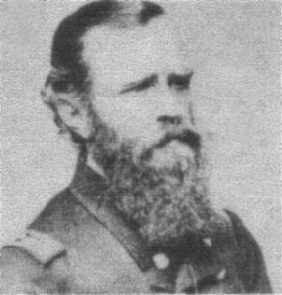
Lt. John L. Worden had been captured by the Confederates in April 1861 and served seven months in prison. He had recently recovered his health, when he took command of the USS Monitor. All of his crew were volunteers. Worden placed his ship in front of the Minnesota, to protect the grounded flagship from the CSS Virginia. The Virginia even attempted to ram the Monitor. When the Monitor disengaged after two hours of combat to re-supply her ammunition, the Virginia inflicted some damage on the Minnesota. The battle continued until around noon, when Worden was temporarily blinded by a direct hit to the observation slit on the pilothouse and the Virginia was temporarily grounded. The Monitor withdrew to assess damages and the Virginia withdrew after freeing herself. Both sides claimed victory. Worden became a hero, and Lincoln visited his bedside. He remained blind in one eye and suffered physical pain the rest of his life. He returned to duty later in the year and finished his career as a rear admiral.

Historic Site of the Month

The USS Monitor Center at The Mariner’s Museum
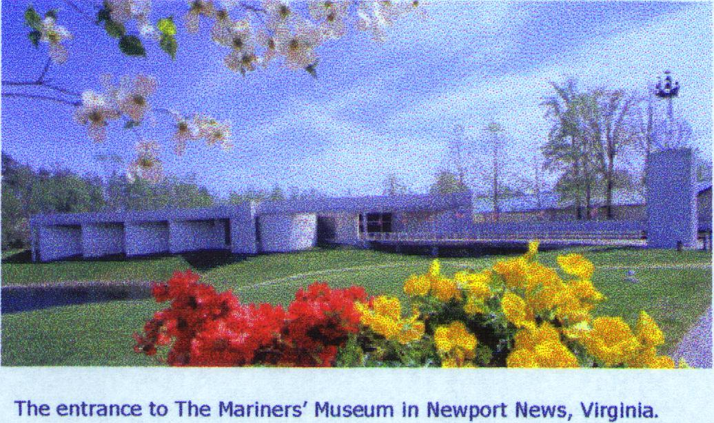
The USS Monitor Center is located in the The Mariners’ Museum in Newport News, Virginia. This new $30 million, 63,500-square-foot facility opened on March 9, 2007, exactly 145 years after the historic clash between the USS Monitor and CSS Virginia. The story of these ironclads is told through displays of the original artifacts, archival material, multimedia experiences and recreated ship interiors. The Conservation Facility provides a close up view at the conservation and reconditioning of actual pieces of the USS Monitor. The Mariners’ Museum is located at 100 Museum Drive, Newport News, Virginia (west of the intersection of Warwick and J. Clyde Morris boulevards, exit 258-A, off I-64). The museum is open Monday – Saturday 10 A.M. to 5 P.M. and Sunday 12 to 5 P.M.; closed Thanksgiving and Christmas. Admission is $8 Adults; $6 Children ages 6-16; and Free for children 5 and under. Discounts are available for AAA, active-duty military and people aged 65 and above. Group rates are also available. For more information, please call (757) 596-2222, visit http://www.monitorcenter.org or email marketing@mariner.org.

WAR ON THE RIVER
St. Louis, Memphis, Vicksburg, Natchez
Annual Trip of the Indianapolis Civil War Round Table
June 16-22, 2007

Ms. Nikki Schofield, Tour Director Tel.: 317-328-8782
7929 Hunters Path Nikki1942@sbcglobal.net
Indianapolis, IN 46214-1535

We will be heading to the Deep South, on a Star of America bus, with Noah Young at the wheel. There must be 36 people signed up to cover the cost of the bus.
By popular demand, we will be staying only at Hampton Inns. This means that your breakfast is included in the cost. Also, there will be some lunches included.

Saturday, June 16 Meet the bus at the Speedway Baptist Church parking lot, 2986 Moller Road, phone 317-291-8570. Arrive at 7:30 a.m. and depart at 8:00 a.m. We will drive 240 miles, 3 hrs. 23 min., to St. Louis, Missouri, where we will eat lunch. At 1:00 p.m., a park ranger will speak to us in the Old Courthouse, where the first Dred Scott decision was rendered. In mid afternoon, we will meet Marc Kollbaum, who will be our step-on guide at Jefferson Barracks. We will tour the grounds and the Powder Magazine Museum. Our first night will be at the Sunset Hills Hampton Inn, in south St. Louis, phone 314-984-8181.

Sunday, June 17 Depart Sunset Hills. Drive to Memphis, Tennessee, 276 miles (four hours). We will eat box lunches then tour the five Civil War galleries at Mud Island River Park. Besides the exhibits, we can board a reconstructed ironclad gunboat. Leaving Memphis, we will drive 250 miles (3 ½ hours) to Vicksburg, and check into our Hampton Inn, 3330 Clay Street, phone 601-636-6100. We will stay here three nights. Brig. Gen. (ret.) Parker Hills, our evening speaker, will give an audio visual lecture on Grant’s Bayou Expeditions in the winter of 1863.

Monday, June 18 Terry Winschel, National Park Service historian, will give us a tour of the Vicksburg National Military Battlefield, from 9:00 a.m. until 4:00 p.m. We will have a box lunch from Heavenly Ham at the USS Cairo Museum and Gunboat. Dinner will be near our Hampton Inn, followed by a musical evening in the motel meeting room. The duo called Hardtack & Coffee, with Jim Woodrick singing and Tim Waltman on guitar will present songs and narration from the Civil War.

Tuesday, June 19 Depart Vicksburg for Natchez, Mississippi, traveling on the scenic Natchez Trace. At 10:00 a.m., we will tour the Natchez City Cemetery, and see the antique roses as well as Civil War burials. There is a beautiful view from the cemetery overlooking the Mississippi River. We will have lunch at Magnolia Hall, following by a tour of the historic house. John Saleeby will be our afternoon step-on guide for a city tour of Natchez. We will stop at Longwood, the largest octagonal house remaining in American, for a house tour. When the Civil War began, the carpenters put down their tools and went to fight, so lovely Longwood was never completed. Back to Vicksburg for the night, we will have a free evening, so everyone can pack.

Wednesday, June 20 Check out of the Vicksburg Hampton Inn. Tour Vicksburg’s Old Courthouse, where bullet holes can still be seen. We will have a step-on guide for a two-hour city tour. Going east 45 miles, we will eat lunch in Jackson. We will drive along the scenic Natchez Trace, 266 miles (4 ½ hours) to Tupelo, Mississippi. We will stop at the gravesites of 13 Confederate and see the Old Trace. That evening, we check into the Hampton Inn in Tupelo, phone 662-840-8300

Thursday, June 21 Before departing Tupelo, we will go to the Natchez Trace Parkway Vistiro’s Center, where we will hear a lecture and see exhibits. Leaving at 9:30, we travel on the Natchez Trace to Brentwood, south of Nashville, 246 miles (5 hours 9 minutes). Lunch along the way. Afternoon tour of the Traveler’s Rest Plantation and Museum, phone 615-832-8197. We will see the special Tennessee Cavalry exhibit, “Hoofbeats in the Heartland,” the museum, and the plantation house. That evening, we will stay at the Hampton Inn in Brentwood, phone 615-373-2212.

Friday, June 22 Leave at 8:30 for a morning railroad tour with Rick Hollis as step-on guide, from Kingston Springs to Dickson, TN. This railroad was constructed by U.S. Colored Troops, and was needed because of guerilla warfare from civilians, coordinated by scouts of General Joe Wheeler and That Devil Forrest. Lunch at Miss Mable’s Tea Room or Front Porch restaurant in Dickson. 1:30, depart Dickson for Nashville, 40 miles east, then Nashville to Indianapolis, 300 miles (five hours), arriving about 7:00 p.m.

You do NOT need to be a member in any Civil War Round Table. We will have a release form for your parked car when you arrive at the church. Please send a check for $100 as down payment as soon as possible, no later than May 1, and final payment of $600.00 by June 1, 2006. I need to pay 10% down on the bus by March 29, so would appreciate some early down payments.

COSTS PER PERSON:
Star of America chartered bus $182.00
Baggage handling for the week, by Jon Elliott $10.00
Sunset Hills Hampton Inn (Saturday) $58.00
Vicksburg Hampton Inn (Sunday-Tuesday) $240.00
Box lunches on Sunday and Monday $20.00
Natchez City Cemetery tour $12.00
Magnolia Hall lunch on Tuesday $18.00
Hampton Inn, Tupelo, MS (Wednesday) $45.00
Hampton Inn, Brentwood, Tennessee (Thursday) $60.00
Fees for guides, speakers, musicians $20.00
Admissions to museums, NMP and historic houses $30.00
Xeroxing, phone calls, postage $5.00
TOTAL: $700.00
Make checks payable to: Nikki Schofield, and mail to 7929 Hunters Path, Indianapolis, IN 46214-1535. The price is for one person, and based on two people per room. For a private room, double the motel charges. If three or four people stay in one room, motel costs will be adjusted accordingly. Contact me by phone at 317-328-8782 or email at Nikki1942@sbcglobal.net.
Re-enlist NOW for the 2007-2008 Campaign and save 5.00!!

Membership dues for the 2007-2008 campaign of The Indianapolis Civil War Round Table
will increase by $5.00 effective July 1, 2007
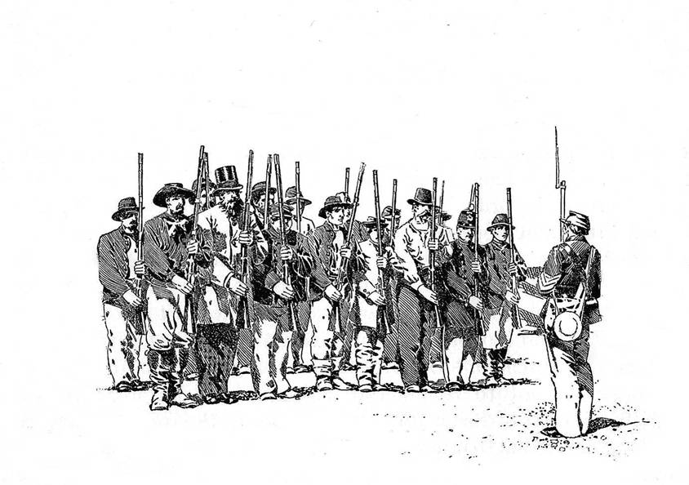
Beat the dues increase by re-enlisting NOW at current rates!

To encourage early re-enlistments, the ICWRT is extending a $5.00 discount on all new or renewal memberships for next year that are received by the end of June. This discount will effectively offset a $5.00 dues increase applicable to all membership levels for next season.

All ICWRT members may continue to receive the monthly newsletter, HARDTACK, via email at no additional charge. Members who prefer to receive the HARDTACK by U.S. Mail are asked to pay an additional $12.00 to help cover printing and mailing costs.

Please bring your completed re-enlistment form (below) together with your payment to Peg Bertelli, ICWRT Treasurer, at the next Round Table meeting, or mail your re-enlistment form and payment to:

Peg Bertelli
11827 Corbin Drive Phone: (317) 596-9193
Fishers, Indiana 46038 Email: pbbertelli@insightbb.com

Please complete and detach the form below and include with your check:
-------------------------------------------------------------------------------------------------------

ICWRT Membership Enlistment for July 2007 thru June 2008
Please print legibly!

Name…………………………………………………….…. Date ………………..

Address……………………………………………………………………….

……………………………………………………………………….

Phone: (………) …………………… Email Address: ……………………..………..

We must have a valid email address if you wish to receive the HARDTACK newsletter free of charge!

Discounted Dues for the 2007-2008 must be paid by June 30, 2007* (please specify Membership Level):

_____ $25 Individual (reg. $30) _____$30 Family (reg. $35) _____ $10 Student (reg. $15)

* If paying after June 30, 2007, please pay the regular dues amount as shown above

______ I wish to receive the newsletter via U.S. Mail for an additional $12

In addition to my membership dues, please accept my generous gift of $ _________
to the ICWRT general operating account (This donation is not tax deductible)

Individuals attending the Indianapolis Civil War Round Table, June 11, 2007 dinner meeting:

Name Name

Reservation form and payment must be received by June 1, 2007.

Cost: $20 per person. Please make check payable to Indianapolis Civil War Round Table. Payment and this reservation form can be brought to the April or May Indianapolis Civil War Round Table meeting or mailed to Peg Bertelli, and must be received by June 1, 2007.
************************************************************************

Please detach and mail this form, along with payment, to Peg Bertelli

Indianapolis Civil War Round Table
Annual Dinner Meeting

June 11, 2007
at

Primo Banquet & Conference Center *

5649 Lee Road, Indianapolis, Indiana 46216
(317) 545-5499

Cost is $20 per person
Buffet dinner will be served starting at 6:30 PM and includes:
- Entrées: Roast Beef Au Jus or Chicken Marsala
- Sides: Italian roasted potatoes or Vegetable Medley
- Salads: Tossed Salad or Pasta Salad
- Dinner rolls with butter
- Iced tea or coffee
Our Guest Speaker: Terry Winschel
* Directions: Take 56th Street east from I-465 on the east side of Indianapolis. Take a left on Lee Road, which is the traffic signal immediately before the railroad overpass (on the grounds of the former Ft. Benjamin Harrison). Primo is on your immediate right. Take the second right off Lee Road (this is the North entrance to Primo).
Reservation form (attached above) should be completed and submitted, along with payment, by June 1, 2007. Reservation form and payment can be brought to the April or May meeting or mailed to:

Peg Bertelli

11827 Corbin Drive
Fishers, Indiana 46038

