HARDTACK

The Newsletter of the Indianapolis Civil War Round Table

Celebrating Our 50th Anniversary

January 2005

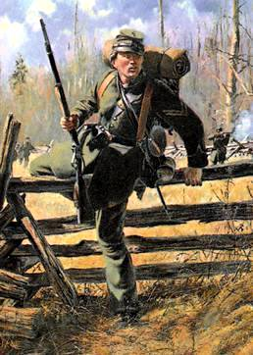
Berdan’s
Sharpshooters
Presented by Gerald Jones
Monday, January 10, at 7:30 P. M.
In June of 1861, Hiram Berdan, a New York engineer, inventor and celebrated marksman, won approval from President Lincoln to organize a regiment of sharpshooters, to be armed with highly accurate, long-range rifles. Berdan immediately set about hand-picking volunteers at shooting trials, requiring prospective recruits to place ten consecutive shots within five inches of the bullseye, firing from a range of 200 yards. Those who proved their marksmanship were mustered into the 1st U.S. Sharpshooters, with Berdan as their colonel. Berdan’s efforts would eventually produce eighteen companies comprised of men from several Northern states, allowing for the organization of a second regiment of U.S. Sharpshooters.
“Company D, 2nd U.S. Sharpshooters, Fall 1862”
by Don Troiani
© Don Troiani. Used by Permission.
Berdan clothed his Sharpshooters in distinctive dark green frock coats, forage caps and trousers, as well as other non-regulation gear such as russet leather leggings, gray felt havelock hats, greatcoats of gray trimmed in green, and “Prussian Pattern” fur-covered, calfskin knapsacks. The “Green Coats” were initially armed with Colt revolving rifles and privately procured target rifles. Eventually, Berdan was able to acquire the new Model 1859 Sharps breech-loading rifle for both of his celebrated regiments. In his presentation to the Round Table, Gerald Jones will examine Hiram Berdan’s original plan for fielding a regiment of well-armed marksmen able to fire from long range, his success in implementing that plan, and its effectiveness as a demoralizing force against the enemy.
About Our Speaker: Gerald Jones has been a student of the Civil War since 1970. He is a member and past President of The Indianapolis Civil War Round Table and an active member of the Benjamin Harrison Camp of the Sons of Union Veterans of the Civil War. A resident of Anderson, Indiana, Gerald has served as Chairman of the Madison County Historical Society Civil War Round Table since its inception in 1992. He is a graduate of Ball State University and retired from General Motors after 34 ½ years. Gerald is married with three children.


The Indianapolis Civil War Round Table
2004-2005 Campaign

Officers:
President: Anthony Roscetti
Vice President: Ray Shortridge
Secretary: Dr. Betty Enloe
Treasurer: Doug Wagner

Committee Chairs:
Programs: Ray Shortridge rayshortridge@netscape.net

Publicity: Norris Darrall norrisdarrall@hotmail.com
Preservation: Andy O’Donnell odar1@aol.com
HARDTACK Newsletter:
Editor: Dave Klinestiver HardtackEditor@comcast.net
Distribution:
Dorothy Jones joejones@iquest.net
Peg Bertelli pbbertelli@insightbb.com


ICWRT Meeting January 10, 2005, at 7:30 P.M.
at the
Indiana Historical Society Auditorium
450 West Ohio Street, Indianapolis, Indiana
PLEASE NOTE: Due to a scheduling conflict with the IHS, our meeting next month (February 14) will be held at the Indiana War Memorial Auditorium
_____________________________
Join Us Before the Meeting at Shapiro’s Deli!
All ICWRT members and guests are invited to join us at Shapiro’s Delicatessen before the meeting to enjoy dinner and fellowship. This year, we will be holding informal “round table” discussions on a selected topic of general interest. See you at Shapiro’s, 808 S. Meridian St. (just south of McCarty St.) beginning at 5:30 P.M.
_______________________________________________________

The Indianapolis Civil War Round Table gratefully acknowledges the co-sponsorship of
The Indiana War Memorial
for our Speakers Program during the 2004-2005 Campaign

In this issue of HARDTACK: Page
Jan. 2005 Meeting: Berdan’s Sharpshooters / Gerald Jones.………...1-2
Upcoming ICWRT Programs ………………………..…….……….………3
Calendar of Events…..……………………..………………….…………..... 3
Civil War Historian Magazine Debuts …………………………………..…4
Trimble’s Trivia by Quizmeister Tony Trimble……………………..…….. 5
University of Virginia Lecture/Tour Series……………………………..5-6
From the Bookshelf: ………………………………………………….......6-8
The Art and Scholarship of Don Troiani .…………………...6-7
Berdan’s and Other Sharpshooters………………………….7-8

Upcoming ICWRT Programs

All of the following meeting dates are the second Monday of the month.

January 10, 2005 Berdan’s Sharpshooters Gerald Jones, ICWRT
February 14, 2005 Black Civil War Soldiers Dick Skidmore, Past-President, ICWRT
** PLEASE NOTE: February’s Meeting will be held at the Indiana War Memorial **
March 14, 2005 Indiana Regimental Photographs Dave Buchanan, Col. Lilly Civil War Museum
April 11, 2005 Draft Riots Iver Bernstein, Washington University
May 9, 2005 Topic to be Announced Mark Neely, Penn State University
June 13, 2005 Annual Banquet/ Battlefield Dave Duncan and Jim Lighthizer, CWPT
Preservation Update & Fundraiser

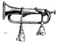
Calendar of Events
January 10 | ICWRT: Berdan’s Sharpshooters presented by Gerald Jones, ICWRT  Indiana Historical Society, 450 W. Ohio St., Indianapolis. IN 7:30 PM  http://indianapoliscwrt.org
January 16 | Randolph County CWRT: Sibley’s New Mexico Campaign, Part II by Phil DeHaven  Randolph County Historical Society Museum, 416 South Meridian Street Winchester, IN
January 19 | Carmel CWRT: The Battle of Pea Ridge presented by Norris Darrall  Carmel/Clay Historical Society, Old Monon Depot, 211 First Street, S.W., Carmel, IN 7:30 PM
January 25 | CWRT of West Central Indiana: Joseph Hooker, presented by Jim Goecker  F. W. Olin Biological Sciences Building, Depauw University campus, Greencastle, IN 7:30 PM  http://www.rose-hulman.edu/civilwar
January 28-30 | 4th Annual Civil War Civilian Conference  Crystal Lake, Illinois. Registration: $125 before Jan. 7; $140 thereafter.  Sponsored by the Midwest Civil War Civilian Education, Inc.  Contact: Marta Vincent (847) 683-0071, email: midwestcivilian@aol.com

We recommend confirming all dates, times and locations for events not sponsored by the ICWRT
If you know of a Civil War-related event that may be of interest to ICWRT members, please send your information to Norris Darrall (norrisdarrall@hotmail.com).

A New Civil War Magazine Makes Its Debut

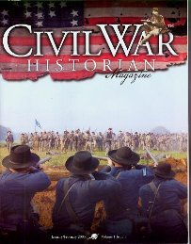
This month marks the debut of a new magazine that may be of interest to many Round Table members. Judging from its premier issue, Civil War Historian will be a welcome addition to the somewhat staid field of Civil War ephemera. In contrast to more mainstream periodicals which focus on battles and personalities of the conflict, Civil War Historian addresses topics that will appeal primarily to those in the reenacting community, both military and civilian, who explore the social as well as martial aspects of the era through “living history.”

The articles featured in Issue No. 1 include: “Hints to Campaigners” (excerpts from a Civil War era journal); “Fresh from the Garden: A Retrospective of 1860s Heirloom Fruit and Vegetable Varieties”; and “Outdoor Cooking in Antebellum America.” The January-February 2005 issue also contains articles on the battlefield preservation efforts at Chancellorsville; the Victorian art of letter writing; period fashions; and a visit to the Motts Military Museum. Two critiques/reviews of 2004’s “mega-reenactment” at Franklin, Tennessee, are also included.

Civil War Historian is not the first magazine to be published for reenactors. It does, however, combine the professional look of a large circulation “newsstand” magazine (including full color printing on glossy paper) with an editorial staff that is actively engaged and well-respected in the hobby. With the Camp Chase Gazette—the once-proclaimed “Voice of Civil War Reenacting”—now under new ownership and moving in a less progressive editorial direction, Civil War Historian provides serious living historians with a fresh source for well-researched and informative articles in a first-rate presentation.

Civil War Historian will be published six times a year; annual subscriptions are $28. For more information, contact their Circulation Dept.: P.O. Box 500, Missouri, TX 77459; Phone (888) 760-8108; or visit their website: http://www.civilwarhistorian.com.


50th Anniversary Desk Caddies Still Available!

Don’t miss out on your chance to buy a 50th Anniversary commemorative desk caddy. The black leatherette caddies, which contain a notepad and compartments for pens and other desktop miscellanea, feature the Soldiers and Sailors Monument and “Indianapolis Civil War Round Table / 50th Year 1955-2005” imprinted in gold on the cover. Each of our speakers this year will be receiving one of these caddies as a gift. The desk caddies are available to members on a first-come, first-served basis, and will be available for purchase at the January meeting. The cost is $20 each.

Trimble’s Trivia

1. Who was the youngest of the 1,367 officers to receive the rank of brevet general?

2. What do Generals William H. Powell and Joshua T. Owen have in common?

3. What major battle spanned two different years?

4. Name the two Union generals killed at Perryville.

5. Which states are represented on the seven-star Confederate Flag of 1861?

---Answers will be published in the February issue---

Answers to December’s “Nickname” Quiz:

1. “Kill Cavalry”: Hugh Judson Kilpatrick

2. “Dick” (3 Confederate officers):
Generals Richard Anderson, Richard Ewell and Richard Taylor
(extra credit: Gen. Richard Garnett)
3. “Little Billy”: William H. Whiting

4. “French Mary”: Marie Tebe, Union Viviandiere

5. “Parson”: William Brownlow, editor, Knoxville Whig

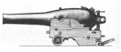

University of Virginia Offers Lecture & Tour Series

The University of Virginia is offering two outstanding Civil War study series for 2005. Part of UVA’s “On the Road” series, a four-day program addressing “Great Battles and Turning Leading Civil War” will be held in Charleston, South Carolina, March 9-12, 2005, at the historic Mills House Hotel. Leading Civil War author-scholars Gary W. Gallagher and James M. McPherson will lead the conference, which includes lectures by both professors as well as tours of Fort Sumter and the C.S.S. Hunley exhibit. Although rather pricey (the full program fee with double lodging is $2395), this program offers the chance to combine a private seminar taught by two highly respected Civil War historians with a pleasant visit to one of the great old cities of the South.

UVA’s Seventh Annual Civil War Conference Series will be held in Richmond, Virginia, May 25-29, 2005, and will focus on “The Campaign and Battle of Spotsylvania.” Faculty for this series includes Gary Gallagher, Robert K. Krick, former ICWRT member/presenter Peter Carmichael and several other noted historians and authors. This series combines classroom lectures with extensive battlefield touring, including sites seldom visited by, and often unknown to, the general public. As a participant in a previous program on the 1862 Valley Campaign, your editor can personally attest to the outstanding quality of this series, and one can expect the same at this conference. The program fee is a much more reasonable $745 (which includes a double room on-site at the University of Richmond). This program is extremely popular, with many repeat attendees, and usually fills up quickly. Early registration, which opens January 5th for new participants, is strongly recommended.

To register for either of these programs, call (800) 346-3882 or (434) 982-5252. For more information, visit www.uvaTravelLearn.org (for the March program in Charleston) or www.uvaCivilWar.org (for the May program in Richmond), or send an email to: uvaseminars@virginia.edu.

From the Bookshelf
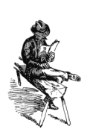
The Civil War Art and Scholarship of Don Troiani

This month’s HARDTACK cover features the artwork of acclaimed Civil War artist Don Troiani. Among the many contemporary artists working today in the field of Civil War art, none surpass Mr. Troiani in terms of pure artistic talent, concern for historical accuracy and attention to detail. Limited edition prints of Troiani paintings are highly prized and widely collected (original issue prints are available through Historical Art Prints, www.historicalartprints.com; there is also an active secondary market for Troiani prints, which are advertised by many dealers in Civil War collectibles and, of course, on ebay).

Mr. Troiani’s work frequently graces the covers of Civil War books and periodicals, and he has graciously permitted HARDTACK to reproduce in this issue his rendering of a Berdan’s Sharpshooter as he would have appeared in action in Virginia, circa late 1862.

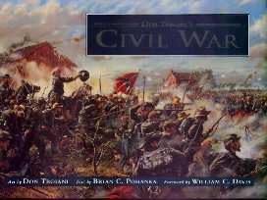
An avid historian and collector as well as a prolific painter, Don Troiani has collaborated on three books which feature his Civil War artwork. All of them warrant shelf space in any Civil War library.

The aptly titled Don Troiani’s Civil War (Stackpole Books 1995) reproduces many of the artist’s best known works, including the dramatic Barksdale’s Charge at Gettysburg, which is featured on the cover. Organized chronologically and covering the four-year span of the War, Troiani’s art is accompanied in this volume by Brian Pohanka’s narrative description of the illustrated scenes and soldiers. A wonderful book that would have benefited from an “oversize” format.

Although not strictly Civil War-related, Don Troiani’s Soldiers in America 1754-1865 (Stackpole Books 1998) features a number of the artist’s Civil War battle scenes and full-length studies of soldiers not found in his earlier volume. This large book also features many photographs (regrettably, not in color) of some of the uniforms, accoutrements and weapons that served as reference artifacts for Troiani, together with an authoritative text by Earl J. Coates and James L. Kochan.

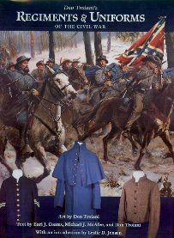
Don Troiani’s Regiments & Uniforms of the Civil War (Stackpole Books 2002) follows, and improves upon, the format of his preceding book. In this volume, the artifacts are photographically reproduced in full color together with Troiani’s artwork depicting both distinctive unit uniforms and those of veteran soldiers on campaign. The well-researched text, including source references, is provided by Earl J. Coates, Michael J. McAfee and Troiani himself.

Each of these Troiani books, by the way, features artwork depicting Berdan’s Sharpshooters, accompanied by valuable information regarding their uniform and equipment.

Set Your Sights On Berdan’s Sharpshooters

Looking for something more to read on Hiram Berdan and his storied Sharpshooters?
Here are some titles you may want to target:
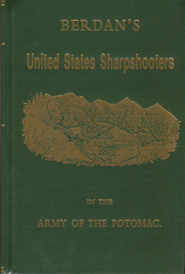
Berdan’s United States Sharpshooters in the Army of the Potomac
by Capt. C.A. Stevens (Morningside Books reprint eds); 597 pp., illus., cloth

A new reprint edition is now available from Morningside of this
important history by a former officer of the 1st U.S. Sharpshooters,
first published in 1892. Handsomely bound in green cloth
(shown at right).

Sharpshooter: Hiram Berdan, His Famous Sharpshooters and
their Sharps Rifles
by Wiley Sword (Andrew Mowbray Pub. 1988); 288 pp.

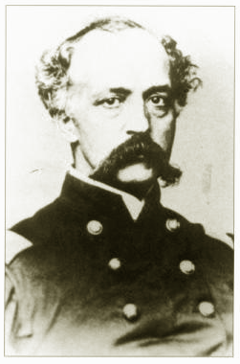

Civil War Chief of Sharpshooters Hiram Berdan:
Military Commander and Firearms Inventor
by Roy M. Marcot (Northwood Heritage Press 1989); 342 pp.

Letters from a Sharpshooter: The Civil War Letters of
William B. Greene, Co. G, 2nd United States Sharpshooters (Berdan’s) Army of the Potomac 1861-1865
by William H. Hastings (Historic Publications 1994); 329 pp.

The Best the Union Could Muster: The True Story of
Berdan’s U.S. Sharpshooters at the Battle of Gettysburg
by Michael L. Fahle (Greencoat Productions 1998)

Col. Hiram Berdan

for an illustrated primer on sharpshooters on both sides of the lines:

Sharpshooters of the American Civil War 1861-65
(Osprey Warrior Series, No. 60)
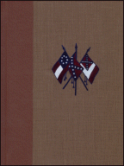
by Philip Katcher, illustrated by Stephen Walsh
(Osprey Publishing 2002); 64 pp.; softcover

…and for more on the sharpshooters of the South:

Lee’s Sharpshooters
by Major W.S. Dunlop
(Morningside Books reprint eds.); 499 pp.; decorative hardcover (shown)
(Digital Scanning 2001; reprint ed.); 496 pp.; hardcover

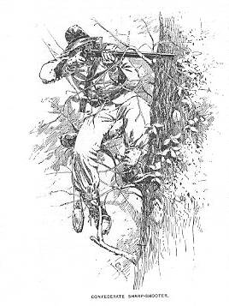

HARDTACK, the newsletter of The Indianapolis Civil War Round Table, is published monthly, September through June, each year. In addition to information about upcoming programs, HARDTACK features articles, news, reviews and a calendar of Civil War-related events. HARDTACK is distributed by mail or email to all ICWRT members.

If you have a short article, book review or some other item that may be of interest to our members, we invite you to submit it for consideration. Please send your material via email to the editor at: HardtackEditor@comcast.net. Please include a telephone number and email address where we may contact you.

Visit the website of The Indianapolis Civil War Round Table: http://indianapoliscwrt.org/

