HARDTACK

The Newsletter of the Indianapolis Civil War Round Table

Celebrating Our 50th Anniversary

February 2005

Monday, February 14, 2005 7:30 PM at the Indiana War Memorial
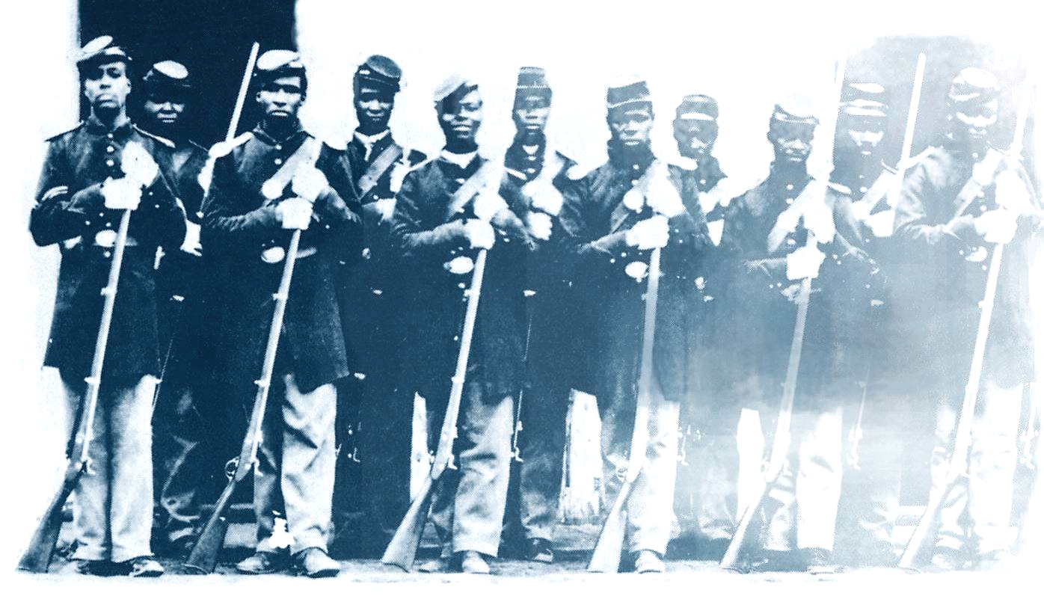
Black Civil War Soldiers:

almost invisible

presented by
Richard S. Skidmore

How can it be? – Nearly 180,000 African Americans served in the Union Army’s “colored” regiments -- and yet we know so little about them. Black soldiers fought in 39 major battles, 17 were awarded the Medal of Honor, and 39,300 died in the War. Yet, the exploits, courage and emotions of these American soldiers are seldom revealed.

“Black Civil War Soldiers: Almost Invisible” will trace the experiences of three soldiers. Each had been a slave, each struggled in the culture of the time, and each proudly served his country. One, Osberry Alums from Hanover, Indiana, was killed in a dramatic Civil War battle. Another, Benjamin Mills, was wounded and lived out his life in Louisville. The third, Corporal John Forson, came home to farm and is buried in the old Graysville area, north of Hanover.

As the title of our program suggests, the story of Black soldiers in our Civil War has been hidden from view. This longtime gap in our history will be explained, as will the laws and customs of the 19th century. The 55-slide program presented by Dick Skidmore will give a small voice to the contribution of Black soldiers, three in particular.

About our Speaker: A native Hoosier and graduate of Indiana State University, Dick Skidmore retired from IBM in 1987. He has published two Civil War books and has written several items on Indiana soldiers in the Civil War, including the “Civil War” entry in The Encyclopedia of Indianapolis. Dick successfully coordinated the conservation of 160 military oil portraits at the Indiana Veterans’ Home. He also helped organize the recently implemented John Hunt Morgan Heritage Trail in southeastern Indiana. In 1996, Dick was named a Hoosier Historian by the Indiana Historical Society in recognition of his contributions to that group. He is a past-president of the ICWRT. Dick and his wife, Wilda, live in Hanover.

ICWRT Meeting:

The Indianapolis Civil War Round Table
2004-2005 Campaign

Officers:
President: Anthony Roscetti
Vice President: Ray Shortridge
Secretary: Dr. Betty Enloe
Treasurer: Doug Wagner

Committee Chairs:
Programs: Ray Shortridge rayshortridge@netscape.net

Publicity: Norris Darrall norrisdarrall@hotmail.com
Preservation: Andy O’Donnell odar1@aol.com
HARDTACK Newsletter:
Editor: Dave Klinestiver HardtackEditor@comcast.net
Distribution:
Dorothy Jones joejones@iquest.net
Peg Bertelli pbbertelli@insightbb.com

February 14, 2005, at 7:30 P.M.
at the
Indiana War Memorial Auditorium
Indianapolis, Indiana
PLEASE NOTE THE LOCATION !!
Due to a scheduling conflict with the IHS, our meeting this month will be held at the Indiana War Memorial
_____________________________
Join Us Before the Meeting at Shapiro’s Deli!
All ICWRT members and guests are invited to join us at Shapiro’s Delicatessen before the meeting to enjoy dinner and fellowship. This year, we will be holding informal “round table” discussions on a selected topic of general interest. See you at Shapiro’s, 808 S. Meridian St. (just south of McCarty St.) beginning at 5:30 P.M.
_______________________________________________________

The Indianapolis Civil War Round Table gratefully acknowledges the co-sponsorship of
The Indiana War Memorial
for our Speakers Program during the 2004-2005 Campaign

In this issue of HARDTACK: Page
Feb. 2005 Meeting: Black Civil War Soldiers / Dick Skidmore.…….....1-2
ICWRT News…………………………………………………………………...3
Annual Field Trip: “On To Richmond”…………………………………....3
Upcoming ICWRT Programs ………………………..…….……….……….4
Calendar of Events…..……………………..………………….…………..... 4
Trimble’s Trivia by Quizmeister Tony Trimble……………………..…….. 5
From the Bookshelf: Books on Black Soldiers…………………......6-10
Member Survey………………………………………………………Endsheet

ICWRT News

At the January meeting, President Tony Roscetti announced that the Indianapolis Civil War Round Table will make a matching contribution on all cash donations to the Civil War Preservation Trust (CWPT) by our members at the June meeting. All donations to the CWPT submitted through the Round Table will be matched dollar-for-dollar, up to a total of $5,000.00. The CWPT is a non-profit organization dedicated to Civil War battlefield preservation.

Members’ contributions, together with the Round Table’s matching gift, will be presented to the CWPT at our annual banquet meeting in June. CWPT representatives Dave Duncan and Jim Lighthizer will be our featured guests at the banquet (the location of which will be announced at a later date). Anyone wishing to make a contribution to the CWPT at to the June meeting should contact Andy O’Donnell or Ray Shortridge.

President Roscetti also announced the appointment of Nikki Schofield, Steve Hill and Tom Krasean to serve as the Round Table’s three-member nominating committee. The committee is charged with selecting a slate of candidates to serve as ICWRT officers for the 2005-2006 campaign. The slate of nominees will be presented to the membership at the February meeting.

Annual Field Trip

“On To Richmond” Set for June 18-24!!

“On To Richmond” is the name of this year’s ICWRT summer field trip, which will take place June 18-24, 2005. Trip organizer Nikki Schofield has announced that participants will depart Indianapolis on Saturday, June 18, stay in Lexington, Virginia, the first night, and then spend four nights in Richmond, Virginia. Plans include visits to Tredegar Iron Works, the Museum of the Confederacy, the White House of the Confederacy, Hollywood Cemetery, as well as other places of interest in the capital of the Confederate States of America. The group will spend Thursday night in Lexington, Kentucky, arriving home on Friday, June 24.

If you have not been on one of our annual bus trips, please let Nikki know you are interested. For those who have attended in the past, you will receive information in the mail. Contact Nikki at: 317-328-8782.

Have you turned in your Survey?

If you have not yet turned in a completed Member Survey, please take a few minutes to answer the questions on the form accompanying this issue of HARDTACK. You may turn in your completed Survey form at the February meeting, or you may mail or email your responses using this same form. The Survey is intended to help us better understand the interests of our members. The information you provide will not be disclosed to anyone outside our organization.

Upcoming ICWRT Programs

All of the following meeting dates are the second Monday of the month.

February 14, 2005 Black Civil War Soldiers Dick Skidmore, Past-President, ICWRT
** PLEASE NOTE: February’s Meeting will be held at the Indiana War Memorial Auditorium **
March 14, 2005 Indiana Regimental Photographs Dave Buchanan, Col. Lilly Civil War Museum
April 11, 2005 Draft Riots Iver Bernstein, Washington University
May 9, 2005 Topic to be Announced Mark Neely, Penn State University
June 13, 2005 Annual Banquet/ Battlefield Dave Duncan and Jim Lighthizer, CWPT
Preservation Update & Fundraiser

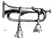
Calendar of Events
January 26  thru  March 5 | “A Woman Called Truth”: a play about Sojourner Truth by Sandra Fenichel Asher  Indiana Repertory Theater (Upperstage) 140 West Washington Street, Indianapolis, IN; Ticket Office: (317) 635-5252  www.indianarep.com
February 14 | ICWRT: Black Civil War Soldiers presented by Dick Skidmore, ICWRT  Special Location: Indiana War Memorial Auditorium, Indianapolis, IN 7:30 PM  http://indianapoliscwrt.org
February 20 | Randolph County CWRT: The Confederate Chaplaincy presented by Jim Orr  Randolph County Historical Society Museum, 101 West Franklin Street, Winchester, IN 1:30 to 3:00 PM
February 21 | “Honoring Lincoln: Why We Remember Our 16th President” sponsored by  The Lincoln Group of Indiana and the Indianapolis Marion County Public Library; featured speaker: Hon. Andy Jacobs, Jr.  Glendale Branch Public Library (in the Glendale Shopping Mall)  6101 N. Keystone Avenue, Indianapolis, IN 6:30--Reception 7:00--Program  Contact: Angela Gilmer (317-253-8857) aeg123@sbcglobal.net
February 22 | CWRT of West Central Indiana: Civil War Music presented by Wes Hanson  Special Location: Greencastle Library, Greencastle, IN 7:30 PM  http://www.rose-hulman.edu/civilwar
February 26-27 | National Gun Day and Civil War Show  Fair and Expo Center, Louisville, KY  Contact: Ron Dickson (513-523-3574)

We recommend confirming all dates, times and locations for events not sponsored by the ICWRT

If you know of a Civil War-related event that may be of interest to ICWRT members, please send your information to Norris Darrall (norrisdarrall@hotmail.com) and HARDTACK (HardtackEditor@comcast.net).

Trimble’s Trivia

1. What is a “bog-trotter”?

2. What is a “hospital bullet”?

3. Presidential slang used by Union troops to describe hardtack.

4. What was “robbers’ row”?

5. Who or what was known as the “Provost Marshall”?

---Answers will be published in the March issue---

Answers to January’s Quiz:

1. Who was the youngest of the 1,367 officers to receive the rank of brevet general? Lewis T. Barney

2. What do Generals William H. Powell and Joshua T. Owen have in common? Only generals born in Wales

3. What major battle spanned two different years? Stones River

4. Name the two Union generals killed at Perryville. James S. Jackson; William R. Terrill

5. Which states are represented on the seven-star Confederate Flag of 1861? SC, MS, FL, AL, GA, LA, TX

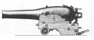

50th Anniversary Desk Caddies Still Available!

Don’t miss out on your chance to buy a 50th Anniversary commemorative desk caddy. The black leatherette caddies, which contain a notepad and compartments for pens and other desktop miscellanea, feature the Soldiers and Sailors Monument and “Indianapolis Civil War Round Table / 50th Year 1955-2005” imprinted in gold on the cover. Each of our speakers this year will be receiving one of these caddies as a gift. The desk caddies are available to members on a first-come, first-served basis, and will be available for purchase at the January meeting. The cost is $20 each.

From the Bookshelf
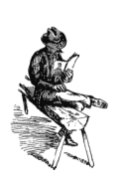
Lifting the Veil of Invisibility: Books on Black Soldiers

February is Black History Month and, appropriately, our February program looks at the experiences of three African American soldiers with ties to Indiana. As the program introduction points out, at least until very recently, writers have largely ignored the contribution of Black soldiers in the Civil War. Dudley Taylor Cornish’s The Sable Arm: Black Troops in the Union Army, 1861-1865, first published in 1956 (and still available from the University Press of Kansas), was one of the few authoritative studies to appear in the century following the War, and remained the leading reference on the subject for several decades thereafter.

In the past 10 to 15 years, however, a number of academic historians and writers have turned their attention to this important, and long neglected aspect of the War, and several excellent works are now in print. They are long overdue.

To help shine some light on the story of Black Americans in the Civil War, we provide below a list of recent titles that are deserving of your consideration. The accompanying descriptions are from published editorial reviews.

Like Men of War: Black Troops in the Civil War, 1862-1865
by Noah Andre Trudeau (Little Brown 1998) 548 pages (pb ed.: Back Bay Books 1999) 576 pages
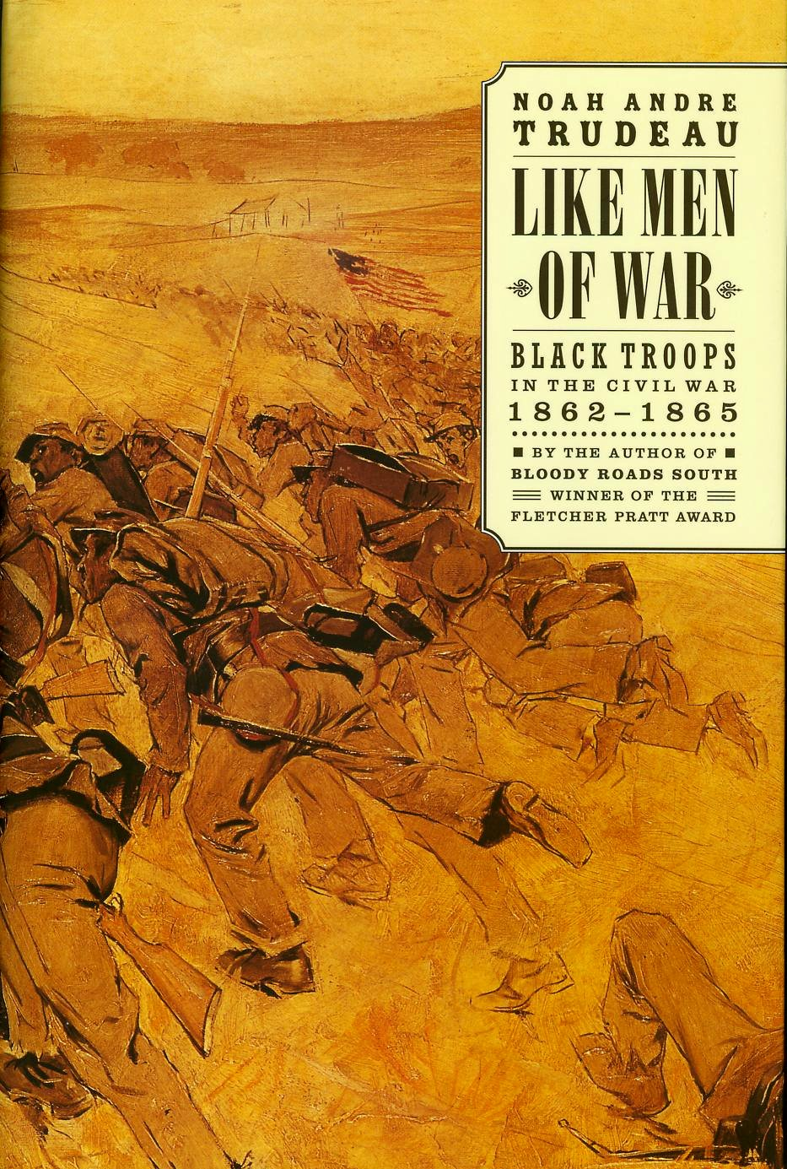
Using letters, diaries, service records, and other contemporary material, Noah Andre Trudeau tells the story of the brave black men who fought and died for their freedom in the Civil War. The tale begins in 1862, when many in the Union opposed recruiting blacks as soldiers. The story ends after Reconstruction, with their hopes for equality dashed, as Federal troops ceded control of the South to Southerners. In addition to photographs, Like Men of War includes 60 maps and accounts of many of the 449 engagements in which blacks fought.
Trudeau presents the fullest study of the battlefield experiences of black Union regiments. The many maps help the reader make sense of famous engagements (Fort Wagner and the Crater) and notorious incidents (Fort Pillow) in which black soldiers fought, as well as scores of lesser-known clashes. Rich archival research is integrated into a lively narrative that places the raising and deployment of black regiments in broader contexts.
Black Soldiers in Blue: African American Troops in the Civil War Era
by John David Smith (Univ. of North Carolina Press 2002) 464 pages
Inspired and informed by the latest research in African American, military, and social history, the fourteen original essays in this book tell the stories of the African American soldiers who fought for the Union cause. An introductory essay surveys the history of the U.S. Colored Troops (USCT) from emancipation to the end of the Civil War. Seven essays focus on the role of the USCT in combat, chronicling the contributions of African Americans who fought at Port Hudson, Milliken's Bend, Olustee, Fort Pillow, Petersburg, Saltville, and Nashville. Other essays explore the recruitment of black troops in the Mississippi Valley; the U.S. Colored Cavalry; the military leadership of Colonels Thomas Higginson, James Montgomery, and Robert Shaw; African American chaplain Henry McNeal Turner; the black troops who occupied postwar Charleston; and the experiences of USCT veterans in postwar North Carolina. Collectively, these essays probe the broad military, political, and social significance of black soldiers' armed service, enriching our understanding of the Civil War and African American life during and after the conflict.

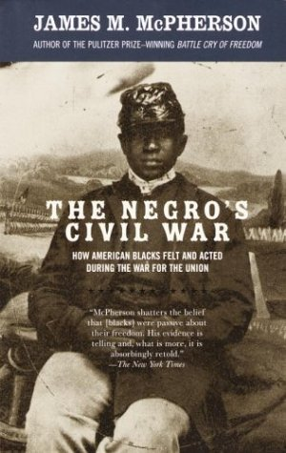
The Negro's Civil War: How American Blacks Felt and Acted During the War for the Union
by James M. McPherson (Vintage 2003) 400 pages
Pulitzer Prize-winning author James M. McPherson deftly narrates the experience of blacks--former slaves and soldiers, preachers, visionaries, doctors, intellectuals, and common people--during the Civil War. Drawing on contemporary journalism, speeches, books, and letters, he presents an eclectic chronicle of their fears and hopes as well as their essential contributions to their own freedom.

Through the words of these extraordinary participants, both Northern and Southern, McPherson captures African-American responses to emancipation, the shifting attitudes toward Lincoln and the life of black soldiers in the Union army. Above all, we are allowed to witness the dreams of a disenfranchised people eager to embrace the rights and the equality offered to them, finally, as citizens.

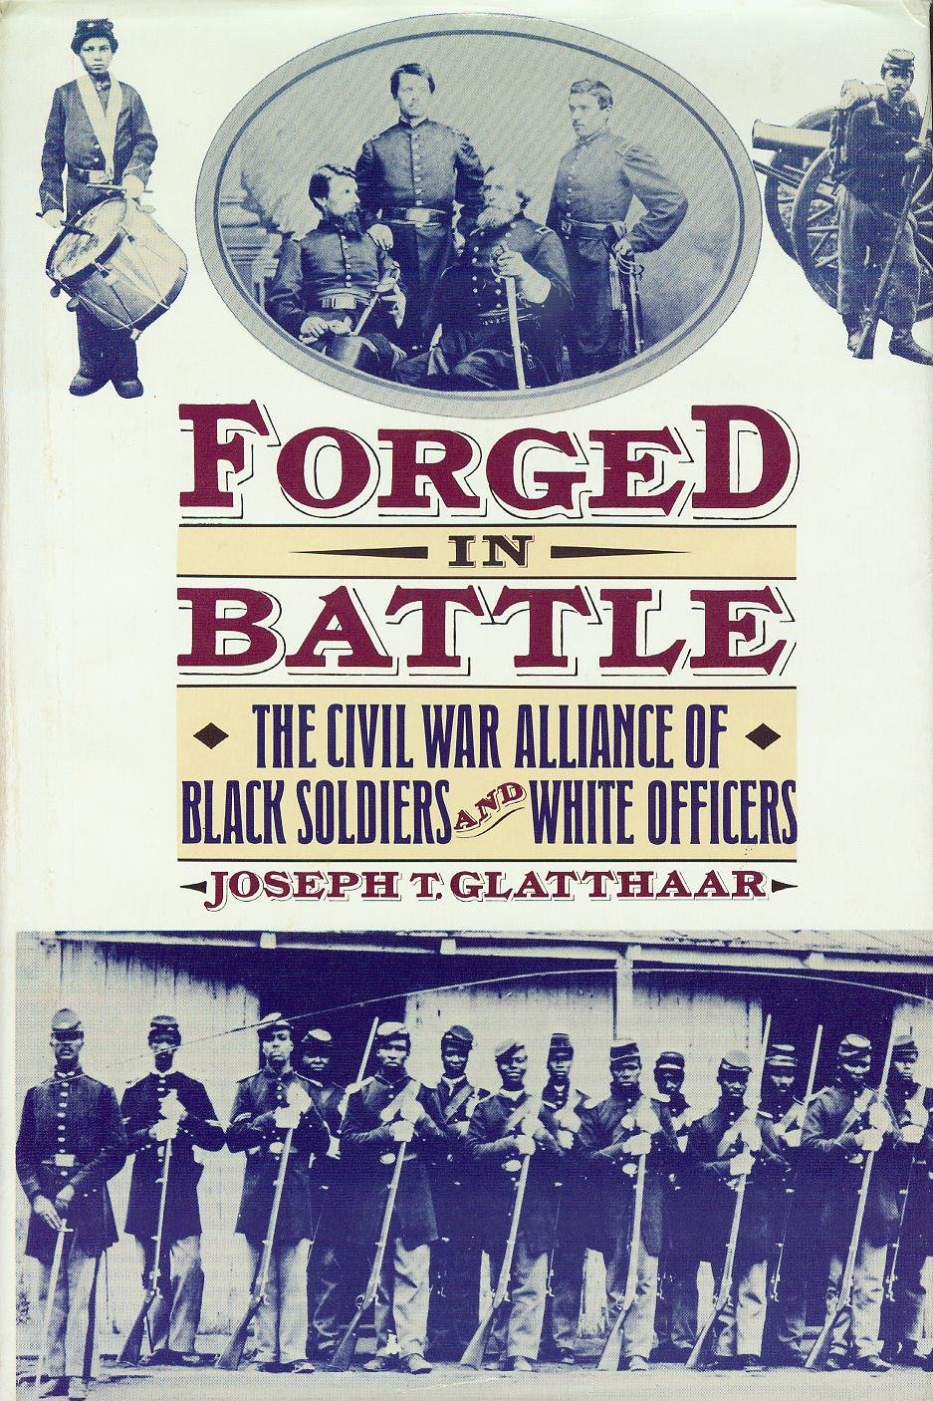
Forged in Battle: The Civil War Alliance of Black Soldiers and White Officers
by Joseph T. Glatthaar (Free Press 1989) 370 pages
Joseph Glatthaar’s study of rank and race relations in the Union Army was one of the first studies to emerge from academia recent years.
Drawing on personal letters and official documents, Glatthaar explores the uneasy alliance between black soldiers and white officers who were divided by racial tension and ideology but united by the trials and bonds of the war they fought side by side.
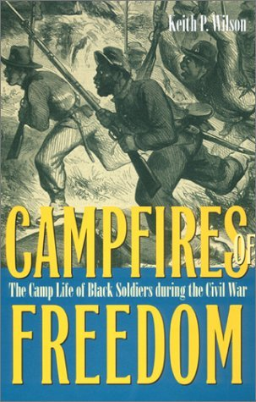
Professor Glatthaar’s book includes extensive notes, appendices and bibliography, as well as numerous photos and illustrations from the period.

Campfires of Freedom: The Camp Life of Black Soldiers During the Civil War
by Keith P. Wilson (Kent State Univ. Press 2002) 336 pages

Monash University (Australia) history professor Keith P. Wilson outlines three broad purposes in writing his book on the camp life of the American Civil War's United States Colored Troops (USCT): “to describe the soldiers’ lives...to bring into focus the emotional texture of military life...[and] to analyze the process of cultural change that occurred within the army camps.” Why camp life? As Wilson states it, camp life helped the African-American, “divided from the mainstream of American cultural life,” to “bridge this divide, and to negotiate the changes necessary to meet the demands of army life...to reconfigure race relations and give black people a new definition...to challenge existing notions of race and relationship.” Wilson does not explore the troops’ experiences in combat; he knows other studies cover that issue (see Noah Andre Trudeau’s Like Men of War). To say this work is well researched would be a bit of an understatement. The book contains eighty-five pages of worthwhile endnotes.
A Grand Army of Black Men : Letters from African-American Soldiers in the Union Army 1861-1865
ed. by Edwin S. Redkey, Albert Gelpi and Ross Posnock (Cambridge Univ. Press 1992) 322 pages
Although most of the nearly 200,000 African-American who served in the Union Army were illiterate ex-slaves, several thousand were well educated, free black men from the northern states. The 129 letters in this collection were written by black soldiers in the Union army during the Civil War to black and abolitionist newspapers. They provide a unique expression of the black voice that was meant for a public forum. The letters tell of the men's experiences, their fears, and their hopes. They describe in detail their army days--the excitement of combat and the drudgery of digging trenches. Some letters give vivid descriptions of battle; others protest racism; still others call eloquently for civil rights. Many describe their conviction that they are fighting not only to free the slaves but to earn equal rights as citizens. These letters give an extraordinary picture of the war and also reveal the bright expectations, hopes, and ultimately the demands that black soldiers had for the future--for themselves and for their race.

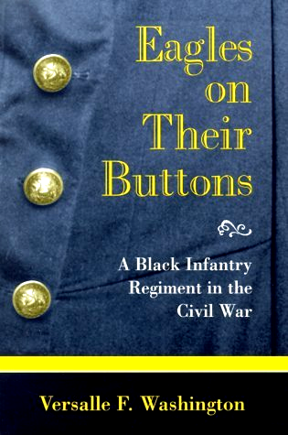
Eagles on Their Buttons: A Black Infantry Regiment in the Civil War (5th USCT)
by Versalle F. Washington (Univ. of Missouri Press 1999) 113 pages
A fascinating examination of the Fifth Regiment of Infantry, United States Colored Troops-the Union Army's first black regiment from Ohio. Although the Fifth USCT was one of more than 150 regiments of black troops making up more than 10 percent of the Union Army at the end of the war, it was unique. The men serving in the Fifth USCT were freemen who were raised in a northern state and saw serving in the army both as a way to gain equal rights under the law and as an opportunity to prove their worth as men.
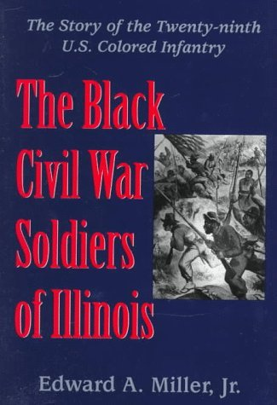
The Black Civil War Soldiers of Illinois: The Story of the Twenty-Ninth U.S. Colored Infantry
by Edward A. Miller, Jr. (Univ. of South Carolina Press 1998) 267 pages
This work is not simply a regimental history, but a deeper study in the lives of black recruits in the Civil War era. Miller has uncovered interesting and valuable demographic and socio-economic data. In addition, Miller explores the culture of the 29th’s white officers, men who were unduly pre-judged as incompetent by their fellow Union soldiers.
The 29th’s only substantial combat experience came at the ill-fated Battle of the Crater, where the employment of black regiments was unfairly blamed for battlefield failures. As such, many in the North wanted to place the responsibility for the disaster upon supposedly inferior black troops. However, Miller's historiography yields a saner assessment through a very detailed account of the battle.
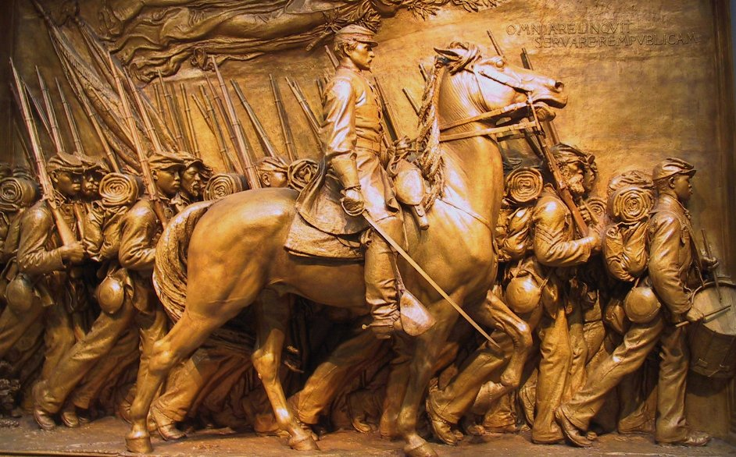
Hope and Glory: Essays on the Legacy of the 54th Massachusetts Regiment
by Martin Henry Blatt, Thomas J. Brown, Donald Yacovone (Univ. of Mass. Press 2000) 336 pages
This volume brings together the best new scholarship on the history of the 54th, the formation of collective memory and identity, and the ways Americans have responded to the story of the regiment and the Saint-Gaudens monument (pictured at right). Contributors use the historical record and popular remembrance of the 54th as a lens for examining race and community in the United States. The essays range in time from the mid-nineteenth century to the present and encompass history, literature, art, music, and popular culture.
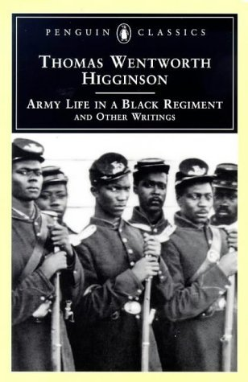
Army Life in a Black Regiment
by Thomas Wentworth Higginson (reprint of 1870 ed. by Time Life Books 1982) 296 pages;(pb. ed with “other writings” of author: Penguin Classics 1997) 368 pages
This is a remarkable book by a Harvard-educated Yankee abolitionist who served as Colonel of the 1st South Carolina Volunteers, a regiment composed primarily of freed slaves. Although the regiment saw limited action, Higginson’s diary-memoir illuminates the daily minutiae of life in a Black regiment and the injustices suffered by the Black population in the rural South. The book is a first-hand narrative of war by an idealist sorely tested by politics and physical hardship.
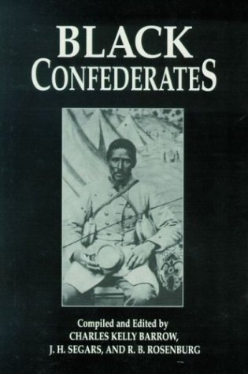
Black Confederates
by Charles Barrow, J. H. Segars, R. B. Rosenburg (Pelican Publishing 2002) 208 pages
Black Confederates is a scholarly analysis of historical evidence of those black Americans who served the Confederacy during the Civil War. Correspondence, military records, preserved narratives and newspaper accounts present as clear a picture as possible of some seemingly self-contradictory people. Why did they fight, and in some cases, lose their lives for the South in a conflict fought to perpetuate the institution of slavery? This question is carefully scrutinized in a historical work that challenges commonly held precepts and brings to light an oft-overlooked side of America's deadliest war.

NEXT MONTH: In Search of the “Real” Lincoln

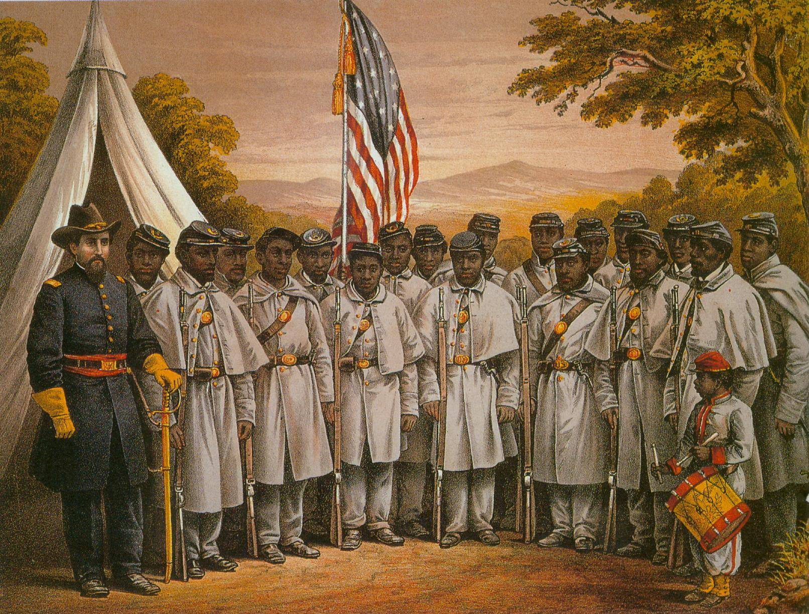

HARDTACK, the newsletter of The Indianapolis Civil War Round Table, is published monthly, September through June, each year. In addition to information about upcoming programs, HARDTACK features articles, news, reviews and a calendar of Civil War-related events. HARDTACK is distributed by mail or email to all ICWRT members.

If you have a short article, book review or some other item that may be of interest to our members, we invite you to submit it for consideration. Please send your material via email to the editor at: HardtackEditor@comcast.net. Please include a telephone number and email address where we may contact you.

Visit the website of The Indianapolis Civil War Round Table: http://indianapoliscwrt.org/

Indianapolis Civil War Round Table

Member Survey

In order to better understand the background, interests, and experience of our membership, the following survey has been created. Please respond to as many questions as possible. Among other uses, this survey will be a resource for scheduling future speakers at ICWRT meetings.
Upon completion, please return the completed form to Tony Roscetti at: 6270 Brixton Lane, Indianapolis, IN 46220, or simply bring it to one of our monthly meetings.

Name:
Age: Gender:
Years as a member of the ICWRT: Regularly attend meetings (Y/N):
Birthplace:
Civil War ancestors (Y/N):
ICWRT officer or position (Y/N):
If so, what office or position and when:

How first got interested in the Civil War:

Member of other Civil War-related groups (i.e. SUVCW, SCV, other round tables, etc):

Civil War interests (i.e. battles, leaders, politics, technology, common soldiers, unit histories, etc.):

Civil War-related activities (i.e. reenacting, NSSA, preservation, collecting, visiting museums and battlefields, etc.):

Comments:

