HARDTACK

The Newsletter of the Indianapolis Civil War Round Table

Celebrating Our 50th Anniversary

December 2004

Our Next Meeting: Monday, December 13, at 7:30 P. M.
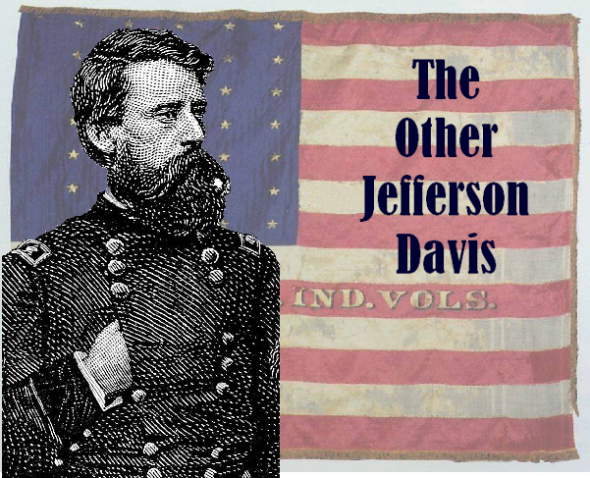
Indiana’s General Jefferson C. Davis
Presented by Gordon D. Whitney
Beyond the name he shared with the Confederate president, Union General Jefferson Columbus Davis (1828-1879) is perhaps best remembered for shooting down his former commanding officer, General William “Bull” Nelson, in the lobby of Louisville’s Galt House in September 1862. Although some claimed the killing was nothing short of cold-blooded murder, Davis was never tried for the homicide and, with the help of politically influential friends such as Indiana Governor Oliver P. Morton, Davis was restored to duty shortly thereafter. A former Regular Army officer who was present at the bombardment of Fort Sumter, Davis served as colonel of the 22nd Indiana until his promotion to brigadier general of volunteers in December 1861. Davis commanded a division at the battle of Pea Ridge and, following the Nelson incident, went on to distinguish himself at Stones River and Chickamauga as well as in the Atlanta campaign, Sherman’s March to the Sea (where he commanded the XIV Corps) and the Carolina campaign. A native of Clark County, Davis served as colonel of the 23rd Indiana after the War. He is buried in Crown Hill Cemetery, near his wife’s home.

About Our Speaker: Gordon D. Whitney is past president of the Chicago and Louisville Civil War Round Tables. He is co-author (with Nathaniel Cheairs Hughs, Jr.) of Jefferson Davis In Blue: The Life of Sherman’s Relentless Warrior (LSU 2002). A retired firefighter, Mr. Whitney lives in Madison, Indiana.


The Indianapolis Civil War Round Table
2004-2005 Campaign

Officers:
President: Anthony Roscetti
Vice President: Ray Shortridge
Secretary: Dr. Betty Enloe
Treasurer: Doug Wagner

Committee Chairs:
Programs: Ray Shortridge rayshortridge@netscape.net

Publicity: Norris Darrall norrisdarrall@hotmail.com
Preservation: Andy O’Donnell odar1@aol.com
HARDTACK Newsletter:
Editor: Dave Klinestiver HardtackEditor@comcast.net
Distribution:
Dorothy Jones joejones@iquest.net
Peg Bertelli pbbertelli@insightbb.com


ICWRT Meeting December 13, 2004, at 7:30 P.M.
at the
Indiana Historical Society Auditorium
450 West Ohio Street, Indianapolis, Indiana
_______________________________
Join Us Before the Meeting for Dinner & Discussion at Shapiro’s Deli!
All ICWRT members and guests are invited to join us at Shapiro’s Delicatessen before the meeting to enjoy dinner and fellowship. This year, we will be holding informal “round table” discussions on a selected topic of general interest. See you at Shapiro’s, 808 S. Meridian St. (just south of McCarty St.) beginning at 5:30 P.M.
_______________________________________________________

The Indianapolis Civil War Round Table gratefully acknowledges the co-sponsorship of
The Indiana War Memorial
for our Speakers Program during the 2004-2005 Campaign

In this issue of HARDTACK: Page
Dec. 2004 Meeting: Gen. Jefferson C. Davis / Gordon Whitney.……..1-2
ICWRT News: Dick Skidmore recognized by UDC………………………3
Upcoming ICWRT Programs ………………………..…….……….………3
Calendar of Events…..……………………..………………….………….... 4
Trimble’s Trivia by Quizmeister Tony Trimble………………………….. 5
Kentucky Civil War Heritage Trail 2005……………………………..…. 5-6
Collector Notes: A rare Booth letter; Confederate cannonballs…..….6-7
End Page …..…………………………………………………………….….. 8
Reporters and Contributors to this Issue:
Norris Darrall, Ray Shortridge, Tony Trimble and Dave Sutherland

ICWRT News

Dick Skidmore receives UDC Award for Morgan Heritage Trail Project
ICWRT member and former president Richard S. Skidmore has been awarded the Jefferson Davis Historical Gold Medal Certificate by the United Daughters of the Confederacy for his work with the John Hunt Morgan Heritage Trail Project.

Dick was instrumental in organizing a committee comprised of Civil War historians and southern Indiana community leaders that launched the Morgan Heritage Trail Project in 1996. With a goal of “identifying, interpreting and promoting the July 1863 Raid (‘The Great Raid’) of Confederate General John Hunt Morgan through southeastern Indiana,” the Project has produced several products including a 56-page Guide Book on the Raid, brochures featuring driving tours and maps, a student guide, and audio recordings featuring first-person accounts and period music. The Project also maintains an informative website at http://hhhills.org/jhmht. The Project received financial support from a number of public and private sources, including the Civil War Preservation Trust.

Raised in Speedway, Indiana, Dick Skidmore is a graduate of Indiana State University and is retired from IBM. He and his wife, Wilda, live in Hanover. In addition to the ICWRT, Dick has served as president of three other Round Tables over the years. He has published two books and has written several articles on Indiana Civil War history, including the "Civil War" entry for The Encyclopedia of Indianapolis. Dick also successfully coordinated the restoration of 160 military oil portraits at the Indiana Veterans’ Home. In 1996, he was named a Hoosier Historian by the Indiana Historical Society.

Congratulations to Dick for this recognition of one of his many contributions to Indiana’s Civil War heritage.

Get Your 50th Anniversary Desk Caddy!

Don’t forget to pick up a 50th Anniversary commemorative desk caddy at the December meeting. The black leatherette caddies, which contain a notepad and compartments for pens and other desktop miscellanea, feature the Soldiers and Sailors Monument and “Indianapolis Civil War Round Table / 50th Year 1955-2005” imprinted in gold on the cover. Each of our speakers this year will be receiving one of these caddies as a gift. The desk caddies are available to members on a first-come, first-served basis. The cost is $20 each.

Upcoming ICWRT Programs

All of the following meeting dates are the second Monday of the month.

December 13, 2004 Indiana’s Gen. Jefferson C. Davis Gordon Whitney, Author
January 10, 2005 Berdan’s Sharpshooters Gerald Jones, ICWRT
February 14, 2005 Black Civil War Soldiers Dick Skidmore, Past-President, ICWRT
March 14, 2005 Indiana Regimental Photographs Dave Buchanan, Col. Lilly Civil War Museum
April 11, 2005 Draft Riots Iver Bernstein, Washington University
May 9, 2005 Topic to be Announced Mark Neely, Penn State University
June 13, 2005 Annual Banquet/ Battlefield Dave Duncan and Jim Lighthizer, CWPT
Preservation Update & Fundraiser

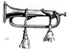
Calendar of Events
December | Carmel CWRT Carmel, IN  Madison County Historical Society CWRT Anderson, IN  Randolph County CWRT Winchester, IN  *** NO MEETINGS IN DECEMBER ***
December 4-5 | 18th Middle Tennessee Civil War Show & Sale  Largest Civil War show in the U.S.; over 900 tables  Tennessee State Fairgrounds, Nashville, TN Sat 9-5, Sun 9-3:30  www.mikekentshows.com
December 13 | ICWRT: Indiana’s General Jefferson C. Davis presented by Gordon D. Whitney  Indiana Historical Society, 450 W. Ohio St., Indianapolis. IN 7:30 PM  http://indianapoliscwrt.org
December 21 | CWRT of West Central Indiana  Greencastle Public Library, Greencastle, IN 6:30 PM  Program will be a wrap up of our membership's Civil War year - come ready to share your favorite trip or site visit, book review or overall best Civil War memory of 2004
January 16 | Randolph County CWRT: Sibley’s New Mexico Campaign, Part II by Phil DeHaven  Randolph County Historical Society Museum, 416 South Meridian Street Winchester, IN
January 19 | Carmel CWRT: The Gallant 14th Indiana presented by Nancy Niblack Baxter  Carmel/Clay Historical Society, Old Monon Depot, 211 First Street, S.W., Carmel, IN 7:30 PM
January 28-30 | 4th Annual Civil War Civilian Conference  Crystal Lake, Illinois. Registration: $125 before Jan. 7; $140 thereafter.  Sponsored by the Midwest Civil War Civilian Education, Inc.  Contact: Marta Vincent (847) 683-0071, email: midwestcivilian@aol.com

We recommend confirming all dates, times and locations for events not sponsored by the ICWRT
If you know of a Civil War-related event that may be of interest to ICWRT members, please send your information to Norris Darrall (norrisdarrall@hotmail.com).

Trimble’s Trivia

Quizmeister Tony Trimble presents his annual nickname quiz. Name the Civil War figure(s) associated with each of the following nom de guerre:

1. “Kill Cavalry”

2. “Dick” (3 Confederate officers)

3. “Little Billy”

4. “French Mary”

5. “Parson”

---Answers will be published in the January issue---

Answers to November’s Quiz:

1. Name the general described by Lee as, “one to whom North Carolina owes a debt she
can never repay.” James G. Martin

2. Douglas Southall Freeman wrote of this commander that had he not been killed at Fraser’s Farm, he “almost certainly would have risen to the rank of general officer.” Charles C. Lee

3. What was “Fort Skedaddle”? A Confederate earthwork overlooking Washington

4. Name the POW camp named for the State Treasurer of Illinois. Camp Butler for William Butler

5. What was “Long Tom? A huge Whitworth rifled cannon

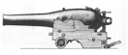

Kentucky Civil War Sites Again Offering Summer Tours
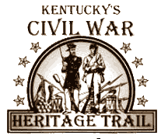
Because of the success of this summer’s Central Kentucky Civil War Heritage Trail, Kentucky’s Civil War sites are again teaming up to present a full week of activities. To be held July 18-24, 2005, the event has been expanded to offer even more opportunities for families, casual visitors, and Civil War enthusiasts alike.
Activities will begin on Monday, July 18, at Perryville, the site of Kentucky’s largest Civil War battle. Speakers and living historians will be on hand to discuss the Civil War in Kentucky, the Battle of Perryville, and to offer battlefield tours. A reception to officially welcome visitors will begin the week’s activities.
The event will continue on Tuesday, July 19, at Mill Springs, which will include a comprehensive immersion tour of this important battleground. Wednesday (July 20) events will take place at Camp Wildcat, the site of a crucial Union victory, and Thursday (July 21) activities will be shared by Richmond and Winchester. Richmond will interpret their battle, which was an overwhelming Confederate victory, while Winchester will host a grand opening and dedication of their Civil War Heritage Park.
Camp Nelson will welcome visitors on Friday, July 22, where they will offer archaeology, tours of the White House museum, and an evening program including a Civil War era meal. Saturday (July 23) activities will be held at Frankfort and New Haven. Frankfort will offer tours of Fort Hill and other area historic sites, and New Haven will discuss a sharp fight involving Confederate cavalry led by John Hunt Morgan.
The week’s events will conclude on Sunday, July 24, at Munfordville and Tebbs Bend. The siege at Munfordville played a key role during the 1862 Kentucky Campaign, and at Tebbs Bend, John Hunt Morgan’s cavalry suffered a severe setback. Munfordville, Tebbs Bend, Winchester, and New Haven are all new additions to this year’s weeklong Civil War event.
Visitors will be greeted with the best these sites have to offer– expertly guided tours, hands-on activities, concerts, living history programs, hands-on archaeology, artillery demonstrations, and more. Many of these experiences have not been available to visitors in the past.
This weeklong event provides a wonderful opportunity to visit many of Kentucky’s Civil War sites at one time. All of these sites will have creative, interactive events planned, and visitors can choose to attend just one event or visit all six sites. The tour has given these sites the opportunity to pool their resources and talents in order to show a national audience what transpired in Kentucky during the Civil War period. For more information about the Central Kentucky Civil War Heritage Trail, call 1-800-866-3705 or visit www.kycivilwar.org.

Collector Notes

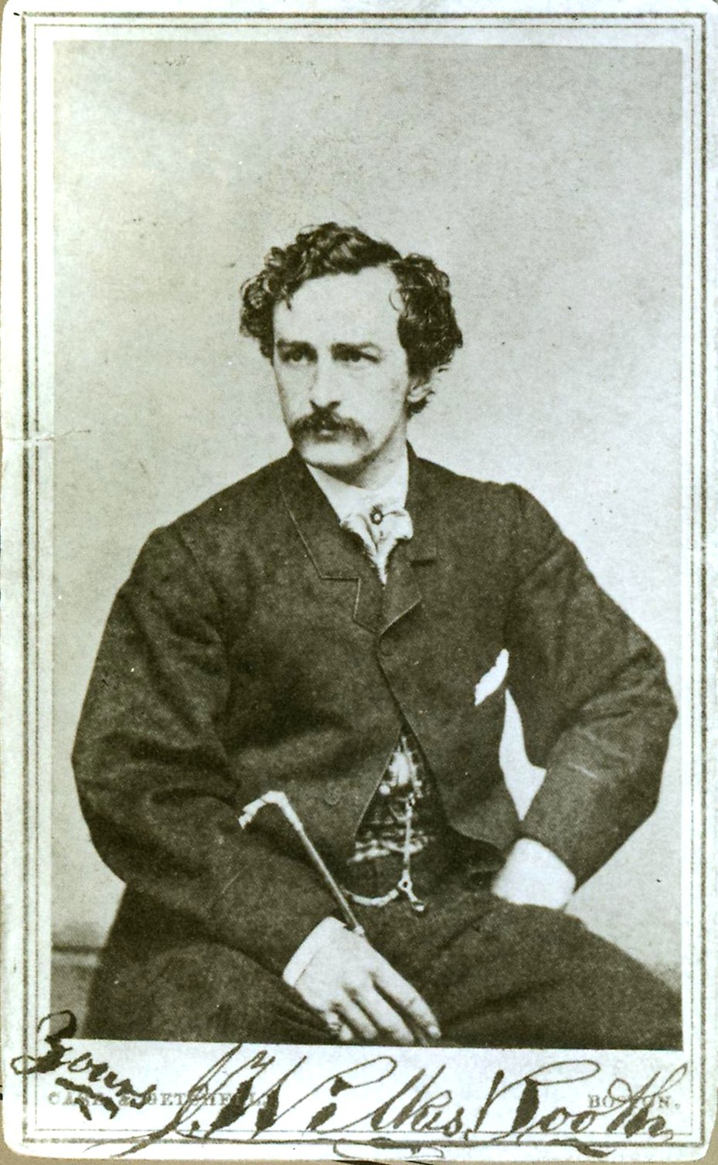
Booth Letter Garners $68,000 at Auction

BOSTON-- A letter written by President Abraham Lincoln's assassin two months before the April 1865 slaying sold at auction on November 21st for a record $68,000.
In the letter, dated February 9, 1865, John Wilkes Booth asks a friend to send him a picture of himself "with cane & black cravat"--the one later used in his wanted poster.
The buyer, historical document dealer Joe Maddalena, said Booth “is the rarest American autograph. When he killed Lincoln, anybody who had any relationship with him burned their letters, because they were so afraid they would be linked to him."
The rarity of Booth’s signature is well reflected in the price realized at auction when compared with prices asked for another highly sought Civil War era autograph—that of Abraham Lincoln. The latest catalog of the Abraham Lincoln Book Shop in Chicago offers a signed Lincoln letter from 1854 for a mere $26,500. A clipped autograph endorsement of the Great Emancipator can be had for the bargain price of $5,500.
A cache of Confederate cannonballs

Lynchburg man with metal detector makes big find near Richmond
LYNCHBURG, Va. -- Robert Compton struck Civil War gold when he unearthed 36 Confederate cannonballs. "It's very rare to find a case of them," said the Lynchburg man, who has turned a metal-detecting hobby into a science. Compton meticulously researches the location of Civil War campsites with the aid of maps from the Library of Congress, war accounts on CD-ROM, Global Positioning System technology and topographic maps. He goes in search of whatever the soldiers may have left behind. He has buckets of bullets, cases of buttons and even a bayonet. But the cannonball find is the big one.
The 12-pound iron cannonballs are being cleaned and defused by a professional -- the fuses could still set off the balls under the right conditions, Compton said. They're loaded with lead shot and gunpowder -- designed to inflict damage on people.
Compton doesn't want to reveal the location of the find, saying only that it was in a county near Richmond. He said he always gets permission from the property owner to hunt. Public property is off limits.
Van Naisawald, Lynchburg's resident expert on Civil War artillery, said such a find is rare. "What he probably found was a battery position," Naisawald said. "They probably skedaddled out of there in a hurry," taking the artillery and leaving the ammunition.
Metal detecting has been Compton's hobby since 1985, but in the last three years he has become an expert on the Civil War. He spent two years at Appomattox but figures too many people already have been there. He is currently following Confederate Gen. Robert E. Lee's retreat. He has found two virgin sites this year -- cavalry camps that are well off the beaten trail because horses could take to more remote terrain.
With his state-of-the-art metal detector, Compton also finds relics others have passed over. The cannonballs, for example, were buried under 3½ feet of dirt. Compton said the reading from his detector was muddled, but he still suspected the site was worth digging. After finding the first cannonball he thought that was it, but further effort revealed another 35 balls in an area of about 5 square feet.
While a dealer has already offered $275 per ball, Compton isn't eager to sell. In fact, he said, he has never sold any of his artifacts. They keep appreciating in value, and may become his retirement package.
His pastime, he admits, is a form of addiction. "It's like opening a Christmas gift up," said the 41-year-old Compton. "It's fun. When you hear a signal [from the metal detector], you don't know what it is." Compton said he can tell the difference between iron, lead and copper by the tone of the signal. He goes hunting every weekend, and estimates that he does six to seven hours of research a week.
Although his couch is draped with a Confederate flag, and Civil War memorabilia dominate his house, Compton said he's not really a Civil War buff. He has no interest in re-enactments, or even in battlegrounds. He prefers contemplating camp life for the average soldier. Though life was pretty miserable, he finds signs of leisure -- bullets carved into chess pieces and the remains of pipes.
Compton, who works for the Lynchburg utilities department, got the collector's bug early in life with football and baseball cards. His favorite find, however, remains one he made in 1996 -- not with a metal detector but with a backhoe. While helping to install a waterline, he found a 1925 Lynchburg High School ring. His research skills enabled him to track down 88-year-old Virginia Baldwin FitzSimons of Baltimore, who was thrilled to get her ring back. Her gratitude meant more than the prestige the cannonball find has brought him in the relic-hunting community, Compton said. "It's just a bunch of cruddy balls to me."
Reported by Shannon Brennan, staff writer at The News & Advance in Lynchburg, Va.

HARDTACK, the newsletter of The Indianapolis Civil War Round Table, is published monthly, September through June, each year. In addition to information about upcoming programs, HARDTACK features articles, news, reviews and a calendar of Civil War-related events. HARDTACK is distributed by mail or email to all ICWRT members.

If you have a short article, book review or some other item that may be of interest to our members, we invite you to submit it for consideration. Please send your material via email to the editor at: HardtackEditor@comcast.net. Please include a telephone number and email address where we may contact you.

Visit the website of The Indianapolis Civil War Round Table: http://indianapoliscwrt.org/

