HARDTACK

The Newsletter of the Indianapolis Civil War Round Table

June 2005

Monday June 13, 2005 6:30 p.m. at the Indiana War Memorial
THE ICWRT ANNUAL BANQUET & MEETING!!
The Evening’s Program:


Battlefield Preservation Update & Fundraiser
Guest Speaker:
David Duncan, CWPT

David Duncan is the Director of Membership and Development for the Civil War Preservation Trust. In that capacity, he has the bottom-line responsibility for raising the funds needed to save battlefield land, as well as for increasing the membership of the CWPT, which currently stands at 70,000 nationwide. His presentation the Round Table on June 13th will focus on the current dire state of many of America's most important Civil War sites, specifically, the "perfect storm" of events that is threatening to obliterate key sites in Spotsylvania County, Virginia, associated with the battles of Fredericksburg, Chancellorsville, The Wilderness and Spotsylvania Court House.
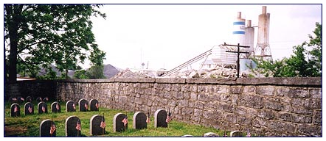
As he has traveled around the nation speaking to Civil War roundtables, David has found that some of the best discussions on battlefield preservation have come from participant questions, so a significant portion of the program will be dedicated to Q & A: Please come prepared to ask any question you may have about the work of the CWPT or preservation in general. If David can't answer it, he'll point you in the direction of someone who can!

About Our Speaker: David Duncan left a successful 14-year career in political direct mail fundraising to pursue his passion, Civil War battlefield preservation. He has been employed by the CWPT since March of 2000, and his team has raised more than $20 million and have tripled the CWPT's membership. David can trace his family lineage to three Confederate ancestors, two of whom served with the 54th Virginia Infantry in the Army of Tennessee and another who served with the 57th Virginia in Robert E. Lee's Army of Northern Virginia.

ICWRT Annual Banquet Meeting

The Indianapolis Civil War Round Table
2004-2005 Campaign

Officers:
President: Anthony Roscetti
Vice President: Ray Shortridge
Secretary: Dr. Betty Enloe
Treasurer: Doug Wagner

Committee Chairs:
Programs: Ray Shortridge rayshortridge@netscape.net

Publicity: Norris Darrall norrisdarrall@hotmail.com
Preservation: Andy O’Donnell odar1@aol.com
HARDTACK Newsletter:
Editor: Dave Klinestiver HardtackEditor@comcast.net
Distribution:
Dorothy Jones joejones@iquest.net
Peg Bertelli pbbertelli@insightbb.com

June 13, 2005, beginning at 6:30 P.M.
at the
Indiana War Memorial
431 North Meridian Street
Indianapolis, Indiana

Please note the location and earlier time!
Entrance on the North side, from Michigan St.
NOT New York St., as incorrectly stated on some
reservation forms for the Banquet

Dinner will be served in the MacArthur Room
Meeting following in the Pershing Auditorium

_________________________________________________

The Indianapolis Civil War Round Table gratefully acknowledges the co-sponsorship of
The Indiana War Memorial
for our Speakers Program during the 2004-2005 Campaign

In this issue of HARDTACK: Page
June 2005 Meeting: Annual Banquet / Dave Duncan, CWPT………..1-2
ICWRT News: New elections for 2005-2006……………………………..3
Membership Survey Results……..…….….….…………………………3-4
ICWRT & CWPT Contributions…………………………………………...5
Review of Programs of the 2004-2005 Campaign...…….…………….5
Calendar of Upcoming Events…………..………………….…………....6
Trimble’s Trivia Answers to May Quiz…………………………………….6
Preservation Update: Spotsylvania County……………………………..7-8
From the Bookshelf: Summer Reading Suggestions………….…..…8-10
Reenlistment Form / 12th Ind. Vol. Inf.…………………..……. Endsheet

ICWRT News

New Vice President and Treasurer to be Elected at June Meeting

As announced at last month’s Round Table meeting, Doug Wagner has informed the Executive Committee that he will step down as ICWRT Treasurer at the end of June. Doug had been re-elected at the February meeting to serve as Treasurer for the upcoming 2005-2006 campaign, an office he has held with dedication and integrity since the 2000-2001 season.

On May 10th, President Tony Roscetti reported to the Executive Committee that Doug Roush would be unable to serve as ICWRT Vice President next year due to other commitments. Until a new Vice President is elected, members of the Executive Committee have assumed responsibility for program planning for the coming year.

President Roscetti has directed the Round Table’s nominating committee (comprised of Steve Hill, Tom Krasean and Nikki Schofield) to conduct a search for candidates to fill both vacancies. The committee will present its nominees for the offices of Vice President and Treasurer for the 2005-2006 campaign at the June meeting, at which time elections will be conducted.

We regret to report that Dorothy and Joe Jones, who have admirably overseen distribution of both the email and hard copy versions of the HARDTACK newsletter for the past several campaigns, have also announced their retirement from active duty in that capacity at the end of this month.

Thank you Doug, Dorothy and Joe for jobs well done.

Membership Dues for 2005-2006 are NOW DUE ---

If you have not yet “re-uped” for the 2005-2006 Campaign, please do so by completing the attached form and returning it to Doug Wagner with the designated dues for your membership category. This form may also be used to make a financial donation to the ICWRT (in addition to your dues) to support our programs and operations.

Results of ICWRT Membership Survey Revealed

by Tony Roscetti
Earlier this year, The Indianapolis Civil War Round Table conducted a survey of its members. The purpose of the survey was to better understand the demographics of the membership as well as the common interests of our members. The results will help in our selection of future programs and activities.
Thirty members submitted their responses to the survey, which accounts for approximately 23% of our membership. Although this was a lower response rate than had been hoped for, a tabulation of the submissions did yield some interesting statistics:
Average age of respondents: 56 years
Average years as a member: 14 years
Male/female ratio: 83% male, 17% female
Percent who regularly attend meetings: 87%
Percent who have Civil War ancestors: 63%
One-third of the respondents have served as an officer or in another official capacity of the ICWRT. Although the large majority of those who completed the survey were born in Indiana, we also have members who were born in Florida, Illinois, Kentucky, Michigan, Ohio, and Texas.
Of those responding to the survey:
10% are members of the SUVCW, while 3% are members of the SCV;
10% are also members of another Civil War round table;
7% indicated they belong to reenacting units.
Of the Civil War interests mentioned by respondents:
70% enjoy the study of battles and leaders;
67% appreciate discussions of the common soldier;
50% like to learn about the politics of the era;
40% are interested in “the details” such as equipment used during the War.
Many of our members have other Civil War-related interests in addition to attending Round Table meetings. Among these are:
Exploring battlefields: 83%
Visiting museums: 73%
Touring Civil War sites: 27%
Preservation: 27%
Collecting Civil War antiques: 27%
Reenacting/Living History: 13%
Genealogy: 3%
It was particularly interesting to learn how many of our members had a very personal connection to the War. Not just ancestors, but also the stories that have been passed down through the family and, sometimes, even memories of a neighbor or friend who had vivid stories dating back a century or longer.
Perhaps we'll try this again at a future date to see how the responses compare.
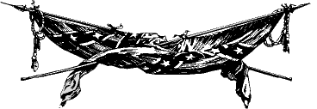

The Indianapolis Civil War Round Table would like to thank the following members who have recently made generous contributions to our organization:

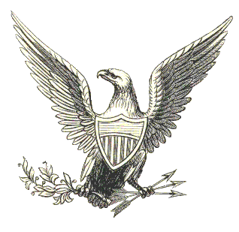
Nikki Schofield
Phil Young
Tom Krasean

Matching Contributions to CWPT are Due at the June Meeting!!
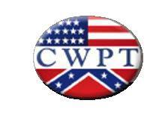
As previously announced, as a demonstration of our commitment to battlefield preservation, the ICWRT plans to match our members’ contributions to the Civil War Preservation Trust at the June meeting/fundraiser.

If you would like to make a contribution to the CWPT and have the Round Table make a matching donation, please deliver your check, made payable to the Civil War Preservation Trust, to Doug Wagner at or before the meeting on June 13th. You can learn more about the CWPT and its important, ongoing work on its website at: www.civilwar.org. The CWPT is a nonprofit, 501(c)(3) organization, and contributions are tax deductible.

ICWRT Programs: The 2004-2005 Campaign in Review

September 13, 2004 The Battle of Stones River Jim Lewis, Stones River Nat’l Military Park
October 4, 2004 The Sultana Disaster Pam Newhouse, Sultana Association
November 8, 2004 Civil War Music Dr. Wesley Hanson, ICWRT
December 13, 2004 Indiana’s Gen. Jefferson C. Davis Gordon Whitney, Author
January 10, 2005 Berdan’s Sharpshooters Gerald Jones, ICWRT
February 14, 2005 Black Civil War Soldiers Dick Skidmore, Past-President, ICWRT
Almost Invisible
March 14, 2005 Indiana Regimental Photographs Craig Dunn, Author
April 11, 2005 Is “The Gangs of New York” Prof. Iver Bernstein
Historically Accurate, and Why Washington University
Should We Care?
May 9, 2005 Abraham Lincoln and American Prof. Mark E. Neely, Jr.
Nationalism in the Civil War Pennsylvania State University

June 13, 2005 Annual Banquet/ Battlefield David Duncan, Civil War Preservation Trust
Preservation Update & Fundraiser

All programs were held at the Indiana History Center Auditorium, except for the February and June meetings, which were held at the Indiana War Memorial.

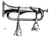
Calendar of Upcoming Events
June 9 | Lincoln Group of Indiana  Nora Branch, Indianapolis Marion County Public Library 7:00 PM  Contact: Angie Gilmer 317-253-8857 (also meeting on August 11)  aeg123@sbcglobal.net
June 13 | ICWRT: Annual Banquet / Battlefield Preservation Update & Fundraiser  Guest Speaker: Dave Duncan, Civil War Preservation Trust  Indiana War Memorial, 431 North Meridian, Indianapolis, IN; 6:30 PM  http://indianapoliscwrt.org
June 10-12 | Billie Creek Village Civil War Days  Rockville, IN Battle re-enactments and Living History demonstrations  Contact: Don Bryan bryan@clay.k12.in.us
June 18-24 | ICWRT Summer Field Trip (Bus Tour): “On To Richmond!”  Scheduled tour sites in Cincinnati, Lexington and Richmond, Va., and Lexington, Ky. For further information, contact Nikki Schofield (317-328-8782)

We recommend confirming all dates, times and locations for events not sponsored by the ICWRT



Trimble’s Trivia

by Quizmeister Tony Trimble

Tony will be back in September with more of his trivia teasers. Here are the answers to last month’s Nickname Quiz:

1. William Smith, C.S.A. Extra Billy
2. Whitelaw Reid Agate
3. Nathan Evans, C.S.A. Shanks
4. Henry Halleck, U.S.A. Old Brains
5. Raphael Semmes, C.S. N. Old Beeswax

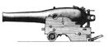

Preservation Update

Spotsylvania Added to Top 10 Most-Endangered Civil War Sites

The following article was published in the Sunday, February 27, 2005, edition of the Washington Post, and posted online at WashingtonPost.com. Because of its newsworthiness and particular relevance to this month’s program on battlefield preservation, we are reprinting it here.

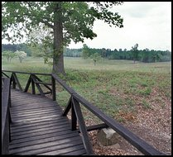
By Michelle Boorstein
Washington Post Staff Writer
Spotsylvania's placement last week [February] on a prominent national list of most-endangered Civil War sites is both a blessing and a curse for the county. For the first time ever, the Civil War Preservation Trust, the nation's largest battlefield preservation organization, placed an entire county on its Top 10 list of at-risk spots. Spotsylvania, home to four major battlefields and legions of new residents with many more on the way, "is ground zero," said Jim Campi, spokesman for the organization, which has 70,000 members.

Earning a spot on the list may help new county leaders who are determined to make Civil War tourism the centerpiece of Spotsylvania's immediate development strategy. Supervisors elected in the last few years have set to work on a vision that fits housing, businesses and roads around the battlefields.
"To me, [the list] increases awareness of the challenges we face," said Supervisor Henry "Hap" Connors Jr. (I-Chancellor), a former spokesman for the National Trust for Historic Preservation. "The list is important because land values are going up and time is crucial."
Campi said the Civil War trust hopes to help purchase battlefield land or negotiate acceptable development in the next two or three years. "Spotsylvania and a few other Virginia counties -- Hanover and Henrico -- are getting the lion's share of our attention," he said. "We are trying to go out and buy the land before landowners put it on the market. In other places in the country, we are in a reactive mode."
Ninety percent of the land preservationists want is zoned for commercial development. Some is zoned rural, and some landowners hoping to sell to developers have expressed interest in applying for rezonings for more intense development, Campi said.
Although preservationists aren't happy about much of the region's growth, Campi said the intense competition for land in Virginia has been a boost for his Civil War group and others like it. A plan two years ago to build 2,000 homes on part of the site of the Battle of Chancellorsville became something of a rallying cry for Civil War enthusiasts across the country.
"When we ask for money, they are more likely to give for places like Spotsylvania than for relatively unknown sites in the country. There is a financial incentive on our part to be more involved in Spotsylvania County," Campi said.
But the increasing pressure on battlefields comes when overall interest in the Civil War is slipping, said George E. Hicks, chief executive of the National Civil War Museum in Harrisburg, Pa.
"Let's face it, we don't have Civil War veterans alive or widows alive. We don't have that last string to that bygone era," he said, adding that it's "high time" state and federal bodies set aside key Civil War sites. "We certainly should be paying homage in places other than cemeteries and not allowing 'progress' to encroach on land that was so dearly paid for."
Other Virginia sites on the trust's list are battlefields from the Bermuda Hundred campaign in Chesterfield County and the two Manassas battlefields.
Turning Spotsylvania into a historic tourist destination rests in substantial part with elected officials who rule on rezoning applications and decide how much developers should contribute in proffers, payments or improvements meant to offset future costs of growth. Supervisors have approved several recent countywide down-zonings, reducing rather than increasing the density of development allowed, but many remaining properties are likely to be controversial.
"There comes a time when you have to say the whole world doesn't have to be black asphalt. However, those decisions are the supervisors' to make," said Gary Partridge, the county's economic development director. "If someone comes to say they want to work on a piece of property and wants me to move it forward [for development], I will work with them -- no matter where it is."

From the Bookshelf
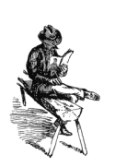
Some Summer Reading Suggestions

Looking for a good book to while away the hours on the bus ride to Richmond later this month? How about something for the beach or poolside on those hot summer days in July and August? Here is an eclectic mix of some recent and soon-to-be published titles—from battle and tactical studies, to antebellum politics, to more specialized works –that may be of interest to you:
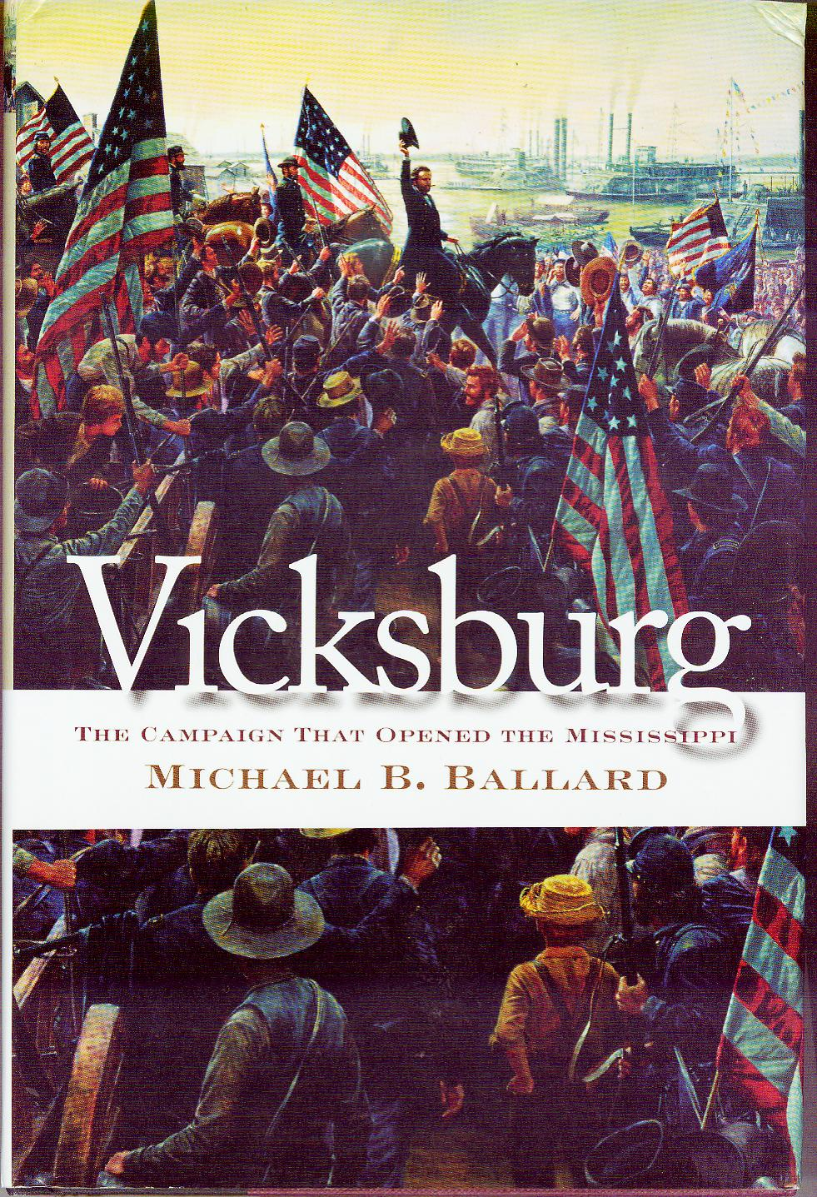

Vicksburg: The Campaign That Opened the Mississippi by Michael B. Ballard (UNC Press 2004) 490 pp.

“Michael Ballard’s Vicksburg must be considered essential reading for all Civil War historians interested in the Western Theater of Operations. His astute analysis and deft interweaving of military decision making, campaign strategy and battle tactics, political economic factors, and the many challenges confronting Southern civilians brings together in one volume the complexity of the fight for mastery of the Mississippi River.” Carol Reardon, Penn State Univ.

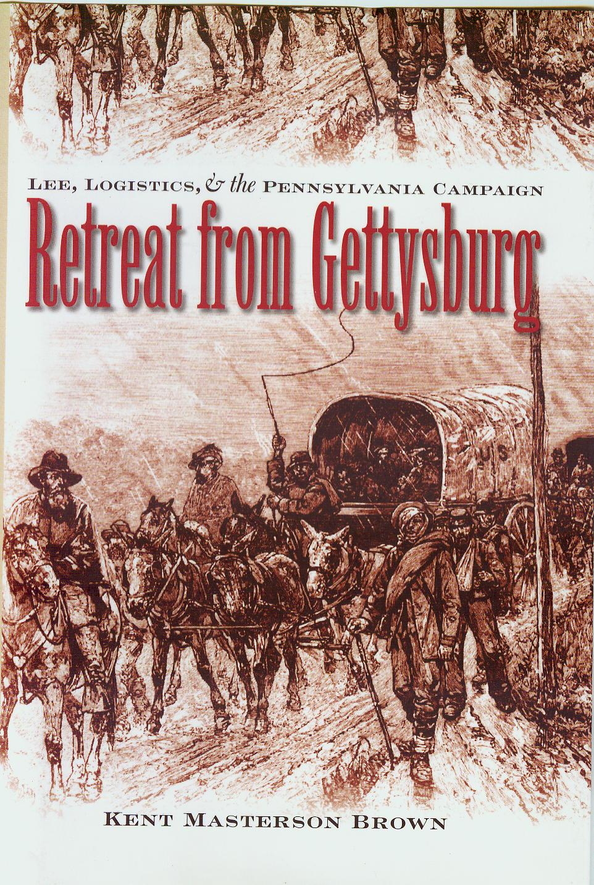
Retreat from Gettysburg: Lee, Logistics, and the Pennsylvania Campaign by Kent Masterson Brown (UNC Press 2005) 528 pp.
"Using an impressive array of untapped source material, Kent Brown has written the first detailed narrative on the Confederate retreat from Gettysburg. This phase of the campaign has often been misunderstood and Brown brings understanding to how and why the Army of Northern Virginia escaped across the Potomac without another full-scale battle against the Army of the Potomac.” D. Scott Hartwig

Field Armies and Fortifications in the Civil War : The Eastern Campaigns, 1861-1864 by Earl J. Hess (UNC Press 2005) 464 pp.

“Field fortifications played a major role in the American Civil War, evolving from a widely despised expedient to a universally recognized necessity. It is a cause for astonishment that no one has attempted a scholarly look at that burgeoning military development--until now. Field Armies and Fortifications ably takes on the important topic, and makes a significant contribution to our understanding of the war.” Robert K. Krick

The Bloody Crucible of Courage: Fighting Methods and Combat Experience of the Civil War by Brent Nosworthy (Carroll & Graf 2003); pb ed. (2005) 752 pp.
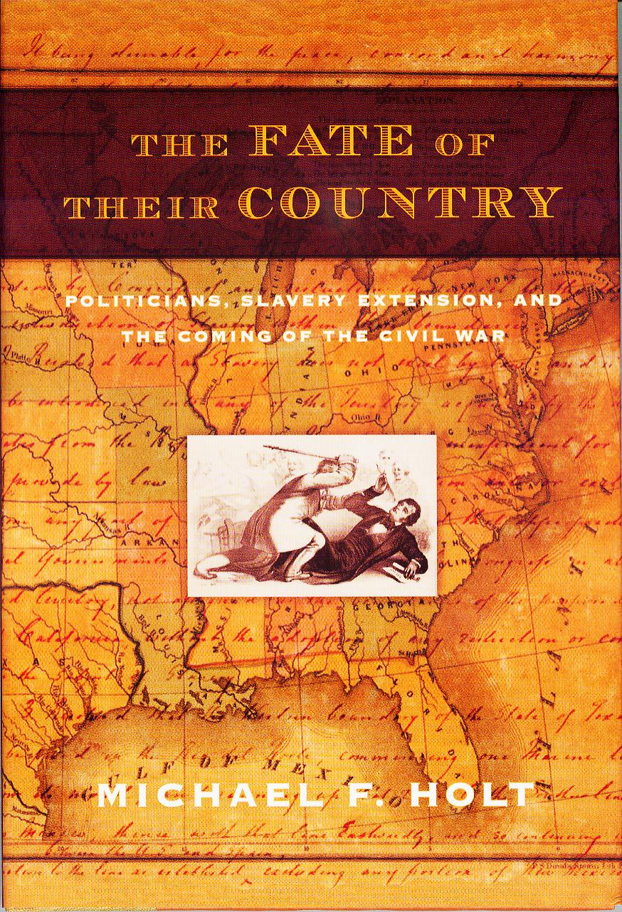
In this groundbreaking achievement in Civil War scholarship, acclaimed military historian Brent Nosworthy leads an all-out attack on the many myths and misunderstandings about how the North and South fought, and covers for the first time in any book the variety of Civil War combat methods in their entirety. Now everything from grand tactics to hand-to-hand combat during our nation’s costliest war is given its proper due in the development of warfare.

The Fate of Their Country: Politicians, Slavery Extension, and the Coming of the Civil War by Michael F. Holt (Hill and Wang 2004); pb ed. 2005

University of Virginia historian Holt (The Rise and Fall of the American Whig Party) provides an elegant, brief analysis of the partisan political forces that, via the great debate over the extension of slavery into the American West, eventually plunged the United States into civil war.

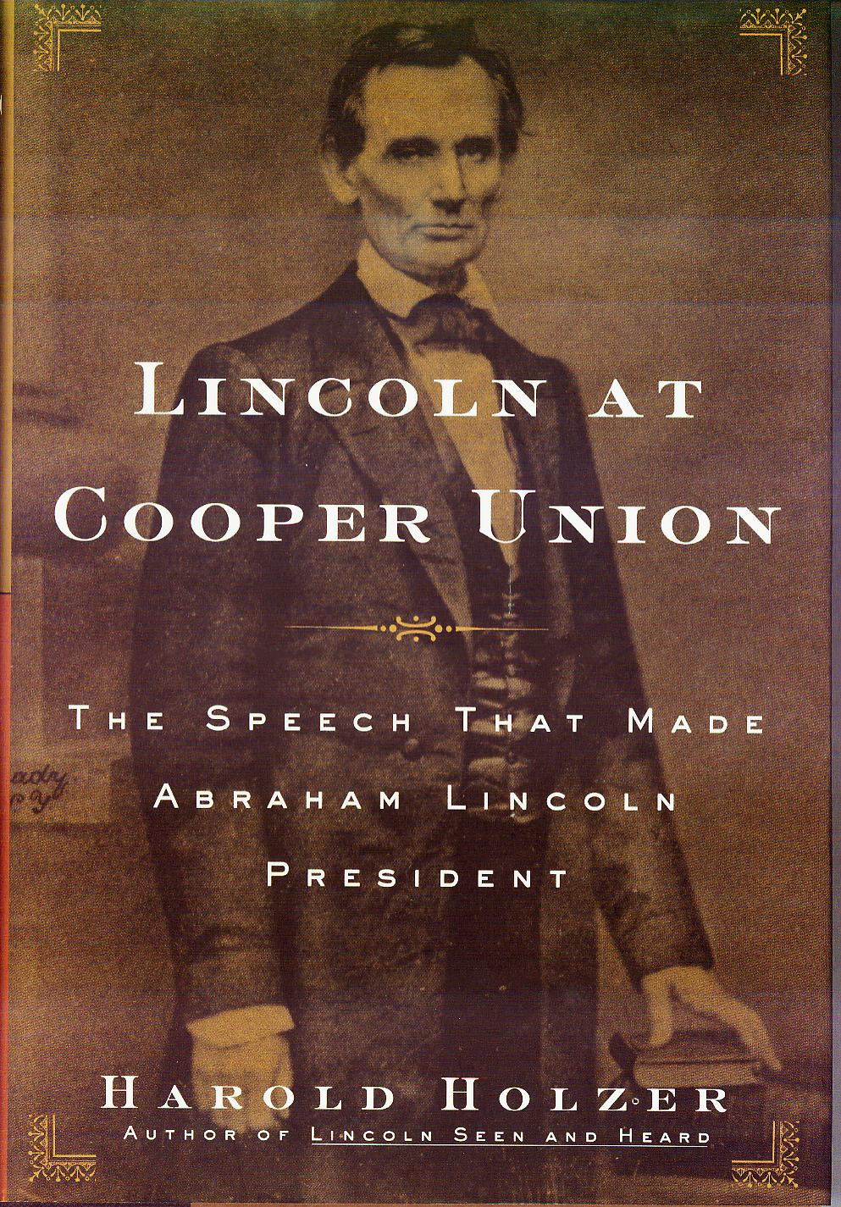
Lincoln at Cooper Union : The Speech That Made Abraham Lincoln President by Harold Holzer (Simon & Schuster 2004) 352 pp.; pb ed. (2005) 368 pp.
Well-known Lincoln scholar Holzer examines how Lincoln’s remarkable speech in New York City in February of 1860 set the stage for his nomination by the Republican Party the following summer. A fascinating look at Lincoln as political thinker, orator and ambitious politician facing a “make or break” test of his political career.

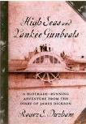
High Seas And Yankee Gunboats: A Blockade-Running Adventure From The Diary Of James Dickson by Roger S. Durham (USC Press 2005) 185 pp.
High Seas and Yankee Gunboats tells of the harrowing adventures of two men from Savannah, Georgia, who sought to breach the Federal blockade early in the Civil War. Roger S. Durham draws from James Dickson’s 1862 Civil War diary to frame the story of the young sailor’s travels with his friend Thomas L. Hernandez from New Jersey to Nova Scotia to the coast of Georgia. Using Dickson’s diary and other primary source materials, Durham deftly recounts their remarkable voyage and makes available a firsthand vantage point of the early war years in which blockade runners enjoyed their greatest success.

Richmond's Wartime Hospitals by Rebecca Barbour Calcutt (Pelican Publishing 2005) 224 pp.
While medical science enjoyed several advances during the Civil War, the doctors and hospitals in the southern states faced overwhelming casualties with few supplies and inadequate personnel. By focusing on facilities in Virginia’s capital, Mrs. Calcutt illustrates how exhausted resources rapidly defeated southern doctors’ heroic efforts.

The Last Generation: Young Virginians in Peace, War, and Reunion
by Peter S. Carmichael (UNC Press 2005) 352 pp.

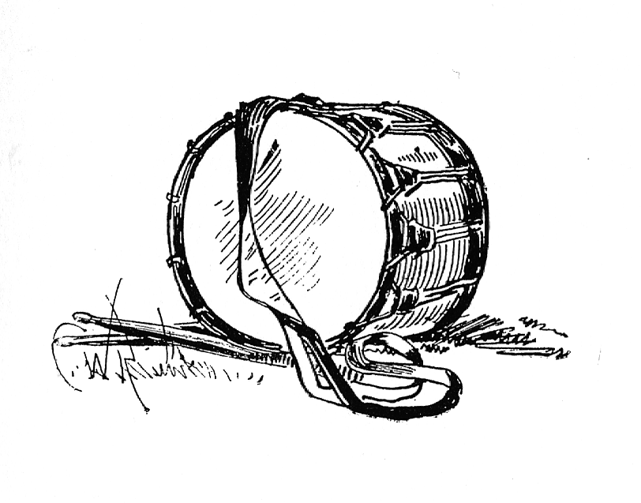
Looking closely at over one hundred young white Virginians who came of age in the 1850s and '60s, Carmichael argues that the experiences and the characteristics of the last generation to grow up with the institution of slavery force us to reexamine the nature of Southern manhood and the approach and aftermath of the Civil War.

Have a great Summer.

HARDTACK, the newsletter of The Indianapolis Civil War Round Table, is published monthly, September through June, each year. In addition to information about upcoming programs, HARDTACK features articles, news, reviews and a calendar of Civil War-related events. HARDTACK is distributed by mail or email to all ICWRT members.

If you have a short article, book review or some other item that may be of interest to our members, we invite you to submit it for consideration. Please send your material via email to the editor at: HardtackEditor@comcast.net. Please include a telephone number and email address where we may contact you.

Visit the website of The Indianapolis Civil War Round Table: http://indianapoliscwrt.org/

Re-enlist Now for the 2005-2006 Campaign !!

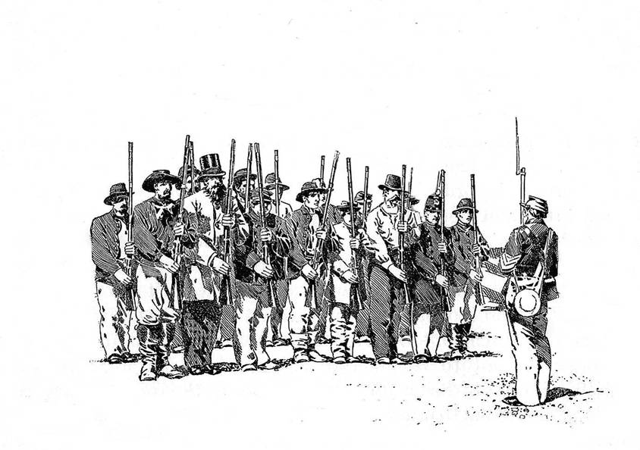
The 2005-2006 campaign of The Indianapolis Civil War Round Table will soon be upon us. Now is the time to get your re-enlistment paid. Individual membership is $25.00, family membership is $30.00 and student membership is $10.00. Please make your check payable to "Indianapolis Civil War Round Table" and mail to Doug Wagner at 5245 Kathcart Way, Indianapolis, IN 46254. If you have any questions, please contact Doug at 328-4828 or e-mail at douglas_wagner@sbcglobal.net. A re-enlistment form is provided below. The HARDTACK newsletter will be sent via e-mail to those of you who have an e-mail address. Please be sure to include your e-mail address on your enlistment form.

The Indianapolis Civil War Round Table

Enlistment for the 2005-2006 Campaign

Mail to:

Douglas A. Wagner
5245 Kathcart Way
Indianapolis, Indiana 46254

Phone: (317) 328-4828
Email: douglas_wagner@sbcglobal.net

Please complete and detach the form below and include with your check:
------------------------------------------------------------------------------------------------------------------

ICWRT Enlistment for July 2005 thru June 2006

Make your check payable to “Indianapolis Civil War Round Table”

Name…………………………………………………….…. Date ………………..

Address……………………………………………………………………….

……………………………………………………………………….

Phone:…………………………… Email:…………………………..………..

The year you joined the ICWRT…………………

Enlistment Status for July 2005 thru June 2006 (please specify):

$25 Individual …… $30 Family ……. $10 Student …….

In addition to my membership dues, please accept my generous gift of $ ________
to the ICWRT general operating account (this donation is not tax deductible)
12th Indiana Volunteer Infantry, 1864
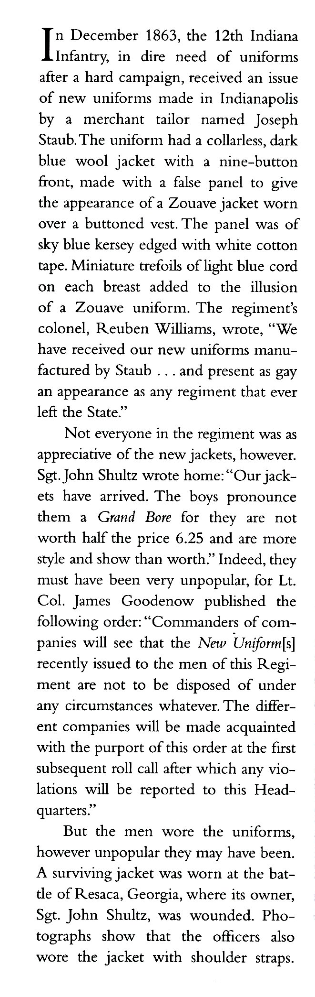
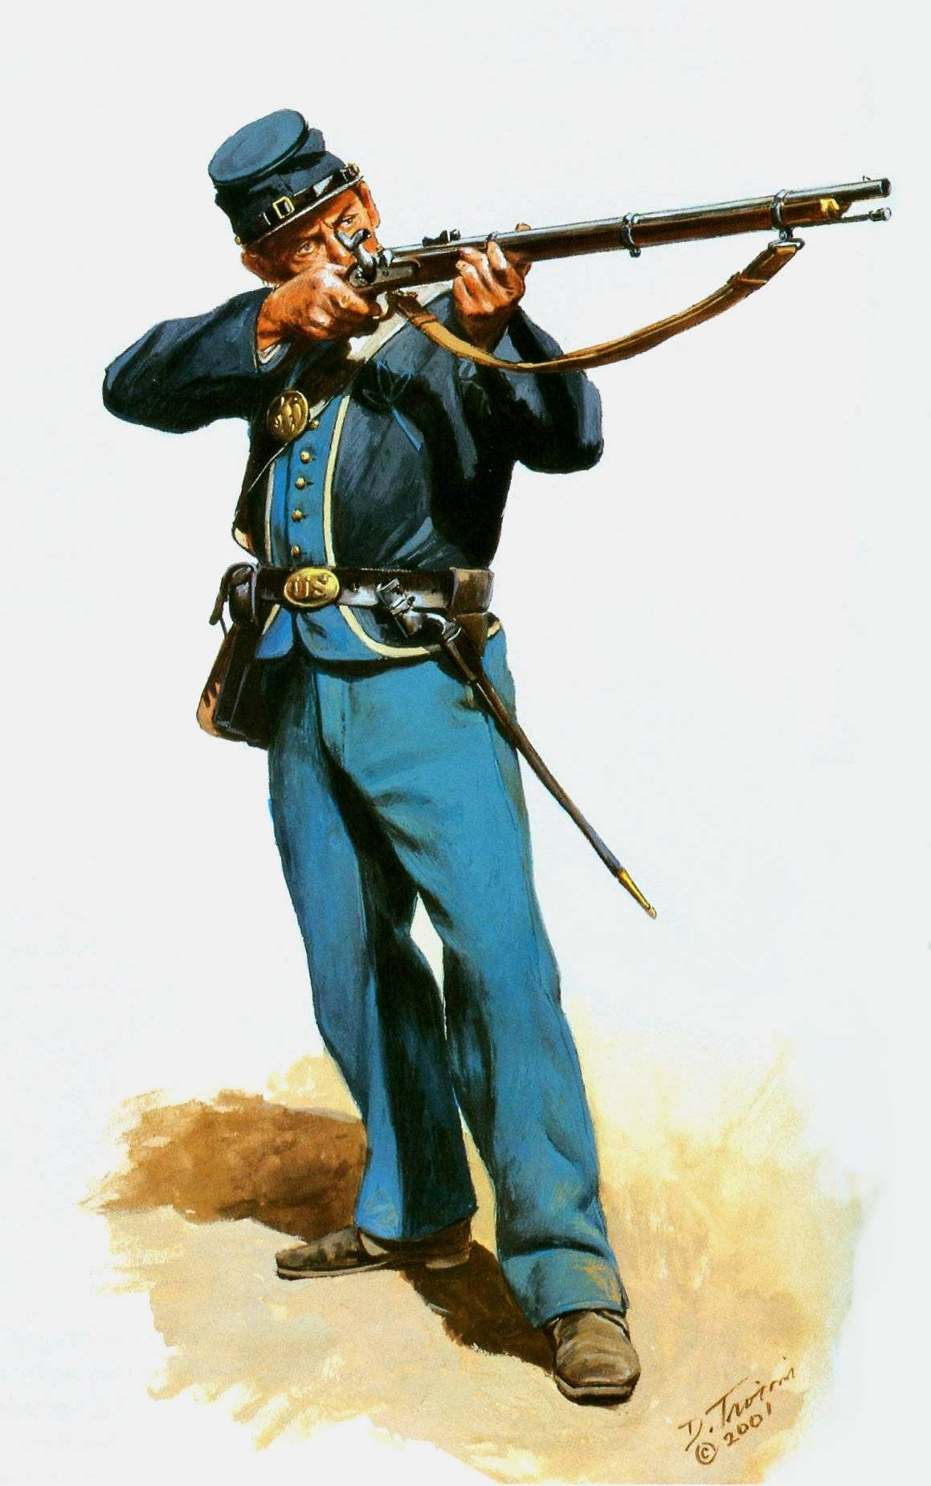

From: Don Troiani’s Regiments & Uniforms of the Civil War
Art by Don Troiani, Text by Earl J. Coates, Michael J. McAfee and Don Troiani (Stackpole Books 2002)

Image Copyright © 2001 Don Troiani. Used by permission. Visit www.historicalartprints.com

