HARDTACK

The Newsletter of the Indianapolis Civil War Round Table

May 2005

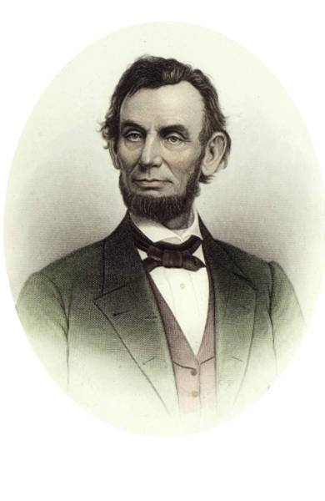
Monday May 9, 2005 7:30 p.m. at the Indiana History Center

The Evening’s Program:

Abraham Lincoln
and
American
Nationalism
in the
Civil War
presented by Mark E. Neely, Jr.

The Indianapolis Civil War Round Table is delighted to welcome leading Lincoln and Civil War Era scholar Mark Neely to our May meeting. Professor Neely’s authoritative work on Abraham Lincoln and his presidency—in particular his study on the impact of Lincoln’s policies and executive actions on civil liberties—has been widely praised for its extensive use of original source material and balanced approach to often controversial subject matter. In his presentation to the Round Table, Professor Neely will test Lincoln's ideas about nationalism by examining three spectacular events from the Civil War: Price’s Raid, the attempt to end martial law in Missouri, and the “near revolt of the Illinois line.”

About Our Speaker: Mark E. Neely, Jr. is currently the McCabe-Greer Professor of the History of the Civil War Era at Pennsylvania State University. His book, The Fate of Liberty: Abraham Lincoln and Civil Liberties (Oxford Univ. Press 1991) won the Pulitzer Prize for History. He is also the author of The Last Best Hope of Earth: Abraham Lincoln and the Promise of America (Harvard Univ. Press 1995) and Southern Rights: Political Prisoners and the Myth of Confederate Constitutionalism (Univ. Press of Virginia 1999). Professor Neely’s most recent book, The Union Divided: Party Conflict in the Civil War North (Harvard Univ. Press 2002), was recently published in paperback. Mr. Neely has also served as Director of the Lincoln Museum in Fort Wayne, Indiana.


The Indianapolis Civil War Round Table
2004-2005 Campaign

Officers:
President: Anthony Roscetti
Vice President: Ray Shortridge
Secretary: Dr. Betty Enloe
Treasurer: Doug Wagner

Committee Chairs:
Programs: Ray Shortridge rayshortridge@netscape.net

Publicity: Norris Darrall norrisdarrall@hotmail.com
Preservation: Andy O’Donnell odar1@aol.com
HARDTACK Newsletter:
Editor: Dave Klinestiver HardtackEditor@comcast.net
Distribution:
Dorothy Jones joejones@iquest.net
Peg Bertelli pbbertelli@insightbb.com

ICWRT Meeting: May 9, 2005, at 7:30 P.M.
at the
Indiana History Center Auditorium
450 West Ohio Street
Indianapolis, Indiana
_____________________________
Join Us Before the Meeting at Shapiro’s Deli!
All ICWRT members and guests are invited to join us at Shapiro’s Delicatessen before the meeting to enjoy dinner and fellowship. This year, we will be holding informal “round table” discussions on a selected topic of general interest. See you at Shapiro’s, 808 S. Meridian St. (just south of McCarty St.) beginning at 5:30 P.M.
_______________________________________________________

The Indianapolis Civil War Round Table gratefully acknowledges the co-sponsorship of
The Indiana War Memorial
for our Speakers Program during the 2004-2005 Campaign

In this issue of HARDTACK: Page
May 2005 Meeting: Abraham Lincoln and American Nationalism in the Civil War presented by Mark Neely…………………………………..1-2
ICWRT News: 50th Anniversary Meeting………..…………….……...3-4
Tour Updates………………………..…….….….…………………………5
ICWRT & CWPT Contributors…………………………………………….6
Upcoming ICWRT Programs ………………………..…….….…….…….7
Calendar of Events…..……………………..………………….…………...7
Trimble’s Trivia …………………………………..………………....……..8
Living History Update ………………………………………………..……9
News of Other Round Tables……………………………………………10
June Banquet Reservation & Reenlistment Forms………………[11-12]
Morgan’s Raid Tour Flyer………………………………………….Endsheet

ICWRT News

Past Presidents Honored at 50th Anniversary Meeting

Indianapolis Civil War Round Table history was both remembered and made on the evening of April 11, 2005, as twenty of the 40 individuals who have served as President of this organization were present to help celebrate our 50th Anniversary meeting.

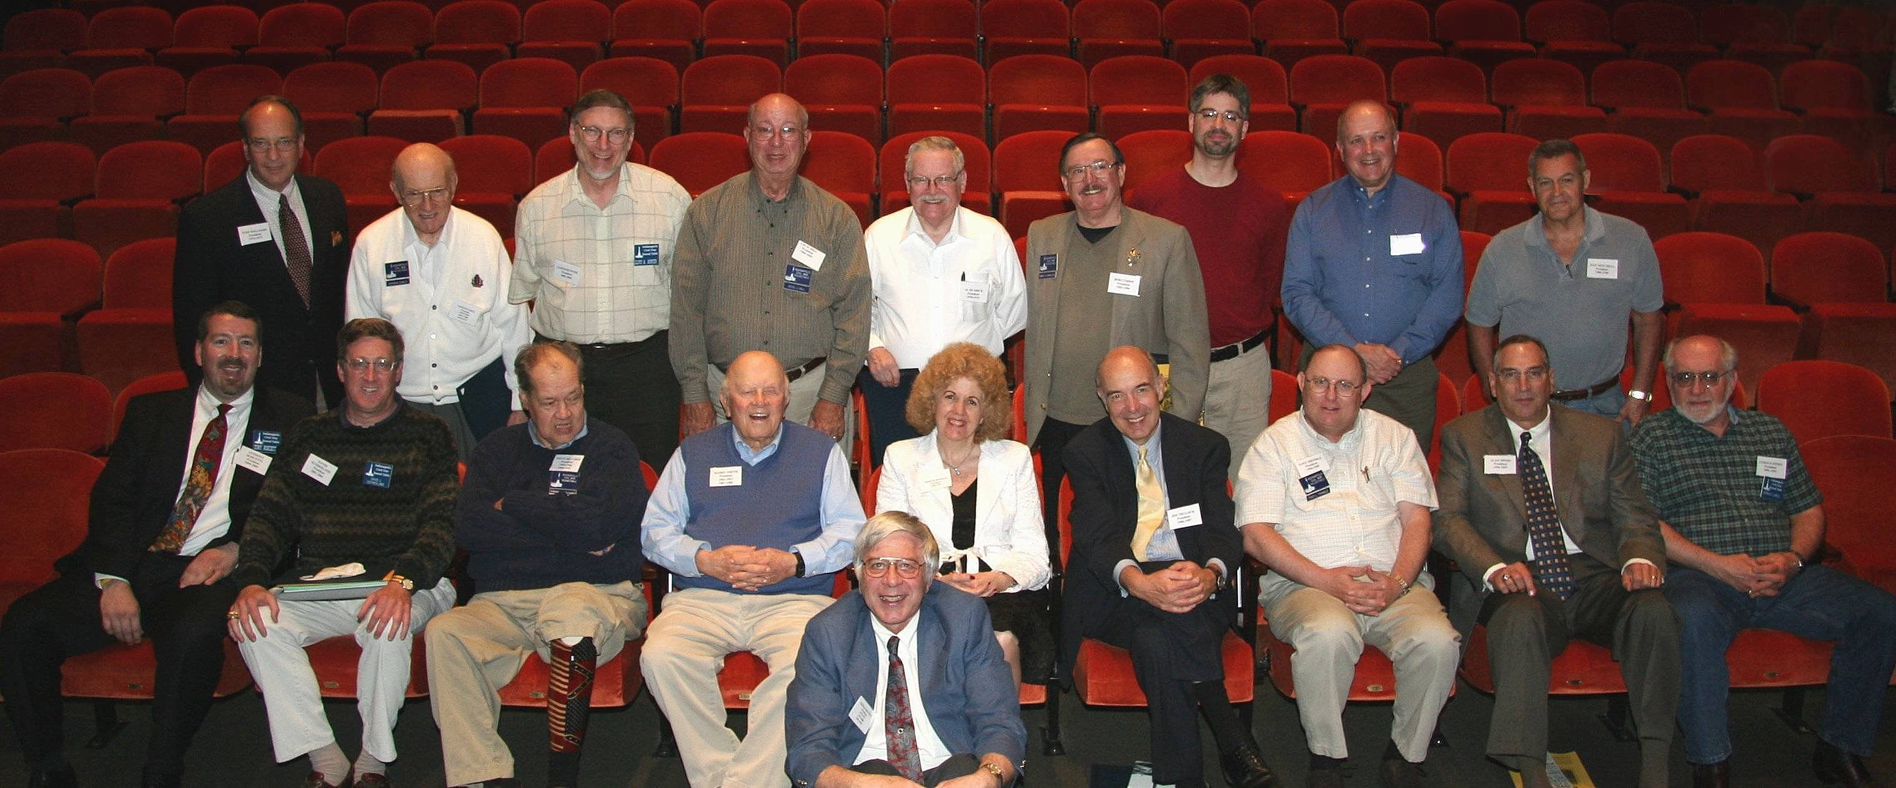

Standing from Left: Tom Williams (1974-75); Vernon Earle (1959-60, 1967-68, 1976-77); Lloyd Hunter (2002-03); Cecil Hill (1964-65); Al Rearick (1978-79); Bob Currie (1983-84); Tom Ayer (1999-2000); Steve Jackson (2000-01); Dan Mitchell (1989-90). Seated from Left: Tony Roscetti (2004-05); Dave Sutherland (2001-02); Steve Belcher (1985-86, 1994-95); Harry Smith (1962-63, 1987-88); Tom Krasean (front) (1970-71, 1979-80, 1993-94); Nikki Schofield (1996-97); Jim Trulock (1986-87); Tony Trimble (1984-85); Alan Hinds (1992-93); Gerald Jones (1991-92). Not Pictured: Steve Hill (2003-04).

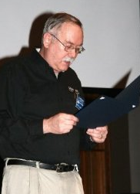
Following welcoming remarks by current President Tony Roscetti, “Past Presidents Ceremony Committee” members Norris Darrall and Nikki Schofield took the stage to formally recognize the former leaders of the Round Table in attendance. Each past President was called forward to receive a certificate of recognition for their service to the ICWRT and a packet of mementos.

Regrettably, ICWRT co-founder and past President Alan Nolan (1958-59) was unable to attend the Anniversary meeting, but was recognized from the podium by President Roscetti.

Following adjournment of the meeting, President Roscetti and eighteen of his predecessors in office gathered for a group photograph to commemorate the occasion.
Master of Ceremonies Norris Darrall

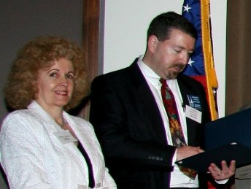
Nikki Schofield, a past ICWRT President and Co-Chair of the Ceremony Committee, with current ICWRT President Tony Roscetti

Three-time President and charter-year member Vernon Earle accepts his Certificate of Recognition
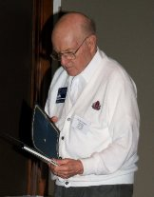

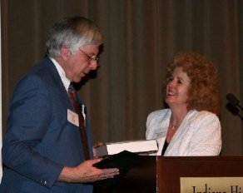

Tom Krasean, another three-time ICWRT President, receives the inaugural Gov. Oliver P. Morton Award for his outstanding service to the club over many years. Tom served as editor for the recently published history of the ICWRT, Indianapolis Civil War Round Table: The First Fifty Years 1955-2005.

Missed out on The First Fifty Years?
Order Your Copy Directly From the Publisher!

Indianapolis Civil War Round Table: The First Fifty Years 1955-2005
edited by Thomas K. Krasean

Copies of this 112 page history of the ICWRT may be ordered in hardback and paperback. Contact:
AuthorHouse
1663 Liberty Drive, Suite 200
Bloomington, Indiana 47403
Telephone: (800) 839-8640
www.AuthorHouse.com

Tour Updates
Large Turn-out for April’s “Generals Tour” at Crown Hill
On Sunday, April 17th, Nikki Schofield conducted a “Civil War Generals Tours” at Crown Hill Cemetery—the first of two such tours she has scheduled for this year. Nikki reports that 75 people participated in the event, including several members of the Round Table. The two-hour afternoon walking tour, which was fortunate to have ideal weather for the occasion, included stops at the gravesites of 16 of the 17 Civil War generals buried at Crown Hill, the nation’s third largest cemetery. Nikki gave a brief synopsis of each general’s career and personalized their stories with photographs of her subjects as they appeared during the War.
Nikki will be conducting the Civil War Generals Tour again on Sunday, October 2, 2005. Norris Darrall, one of the participants in the April tour, recommends it as well worth attending.

Seats Still Available for “On To Richmond!” Field Trip

Speaking of Nikki Schofield and tours, our Round Table Tour Guide reports that seats are still available on the bus for the annual ICWRT field trip. This year’s “On To Richmond!” excursion takes place June 18-24, and includes stops at the recently opened Underground Railroad Museum in Cincinnati; the Stonewall Jackson House and in Lexington, Virginia; and numerous points of interest in and around Richmond including Hollywood Cemetery, the Museum of the Confederacy, the “White House” of the Confederacy, Tredegar Iron Works and several area battle sites such as The Crater at Petersburg National Battlefield Park. On the return trip, the group will stop in Lexington, Kentucky, to visit the John Hunt Morgan House and Civil War Museum.

At $550 per person (double occupancy), this week-long tour has something of interest for everyone at a very affordable price. Two more participants are needed to meet our “break even” point for the bus, so sign up with your spouse or a friend, “leave the driving to us” and enjoy a great summertime adventure combining Civil War history and good fellowship. A deposit of $100 will be required to reserve a seat. Because of the need for advance reservations with motels, the cut-off date is May 18th (when the remaining $450 will be due). Contact Nikki at (317) 328-8782 or Nikki1942@sbcglobal.net.

“Morgan’s Raid” the Subject of September Tour

Attached to this issue of HARDTACK is a one-page flyer we have received from HistoryAmerica Tours (based in Plano, Texas) for their Fall tour entitled Morgan’s Raid: Riding with the “Thunderbolt of the Confederacy.” The one-week tour, scheduled for September 17-23, 2005, will depart from Nashville, Tennessee and proceed through Kentucky, Indiana and Ohio. Well-known Civil War historian Edwin C. Bearss will serve as tour guide. The cost is $1,795 per person (double occupancy) or $2,065 (single occupancy room). HistoryAmerica Tours advises us that our Round Table will receive a contribution for every ICWRT member who signs up for this tour, so please let them (and us!) know if you plan to attend.

Annual Banquet Fee and Membership Dues are NOW DUE ---

Don’t Forget Those Checks!!…

Included in this issue of HARDTACK is a reservation form for the ICWRT Annual Banquet Meeting to be held June 13th at the Indiana War Memorial. If you have not already done so, please complete the form and return it to Tony Roscetti or Doug Wagner before June 1st. The cost of the buffet dinner is $16.00 per person. As always, guests are welcome.

Also—if you have not yet “re-uped” for the 2005-2006 Campaign, please do so by completing the attached form and returning it to Doug Wagner with the designated dues for your membership category. This form may also be used to make a financial donation to the ICWRT (in addition to your dues) to support our programs and operations.

Those of you who have already signed on for the 2005-2006 Campaign may have noticed that our re-enlistment form now includes a line for donations to the ICWRT general operating account. These contributions help to defray our administrative expenses (including publication of HARDTACK) and allow us to keep membership dues at a reasonable level for all.

The Indianapolis Civil War Round Table would like to acknowledge and thank the following members who have recently made generous contributions to our organization:

Ed Bensman
Coy Halpern
Tom Krasean
Tom Plimpton
Bob Franklin

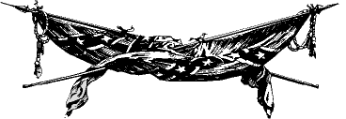

As was previously announced, the ICWRT is planning to match contributions to the Civil War Preservation Trust at the June meeting. To-date, Andy O'Donnell and Marilyn Hoffman have each made a generous contribution for the CWPT.

ICWRT members who would like to make a contribution to the CWPT to be matched by the Round Table should contact Doug Wagner.
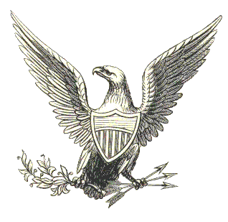

Upcoming ICWRT Programs

Unless otherwise noted, the ICWRT meets on the second Monday of the month

May 9, 2005 Abraham Lincoln and American Prof. Mark Neely, Penn State University
Nationalism in the Civil War

June 13, 2005 Annual Banquet/ Battlefield Dave Duncan and Jim Lighthizer, CWPT
Preservation Update & Fundraiser

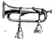
Calendar of Events
May 9 | ICWRT: Abraham Lincoln and American Nationalism in the Civil War  presented by Prof. Mark E. Neely, Jr.  Indiana History Center Auditorium, 450 West Ohio, Indianapolis, IN; 7:30 PM  http://indianapoliscwrt.org
May 16 | Madison County Historical Society CWRT: Following Stonewall  Anderson Public Library, Anderson, IN; 7:00 pm
May 21 | Conner Prairie Civil War Day  13400 Allisonville Rd, Fishers, IN; 9:30 AM to 5:00 PM; re-enactment at 3:00 PM  www.connerprairie.org
May 22 | Uniforms and Equipment of the Common Soldier of America  Mexican War through the Civil War  Johnson County Museum, 135 North Main Street, Franklin, IN; 2:00 to 4:00 PM
June 3-5 | 7th Conference on Women in the Civil War  Virginia Tech University, Blacksburg, VA  http://www.swcw.org/2005/2005.htm
June 10-12 | Billie Creek Village Civil War Days  Rockville, IN Battle re-enactments and Living History demonstrations  Contact: Don Bryan bryan@clay.k12.in.us
June 18-24 | ICWRT Summer Field Trip (Bus Tour): “On To Richmond!”  Scheduled tour sites in Cincinnati, Lexington and Richmond, Va., and Lexington, Ky. For further information, contact Nikki Schofield (317-328-8782)

We recommend confirming all dates, times and locations for events not sponsored by the ICWRT
If you know of a Civil War-related event that may be of interest to ICWRT members, please send your information to Norris Darrall (norrisdarrall@hotmail.com) and HARDTACK (HardtackEditor@comcast.net).


Trimble’s Trivia

by Quizmeister Tony Trimble

Here’s a switch. This time, I’ll give you the name—and you provide the nickname!!!

1. William Smith, C.S.A.

2. Whitelaw Reid

3. Nathan Evans, C.S.A.

4. Henry Halleck, U.S.A.

5. Raphael Semmes, C.S. N.

---Answers will be published in the May issue---

Answers to the April Quiz:

- “_____________is my man and I am his for the rest of the war.”
Fill in the blank, identify the speaker, and the event which provoked this statement.

Grant, Lincoln, Fall of Vicksburg

2. Name the Chief of Ordnance whose son led the team that conquered yellow fever.

Capt. Josiah Gorgas

3. Name the writer who wrote a fictionalized account of his service in the Marion
Rangers. What was the title of the story?

Mark Twain, “The Private History of a Campaign that Failed.”

4. Name the special unit of the Army of Northern Virginia created in 1862 as part of the Richmond defenses. Who was its commander?

The Light Division, A.P. Hill

5. Known as the “Queen of the Confederacy,” hers was the only portrait of a woman to
appear on Confederate currency. Name her.

Lucy Holcombe Pickens

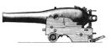

Living History Update

Johnson County Series Features Uniforms of the Common Soldier
The Johnson County Museum, 135 North Main Street in Franklin, Indiana, is hosting a series of programs on the uniforms and equipment of the common soldier of America from colonial times through the Korean Conflict. Norris Darrall attended the first program on March 26th, in which reenactors Larry Cooper and Dan Davis portrayed soldiers from the colonial period through the War of 1812. The program traced the evolution of uniforms and equipment of both militia and Regular forces during that period. Norris reports that it was an excellent program and recommends it to ICWRT members. The next program of the series, featuring uniforms of the Mexican War through the Civil War, will be held at the Johnson County Museum on May 22nd from 2 to 4 pm.
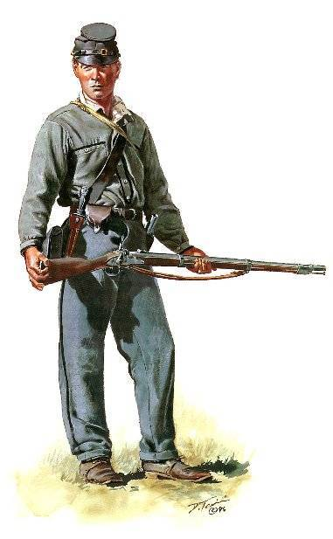
Conner Prairie Civil War Day is May 21st
Area reenactors and “living historians” (including a number of ICWRT members) will gather on the grounds of Conner Prairie in Fishers, Indiana, on Saturday, May 21, 2005, for “Conner Prairie Civil War Day.” The annual event, which is free to all Conner Prairie visitors, takes place between 9:30 a.m. to 5:00 p.m., and will include demonstrations of camp life and drill, as well as a battle skirmish at 3:00 p.m.
Among the reenactor groups participating in the event will be the Fourth Virginia Infantry Association, which has studied and portrayed Company “I” of that regiment—known as the Liberty Hall Volunteers—for over thirty years (for these pseudo sons of the South, the War never ends…!). At Conner Prairie, the L.H.V. will be attired in their “early War” uniforms consisting of gray battleshirts and trousers and blue forage caps. The distinctive outfits have been thoroughly researched and meticulously reproduced by the club’s members using woven-to-order fabrics and other custom made materials. The L.H.V. plan to conduct a recruiting scenario in which civilian onlookers may find themselves “volunteered” and mustered into the ranks for some good-natured instruction in the Manual of Arms.
Billie Creek Civil War Days to Feature ICWRT Speakers
This year’s Civil War Days at Billie Creek Village, June 10-12, 2005, will feature talks by two ICWRT members. The annual event at Billie Creek is traditionally considered the largest Civil War encampment and reenactment in Indiana. The event is held on the grounds of the reconstructed late-19th century Village, which is on U.S. Route 36 just east of Rockville, Indiana.
Norris Darrall will be speaking to visitors on three occasions during the weekend on the subject of the common soldier of the Civil War. Nikki Schofield will speak at 11:00 a.m. on Saturday, in one of the Village churches. Battle reenactments will be held in the afternoon on Saturday and Sunday.
Painting of Liberty Hall Volunteer Copyright © Don Troiani. Used by permission. Visit www.historicalartprints.com

Randolph County CWRT Furls Its Flag for the Last Time

We regret to report that the Randolph County Civil War Round Table has disbanded. After thirty years of active scholarship, camaraderie and service to its community, the RCCWRT held its last meeting on April 17, 2005, according to Phil DeHaven, longtime President of the organization. In addition to Mr. DeHaven, those in attendance at the final gathering included Al Harris, founder of the RCCWRT, and four other remaining members.

The RCCWRT recently lost two of its charter members, Jim Mock and Bill Ward. Their passing in part prompted the decision to disband. “This has been tough,” said DeHaven. “The RCCWRT did good work, had excellent programs, did a great deal of research, provided education about the Civil War, worked for preservation and had a great time doing it.”

Mr. DeHaven reports that the RCCWRT's library, records, information and its cannon will be turned over to the Randolph County Historical Society, as will any remaining general funds of the organization after paying outstanding obligations. The RCCWRT’s preservation and raffle fund will be gifted to the Perryville Battlefield Preservation Society and the Civil War Preservation Trust.

* * *

As we learned of the unfortunate demise of our sister Round Table in Randolph County, HARDTACK received word that a new Round Table has formed in Bloomington. The new organization (the official name of which is unknown to us at this time) has reportedly held three meetings. We welcome this new Hoosier Round Table to the fold, and invite anyone with information regarding its programs and contacts to forward the same to HardtackEditor@comcast.net.

The editor of HARDTACK would welcome receiving program schedules and e-newsletters from ALL area Round Tables so that this information may be shared with our members. We will be pleased to reciprocate in kind.

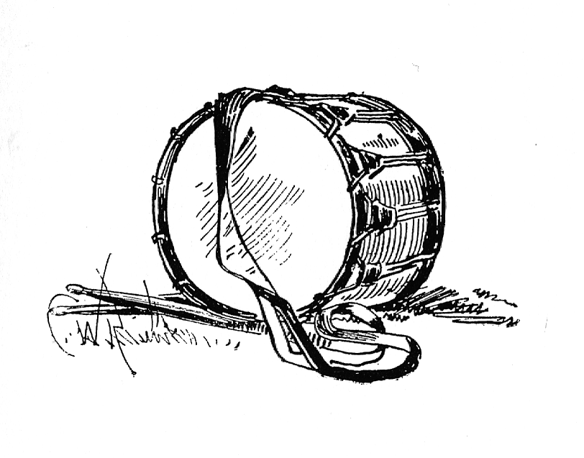

HARDTACK, the newsletter of The Indianapolis Civil War Round Table, is published monthly, September through June, each year. In addition to information about upcoming programs, HARDTACK features articles, news, reviews and a calendar of Civil War-related events. HARDTACK is distributed by mail or email to all ICWRT members.

If you have a short article, book review or some other item that may be of interest to our members, we invite you to submit it for consideration. Please send your material via email to the editor at: HardtackEditor@comcast.net. Please include a telephone number and email address where we may contact you.

Visit the website of The Indianapolis Civil War Round Table: http://indianapoliscwrt.org/

Indianapolis Civil War Round Table

Annual Banquet & Meeting

June 13, 2005

Indiana War Memorial *
431 North Meridian Street
Indianapolis, Indiana

Cost is $16 per person
Buffet dinner will be served starting at 6:30 PM and includes:
- Entrées: chicken breast with lemon Chardonnay sauce, and beef eye of round with Baronies sauce
- Sides: garden wild rice, Antigua blend, and field green salad
- Dinner rolls with butter
- Iced tea or coffee

Guest speakers: Jim Lighthizer and Dave Duncan of the Civil War Preservation Trust

* Entrance to the Indiana War Memorial is on the North side (from Michigan Street). Dinner will be served in the MacArthur Room. The meeting will take place in the Pershing Auditorium.
Reservation form (on reverse side) should be completed and submitted with payment by June 1, 2005

Re-enlist Now for the 2005-2006 Campaign !!

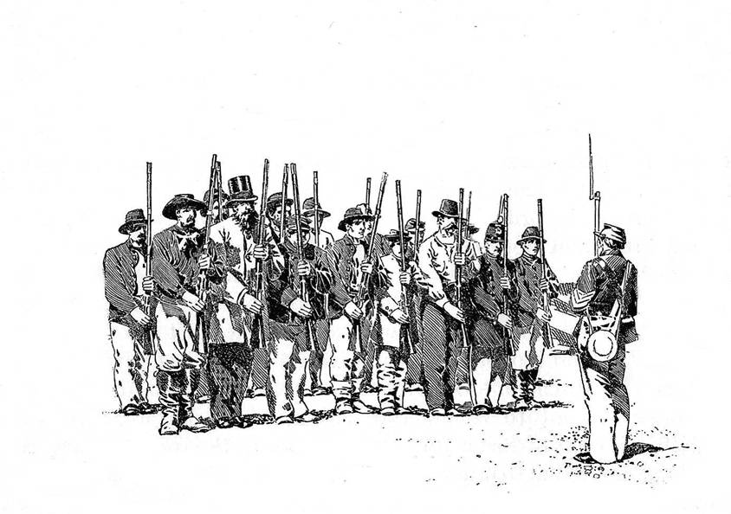
The 2005-2006 campaign of The Indianapolis Civil War Round Table will soon be upon us. Now is the time to get your re-enlistment paid. Individual membership is $25.00, family membership is $30.00 and student membership is $10.00. Please make your check payable to "Indianapolis Civil War Round Table" and mail to Doug Wagner at 5245 Kathcart Way, Indianapolis, IN 46254. If you have any questions, please contact Doug at 328-4828 or e-mail at douglas_wagner@sbcglobal.net. A re-enlistment form is provided on the reverse side. The HARDTACK newsletter will be sent via e-mail to those of you who have an e-mail address. Please be sure to include your e-mail address on your enlistment form.

The Indianapolis Civil War Round Table

Enlistment for the 2005-2006 Campaign

Mail to:

Douglas A. Wagner
5245 Kathcart Way
Indianapolis, Indiana 46254

Phone: (317) 328-4828
Email: douglas_wagner@sbcglobal.net

June 13, 2005 Annual Banquet Reservation Form

Reservation form and payment may be brought to the May meeting or mailed to:
Tony Roscetti or Doug Wagner
6270 Brixton Lane 5245 Kathcart Way
Indianapolis, IN 46220 Indianapolis, IN 46254

Individuals attending the Indianapolis Civil War Round Table, June 13, 2005 dinner meeting:

Name Name

Reservation form and payment must be received by June 1, 2005.

Cost: $16 per person. Please make check payable to Indianapolis Civil War Round Table.

Please complete, detach and include with your check
----------------------------------------------------------------------------------------------------------------------------------
Please complete, detach and include with your check

ICWRT Enlistment Form for July 2005 thru June 2006

Make your check payable to “Indianapolis Civil War Round Table”

Name…………………………………………………….…. Date ………………..

Address……………………………………………………………………….

……………………………………………………………………….

Phone:…………………………… Email:…………………………..………..

The year you joined the ICWRT…………………

Enlistment Status for July 2005 thru June 2006 (please specify):

$25 Individual …… $30 Family ……. $10 Student …….

In addition to my membership dues, please accept my generous gift of $ ________
to the ICWRT general operating account (this donation is not tax deductible)

