HARDTACK

The Newsletter of the Indianapolis Civil War Round Table

April 2005

Monday April 11, 2005 7:30 PM at the Indiana History Center
Our 50th Anniversary Meeting!!

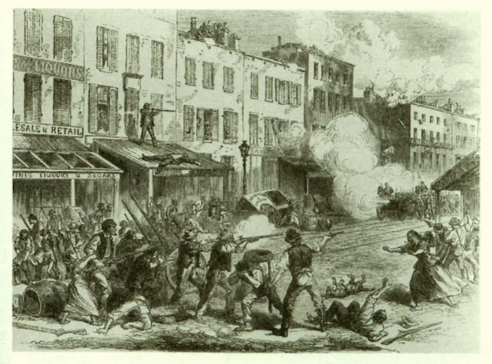

The Evening’s Program: The Draft Riots
presented by Iver Bernstein

For five days in July 1863, New York City was under siege. Angry rioters burned draft offices, closed factories, destroyed railroad tracks and telegraph lines, and hunted policemen and soldiers. Before long, the rioters turned their murderous wrath against the black community. In the end, at least 105 people were killed, making the draft riots the most violent insurrection in American history. At our April Anniversary gathering, Professor Iver Bernstein will examine the social forces behind the riots and their significance in the changing socio-political landscape of the Civil War era.

About Our Speaker: Iver Bernstein is professor of history at Washington University in St. Louis. He is the author of The New York City Draft Riots: Their Significance for American Society and Politics in the Age of the Civil War (Oxford Univ. Press 1990). Mr. Bernstein was awarded the George Washington Eggleston Prize by Yale University in 1985 for his doctoral dissertation that was the basis of that book. Professor Bernstein’s forthcoming book, The Origins of the American Civil War, will be published in June by Oxford University Press.


The Indianapolis Civil War Round Table
2004-2005 Campaign

Officers:
President: Anthony Roscetti
Vice President: Ray Shortridge
Secretary: Dr. Betty Enloe
Treasurer: Doug Wagner

Committee Chairs:
Programs: Ray Shortridge rayshortridge@netscape.net

Publicity: Norris Darrall norrisdarrall@hotmail.com
Preservation: Andy O’Donnell odar1@aol.com
HARDTACK Newsletter:
Editor: Dave Klinestiver HardtackEditor@comcast.net
Distribution:
Dorothy Jones joejones@iquest.net
Peg Bertelli pbbertelli@insightbb.com

ICWRT Meeting: April 11, 2005, at 7:30 P.M.
at the
Indiana History Center Auditorium
450 West Ohio Street
Indianapolis, Indiana
_____________________________
Join Us Before the Meeting at Shapiro’s Deli!
All ICWRT members and guests are invited to join us at Shapiro’s Delicatessen before the meeting to enjoy dinner and fellowship. This year, we will be holding informal “round table” discussions on a selected topic of general interest. See you at Shapiro’s, 808 S. Meridian St. (just south of McCarty St.) beginning at 5:30 P.M.

_______________________________________________________

The Indianapolis Civil War Round Table gratefully acknowledges the co-sponsorship of
The Indiana War Memorial
for our Speakers Program during the 2004-2005 Campaign

In this issue of HARDTACK: Page
April 2005 Meeting: The Draft Riots presented by Iver Bernstein.....1-2
President’s Message …..…………………………………………….….....3
50th Anniversary History Published……………………………………...3
Remembering Our Founding 50 Years Ago……………………….…4-5
Upcoming ICWRT Programs ………………………..…….….…….…….6
Calendar of Events…..……………………..………………….…………...6
Trimble’s Trivia …………………………………..…………………..…….7
50th Anniversary Fun Facts…………………………………………..……8
Annual Field Trip: “On To Richmond”……………………………….9-10
June Dinner Meeting & Reenlistment Forms………….………Endsheets

President’s Message

Our 50th Anniversary: A Milestone Worth Remembering

The mid-twentieth century saw a renewed interest in the watershed event in our nation’s history—the American Civil War. After generations sought to cover over old divisions that had so polarized an entire population, we were once again forced to confront the sectional strife of our past. With the scars of a second cataclysmic World War only beginning to heal, Americans began to rediscover the sacrifices made by so many citizen-soldiers of an earlier time, when the very survival of these United States hung in the balance. When honor, valor and duty compelled so many to defend their country and way of life as each understood it, no one was left untouched by the war that truly forged our nation.

And so it was that fifty years ago, a group of individuals right here in our own community, recognized the critical importance of this event and made a commitment to study the great conflict; to discuss its meanings and outcomes; and, hopefully, to come away with a better understanding of this momentous period in our history. To find a testament to the success of their endeavor, one need only look to the fruits of their early efforts.

Today’s Indianapolis Civil War Round Table is a vibrant, dynamic organization, now stronger than ever. I take great pride in being a steward of this organization and firmly believe that, after fifty years, we are only beginning the great task now before us. With the knowledge and dedication of our membership, our future could not be in better hands.

--Anthony Roscetti
ICWRT President

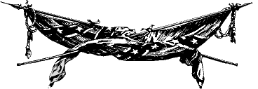

ICWRT Publishes Its First Fifty Years

Tom Krasean is to be commended for his outstanding work as editor of Indianapolis Civil War Round Table: Our First Fifty Years 1955-2005 (AuthorHouse 2005). This is much more than a souvenir of our Golden Anniversary. Beginning with the names of the founding and charter members present at the organizational meeting on February 8, 1955, and closing with a list of all ICWRT members for the 2003-2004 campaign, the 112 page retrospective is filled with facts and fascinating information covering the entire history of the ICWRT.

Each of the fifty campaigns of the Round Table is documented by a narrative synopsis of the happenings and highlights of the year. Of particular interest is a Calendar of Programs listing every program date, title and presenter from April 12, 1955 to the close of last year’s campaign. Other sections of the book provide a complete list of ICWRT officers, awards recipients, field trips and special activities, and editors of the HARDTACK. An index is also included.

Our First Fifty Years should be a valued addition to the bookshelf of any member—past or present—of the Indianapolis Civil War Round Table.

Miss out on ordering your copy of The First Fifty Years?
Our group order for Indianapolis Civil War Round Table: The First Fifty Years 1955-2005
has been placed, and no further orders are being accepted through the Round Table.
Fortunately, it’s not too late to get a copy of this fine history of the ICWRT!
You may order one or more copies of the book—either the hardback or paperback edition—
directly from the publisher. Contact:
AuthorHouse
1663 Liberty Drive, Suite 200
Bloomington, Indiana 47403
Telephone: (800) 839-8640
www.AuthorHouse.com

Remembering Our Founding Fifty Years Ago…

Editor’s Note: The following is adapted from Indianapolis Civil War Round Table: Our First Fifty Years 1955-2005, edited by Thomas K. Krasean (AuthorHouse 2005).

The Indianapolis Civil War Round Table was co-founded by Rudolf K. (Rudi) Haerle, Harry T. Grube, and Alan T. Nolan, and a group of friends with a common interest in the great American conflict. On February 8, 1955, a founders’ meeting was held at Rudi’s home. Those present besides the co-founders were: Howard Bates, Karl Hoffman, Leroy Hoffman, Tom Huston, Joseph Daugherty, and Leroy Wahle. Rudi Haerle was elected President; Howard Bates, Vice President; and Harry Grube, Secretary-Treasurer. The first regularly scheduled meeting was held on Tuesday evening, April 12, 1955. This and succeeding meetings were held in the Northeast Room of the Indiana War Memorial.

For the 20th anniversary of the ICWRT in 1975, co-founders Harry Grube (who passed away in 1981) and Rudi Haerle (who died in 1992 at the age of 90) each wrote a few words of reminiscence about how our Round Table came to be:

Harry Grube: “In the early 1950’s, there was a certain reserve unit based in Indianapolis. Howard Bates, Leroy Wahle and I were officers in this unit and found that we all had a common interest in military history. Since our unit was a station complement consisting of assorted experts in varied fields … infantry, supply, accounting, engineering, etc., it was difficult (in fact impossible) to find a training schedule suitable to all. Our CO finally settled on military history which suited us just fine. About this time there was some talk among us of founding a round table to study the Civil War. We discovered that Rudi Haerle and Alan Nolan had a similar idea….”

Rudi Haerle: “In 1954, Tom Huston exhibited some of his Civil War artifacts in the Allison Company booth at the Hobby Show. I got in contact with him and suggested we organize a Civil War Round Table. Nothing came of it. A mutual friend introduced me to Alan Nolan. His enthusiasm was infectious, but nothing came of it. Then one day Harry Grube appeared at my desk saying he had heard from a friend of my son… that some of us were planning a CWRT. Harry said that we should “get it off the ground.” But nothing came of it! The enthusiasm of Alan Nolan and the urgent plea of Harry Grube kept coming, and so finally on February 8, 1955, the organizational meeting, including the above-mentioned people, plus other interested persons, met at my house and founded the Indianapolis Civil War Round Table.”

Vernon Earle was one of the visitors at the first regular meeting of the Round Table in April 1955. Vernon says that one of his best memories from these early days was his “satisfaction with and appreciation of the collective knowledge of such a group. While each of us had a fair knowledge, we were all stumped occasionally. When that occurred one could bring up the question before the round table and be sure that someone would know the answer. Harry Grube, for instance, was our expert on uniforms and Howard Bates on the Indiana military units. Ed Seitz could answer questions on Gettysburg and Alan Nolan could tell you the whereabouts and activities of the Iron Brigade on any given day of the War. Rudi Haerle’s library was the ultimate in reference sources and his collection of artifacts was remarkable.”

* * *

Fortunately for us, something did come of it. Our Round Table has endured for half a century without interruption. In that time, the ICWRT has presented a long line of outstanding programs by leading scholars and authors as well as our own members (many of whom are also leading scholars and authors!).

We are privileged to continue to count among our active members co-founder Alan Nolan and charter-year member Vernon Earle. Gentlemen, for your roles in creating this Indianapolis Civil War Round Table, for your many contributions to our organization over the past five decades—we thank you, and salute you.

Here’s to our next fifty years!

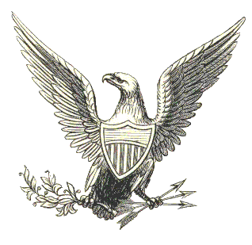

50th Anniversary Desk Caddies Are Going Fast!
Don’t miss out on your chance to buy a 50th Anniversary commemorative desk caddy. The black leatherette caddies, which contain a notepad and compartments for pens and other desktop miscellanea, feature the Soldiers and Sailors Monument and “Indianapolis Civil War Round Table / 50th Year 1955-2005” imprinted in gold on the cover. Each of our speakers this year will be receiving one of these caddies as a gift. The desk caddies are available to members on a first-come, first-served basis, and will be available for purchase at the April meeting. The cost is $20 each.

Upcoming ICWRT Programs

All of the following meeting dates are the second Monday of the month.

April 11, 2005 The Draft Riots Iver Bernstein, Washington University
May 9, 2005 Topic to be Announced Mark Neely, Penn State University
June 13, 2005 Annual Banquet/ Battlefield Dave Duncan and Jim Lighthizer, CWPT
Preservation Update & Fundraiser

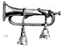
Calendar of Events
April 11 | ICWRT: The Draft Riots presented by Iver Bernstein  Indiana History Center Auditorium, 450 West Ohio, Indianapolis, IN 7:30 PM  http://indianapoliscwrt.org
April 14 | Lincoln Group of Indiana: The Lincoln Assassination (Group Discussion)  Nora Branch Library 7:00 to 8:30 PM  Contact: Angie Gilmer (317-253-8857)  aeg123@sbcglobal.net
April 17 | Crown Hill Cemetery Civil War Generals Tour conducted by Nikki Schofield  2:00 to 4:00 p.m. $5 for adults, $4 for seniors and $3 for students  Enter Crown Hill by the 34th Street gate, off Boulevard Place. For more information, contact Nikki Schofield (317-328-8782)
April 26 | CWRT of West Central Indiana: Civil War Baton Rouge and Port Hudson  presented by Dale Phillips  F.W. Olin Biological Sciences Building, Depauw University campus  Greencastle, IN 7:30 PM http://www.rose-hulman.edu/civilwar
June 18-24 | ICWRT Summer Field Trip: On To Richmond! conducted by Nikki Schofield  Scheduled tour sites in Cincinnati, Lexington and Richmond, Va., and Lexington, Ky. For further information, contact Nikki Schofield (317-328-8782)

We recommend confirming all dates, times and locations for events not sponsored by the ICWRT
If you know of a Civil War-related event that may be of interest to ICWRT members, please send your information to Norris Darrall (norrisdarrall@hotmail.com) and HARDTACK (HardtackEditor@comcast.net).


Trimble’s Trivia

by Quizmeister Tony Trimble

- “_____________is my man and I am his for the rest of the war.”
Fill in the blank, identify the speaker, and the event which provoked this statement.

2. Name the Chief of Ordnance whose son led the team that conquered yellow fever.

3. Name the writer who wrote a fictionalized account of his service in the Marion
Rangers. What was the title of the story?

4. Name the special unit of the Army of Northern Virginia created in 1862 as part of the Richmond defenses. Who was its commander?

5. Known as the “Queen of the Confederacy,” hers was the only portrait of a woman to
appear on Confederate currency. Name her.

---Answers will be published in the May issue---

Answers to the March Quiz:

1. What unit was known as, “Jeff Davis’s Pet Wolves”?
1st Louisiana Battalion

2. What was the object known as, “Jefferson Davis”?
A life-size painted image used by the 4th Ill. for target practice

3. Why did the U.S. Senate reject the nomination of Col. Robert Buchanan to the rank of Brigadier General?
His close friendship with Fitz-John Porter

4. What was the Austrian Lorenz?
A popular alternative to the Enfield Rifle, used primarily by the South

5. Where was Slaughter’s Field?
Port Hudson

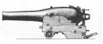

50th Anniversary Fun Facts

In the past 50 years, the ICWRT has had:
- 40 members who have served one or more terms as President
- 18 members who have served as editor of the HARDTACK
- 495 monthly meetings and programs presented (5 meetings cancelled due to snow)

Most terms served as ICWRT President:
3-way tie: Vernon Earle, Harry Grube, Tom Krasean (3 terms each)

Membership dues (individual): September 1955: $2.50; September 2005: $25.00.

Number of enrolled members: April 1955: 9; April 2005: 137

Number of first year members on the muster roll in 2005: 2 (Alan Nolan, Vernon Earle)

Number of regular meeting venues: 2 (Indiana War Memorial; Indiana History Center)

Number of Midwest CWRT Conferences Hosted by the ICWRT: 4 (1984, 1989, 1994, 2000)

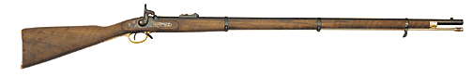

From The Treasurer

Now is the time to start thinking about reenlisting in the ICWRT for 2005-2006 campaign. A Form is attached to this issue of the HARDTACK that you may use to “re-up” for the coming year. Your dues help cover our newsletter expenses and support our program speakers and preservation projects, so they are quite important. Please include your e-mail address (if you have one) and make sure it is legible. The costs for e-mail are small compared to regular “snail mail” and everyone who accepts e-mail is a help to us financially. I am trying to clean up my records, so include your year of joining on the form (which includes my contact information).

--Douglas A. Wagner
ICWRT Treasurer

HARDTACK, the newsletter of The Indianapolis Civil War Round Table, is published monthly, September through June, each year. In addition to information about upcoming programs, HARDTACK features articles, news, reviews and a calendar of Civil War-related events. HARDTACK is distributed by mail or email to all ICWRT members.

If you have a short article, book review or some other item that may be of interest to our members, we invite you to submit it for consideration. Please send your material via email to the editor at: HardtackEditor@comcast.net. Please include a telephone number and email address where we may contact you.

Visit the website of The Indianapolis Civil War Round Table: http://indianapoliscwrt.org/

“On To Richmond!”
The Annual Trip of The Indianapolis Civil War Round Table
June 18-24, 2005

Conducted by Nikki Schofield
Home phone: 317-328-8782
Email: Nikki1942@sbcglobal.net

The Capital of the Confederacy is our destination this year!

- Saturday, June 18, meet the bus at 7:30 a.m. in the parking lot of the Ramada Limited East, 7050 East 21st Street, phone 317-352-0481. The bus, owned by Star of America (formerly Star of Indiana), will have our favorite driver, Noah Young, at the wheel. You will need to sign a release for the motel, saying that you do not hold them responsible for your car. In previous years, you had to bring a copy of the signed release with you, but this year, you can just sign it when you arrive. Try to car pool, as space is limited. We will depart from Indianapolis at 8:00 a.m. If you have not been on a trip with us before, and therefore need a map showing our departure location, please ask me.

Our first stop on Saturday, about 10:00 a.m., will be the Freedom Center (Underground Railroad Museum) overlooking the Ohio River. We will eat lunch here, before heading south. Saturday night, we will stay in the Comfort Inn, Charleston, W.Va. phone 800-798-7886.

- Sunday, June 19, we will drive to Lexington, Virginia, where we will tour the historic town, cemetery, and Stonewall Jackson House.

In Richmond, we are staying four nights in the Hampton Inn, 800 Research Road, phone 804-897-6099. At 7:30, our evening speaker is Sam Craghead of the Richmond CWRT, speaking on Drewry’s Bluff.

- Monday morning, June 20, we will tour Hollywood Cemetery with guides. We will lunch at the Museum of the Confederacy, where we will have two guides. The White House of the Confederacy tour and a seminar will be included. In the evening, Bob Krick, National Park Historian for Richmond Battlefield Park, will be our speaker at 7:00 p.m.

- Tuesday, Petersburg will be our destination. We will visit Pamplin Park, where we will see the Breakthrough, and have lunch in the museum cafe. In the afternoon, we will visit The Crater at the Petersburg National Battlefield Park, and see Drewry’s Bluff on our way back to the motel. Our dinner of Southern Comfort Chicken, a specialty of the house, will be at the historic Jefferson Hotel, on their mezzanine at 7:00.

- Wednesday, we will tour Tredegar Iron Works on the James River in the morning, and the Medical Museum at the site of Chimborazo Hospital in the afternoon. The evening speakers will be Charlie Cook and Mark Gorman.

- Thursday will be a day of driving. As you know, time on the bus is never wasted. We will have videos to watch, Civil War music to listen to, and Civil War enthusiasts with whom too talk. We also have an open microphone, so you can share your favorite trip, CW personality, book review, or thoughts on the trip, with your fellow travelers. We will stay in the Comfort Inn, Barboursville, West Virginia that evening. Their phone number is 304-733-2122.

- Friday, June 24, we will drive to Lexington, Kentucky and visit the John Hunt Morgan House and Civil War Museum, before arriving back in Indianapolis in the late afternoon. I estimate arriving about 5:00 p.m., but there are no guarantees for ETA.

What you do not need -- You do not need to be a member of a Civil War Round Table in order to go on this trip. Nor do you need any prior knowledge of places or events in Richmond. Our guides and speakers will fill you to overflowing with knowledge about that important city during the Civil War. You do not need to submit a form, just your check with name, address and phone number. You do not need a parking release, because those will be available when you arrive at the Ramada Limited East.

COSTS:

Star of America bus $130.00
Comfort Inn, Charleston, W.Va. 46.00
Hampton Inn, Richmond, Va. 209.00
Comfort Inn, Barboursville, W.Va. 40.00
Freedom Center 10.00
Box lunch in Lexington, Va. 10.00
Stonewall Jackson House 5.00
Hollywood Cemetery 7.00
Pamplin Park 12.00
Tredegar Iron Works free
Petersburg National Park 3.00
Museum of the Confederacy
(including box lunch) 28.00
Jefferson Hotel chicken dinner 40.00
John Hunt Morgan House 5.00
Mail, phone, postage 5.00
Total: $550.00

This price is based on two people per room. If you want a private room, the cost will be higher. If you need a roommate, I will try to pair you up with someone, upon mutual agreement.

Down payment -- Please make a down payment of $100.00 as soon as you know that you can go, and the remaining $450.00 by May 18, 2005.

Cut-Off Date – May 18 is the cut-off date, because I have to give final numbers to motels and the places we will visit, one month before we leave.

We would be happy to welcome first-timers on our trip.

My new email address is: Nikki1942@sbcglobal.net.

Now, it’s ON TO RICHMOND!

Indianapolis Civil War Round Table

Annual Dinner Meeting

June 13, 2005

Indiana War Memorial *
431 North Meridian Street
Indianapolis, Indiana
(317) 232-7615

Cost is $16 per person
Buffet dinner will be served starting at 6:30 PM and includes:
- Entrées: chicken breast with lemon Chardonnay sauce, and beef eye of round with Baronies sauce
- Sides: garden wild rice, Antigua blend, and field green salad
- Dinner rolls with butter
- Iced tea or coffee

Guest speakers will be Jim Lighthizer and Dave Duncan
from the Civil War Preservation Trust

* Entrance to the Indiana War Memorial is off New York Street. Dinner will be served in the MacArthur Room. The meeting will take place in the Pershing Auditorium.
Reservation form (attached below) should be completed and submitted, along with payment, by June 1, 2005. Reservation form and payment can be brought to the April or May meeting or mailed to:
Tony Roscetti or Doug Wagner
6270 Brixton Lane 5245 Kathcart Way
Indianapolis, IN 46220 Indianapolis, IN 46254

Please detach and mail this form, along with payment, to either Tony Roscetti or Doug Wagner

Individuals attending the Indianapolis Civil War Round Table, June 13, 2005 dinner meeting:

Name Name

Reservation form and payment must be received by June 1, 2005.

Cost: $16 per person. Please make check payable to Indianapolis Civil War Round Table. Payment and this reservation form can be mailed to either Tony Roscetti or Doug Wagner and must be received by June 1, 2005.

Re-enlist Now for the 2005-2006 Campaign !!

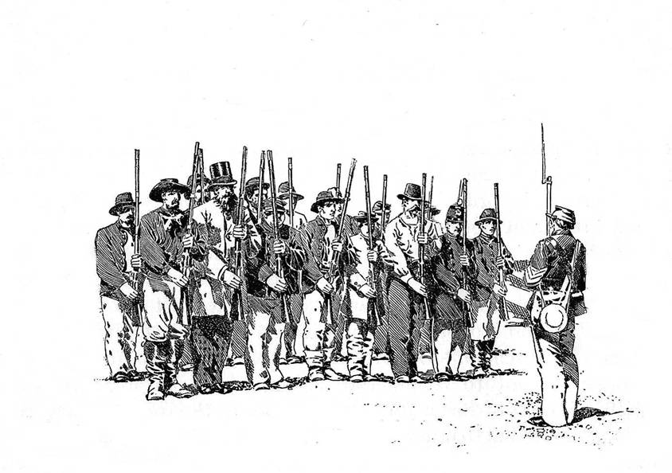
The 2005-2006 campaign of The Indianapolis Civil War Round Table will soon be upon us. Now is the time to get your re-enlistment paid. Individual membership is $25.00, family membership is $30.00 and student membership is $10.00. Please make your check payable to "Indianapolis Civil War Round Table" and mail to Doug Wagner at 5245 Kathcart Way, Indianapolis, IN 46254. If you have any questions, please contact Doug at 328-4828 or e-mail at douglas_wagner@sbcglobal.net. A re-enlistment form is provided below. The HARDTACK newsletter will be sent via e-mail to those of you who have an e-mail address. Please be sure to include your e-mail address on your enlistment form.

The Indianapolis Civil War Round Table

Enlistment for the 2005-2006 Campaign

Mail to:

Douglas A. Wagner
5245 Kathcart Way
Indianapolis, Indiana 46254

Phone: (317) 328-4828
Email: douglas_wagner@sbcglobal.net

Please complete and detach the form below and include with your check:
------------------------------------------------------------------------------------------------------------------

ICWRT Enlistment for July 2005 thru June 2006

Make your check payable to “Indianapolis Civil War Round Table”

Name…………………………………………………….…. Date ………………..

Address……………………………………………………………………….

……………………………………………………………………….

Phone:…………………………… Email:…………………………..………..

The year you joined the ICWRT…………………

Enlistment Status for July 2005 thru June 2006 (please specify):

$25 Individual …… $30 Family ……. $10 Student …….

In addition to my membership dues, please accept my generous gift of $ ________
to the ICWRT general operating account (this donation is not tax deductible)

