HARDTACK

The Newsletter of the Indianapolis Civil War Round Table

Celebrating Our 50th Anniversary

March 2005

Monday, March 14, 2005 7:30 PM at the Indiana Historical Society
Indiana Regimental Photographs
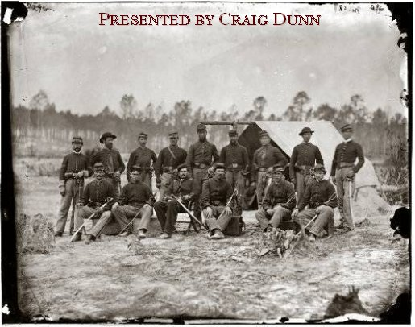
Members of the 3rd Indiana Cavalry near Petersburg, Va., November 1864

The Civil War was the first military conflict in which photography was widespread, and we tend to think of the thousands of soldier photos, battlefield pictures, fading stereographs as something almost commonplace. But to the people of the early 1860’s, photography was a new and exciting idea. Many letters, regimental histories, and memoirs recall the first time young soldiers “had their likeness made” by a photographer, and radiate with pride and emotion on being able to send these amazing technological mementoes home to loved ones. Just as the Civil War was beginning, photography was evolving from a difficult and demanding medium confined to a few “artists” to a standardized process that almost anyone could understand and set up as a small business. The process was still messy, difficult, and expensive, but hundreds of small photographic establishments soon sprung up across the land. In addition, the apparatus, chemicals, and photo-lab equipment were portable enough to be packed into wagons and actually follow the armies.

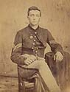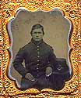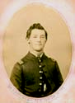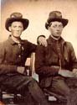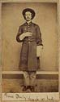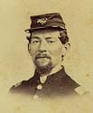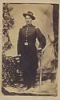

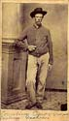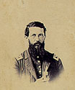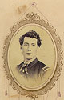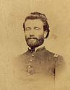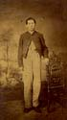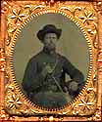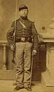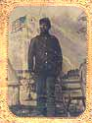

Literally hundreds of thousands of soldier portraits were made during the Civil War. As a long-time collector of Indiana Civil War photographs, Craig Dunn has amassed the largest single collection of images of Hoosier soldiers and personalities of that War—in excess of 2,400 photographs. At our March meeting, Craig will share some of the prize images from his collection —memories of the days of glory when young Hoosier men (and not a few old) stepped forward in record numbers to fight for their country, and on the way, to have their “likenesses” captured for posterity.

About Our Presenter:

Craig L. Dunn is the author of two outstanding books about Indiana regiments: Harvestfields of Death: The Twentieth Indiana Volunteers of Gettysburg (1999) and Iron Men, Iron Will: The Nineteenth Indiana Regiment of the Iron Brigade (1995). In addition to his writing and interest in Civil War photography, Craig finds time to maintain a website dedicated to Indiana Civil War history, which may be found at http://www.civilwarindiana.com. Craig is also involved with The Civil War CD-ROM, an acclaimed, computer-searchable compilation of the Official Records of the Union and Confederate Armies.

A 1975 graduate of Ball State University, Craig owns an investment company and several ancillary businesses in his hometown of Kokomo, Indiana. He is married and the father of four children.

Please join us prior to the meeting for the opening of Craig Dunn’s exhibit, Indiana Regimental Photographs, at the Col. Eli Lilly Civil War Museum located on Monument Circle in the Indiana Soldiers and Sailors Monument 5:30 to 7:00 p.m., March 14th.


The Indianapolis Civil War Round Table
2004-2005 Campaign

Officers:
President: Anthony Roscetti
Vice President: Ray Shortridge
Secretary: Dr. Betty Enloe
Treasurer: Doug Wagner

Committee Chairs:
Programs: Ray Shortridge rayshortridge@netscape.net

Publicity: Norris Darrall norrisdarrall@hotmail.com
Preservation: Andy O’Donnell odar1@aol.com
HARDTACK Newsletter:
Editor: Dave Klinestiver HardtackEditor@comcast.net
Distribution:
Dorothy Jones joejones@iquest.net
Peg Bertelli pbbertelli@insightbb.com

ICWRT Meeting: March 14, 2005, at 7:30 P.M.
at the
Indiana Historical Society Auditorium
450 West Ohio Street
Indianapolis, Indiana
PLEASE NOTE: So that everyone can attend the Exhibit opening at the Col. Eli Lilly Civil War Museum, we will not have our usual dinner gathering at Shapiro’s this month
_______________________________________________________

The Indianapolis Civil War Round Table gratefully acknowledges the co-sponsorship of
The Indiana War Memorial
for our Speakers Program during the 2004-2005 Campaign

In this issue of HARDTACK: Page
March 2005 Meeting: Indiana Regimental Photographs presented by Craig Dunn…………………………………….....................1-3
ICWRT News…………………………………………………………………...4
Upcoming ICWRT Programs ………………………..…….……….……….5
Calendar of Events…..……………………..………………….…………..... 5
Trimble’s Trivia by Quizmeister Tony Trimble……………………..…….. 6
From the Bookshelf: In Search of the Real Lincoln……………........7-9
IHS Opens Faces of Lincoln Exhibition……………………………………9
Andy Jacobs on Why We Remember Lincoln…………………..………10
Annual Field Trip: “On To Richmond”……………………………….[11-12]
50th Anniversary History Order Form………………….…………Endsheet

ICWRT News

At the February meeting, nominating committee representative Steve Hill presented the committee’s slate of candidates for ICWRT officers during the 2005-2006 campaign. The committee’s nominees were approved and elected by voice vote of the members in attendance. They are:

Ray Shortridge President
Douglas Rouch Vice President
Janet Mitchell Secretary
Doug Wagner Treasurer

Tom Krasean reported that editorial work on our forthcoming commemorative history, Indianapolis Civil War Round Table: The First Fifty Years, is nearing completion. The 112-page book should be available in time for our Golden Anniversary celebration at the April meeting. Anyone wishing to reserve a copy should return an order form, together with their full payment, to Treasurer Doug Wagner no later than March 16th. The cost is $20 per volume for the hardback edition and just $10 for the softcover version.

Nikki Schofield announced that the ICWRT annual field trip is set for June 18-24, 2005. Billed as the “On To Richmond!” tour, the trip will include stops in Cincinnati, Lexington and Richmond, Virginia, and Lexington, Kentucky. The full itinerary and particulars may be found in the attached information sheet. Space on the tour bus is limited, so sign up now for a fun and educational experience. Nikki will be happy to answer any questions you may have about the trip. She may be reached at 317-328-8782.

Nikki will also be conducting a “Civil War Generals Tour” at Crown Hill Cemetery on two Sundays this year, April 17th and October 2nd. Crown Hill is the nation’s third largest cemetery and the last resting place of some 17 Civil War generals. Each tour will begin at 2:00 p.m. and will last approximately two hours. See the Calendar of Events in this issue of HARDTACK for more information.

50th Anniversary Desk Caddies Still Available!

Don’t miss out on your chance to buy a 50th Anniversary commemorative desk caddy. The black leatherette caddies, which contain a notepad and compartments for pens and other desktop miscellanea, feature the Soldiers and Sailors Monument and “Indianapolis Civil War Round Table / 50th Year 1955-2005” imprinted in gold on the cover. Each of our speakers this year will be receiving one of these caddies as a gift. The desk caddies are available to members on a first-come, first-served basis, and will be available for purchase at the March meeting. The cost is $20 each.

Celebrate your membership in ICWRT on its 50th Anniversary!
Reserve your copy of Indianapolis Civil War Round Table: The First Fifty Years, TODAY!!
An order form is included with this issue of HARDTACK.
Remember---your order must be placed by March 16, 2005, for delivery at the Anniversary
celebration meeting in April

Upcoming ICWRT Programs

All of the following meeting dates are the second Monday of the month.

March 14, 2005 Indiana Regimental Photographs Craig Dunn
April 11, 2005 Draft Riots Iver Bernstein, Washington University
May 9, 2005 Topic to be Announced Mark Neely, Penn State University
June 13, 2005 Annual Banquet/ Battlefield Dave Duncan and Jim Lighthizer, CWPT
Preservation Update & Fundraiser

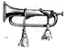
Calendar of Events
March 14 | ICWRT: Indiana Regimental Photographs presented by Craig Dunn  Indiana Historical Society Auditorium, 450 West Ohio, Indianapolis, IN 7:30 PM  http://indianapoliscwrt.org
March 15 | “Will Stott’s Civil War”: first person presentation by Dr. Lloyd Hunter  Franklin College campus Chapel, Franklin, IN  For more information, call Lloyd at 317-738-8221 (office)
March 16 | Clay-Carmel CWRT: Morgan's Raid presented by Dick Skidmore  Monon Depot Museum, 211 First Street, S.W., Carmel, IN 7:30 PM
March 20 | Randolph County CWRT: “Memories of the Blue and Gray, Part 3”  presented by Steve Jackson; Randolph County Historical Society Museum,  416 South Meridian St., Winchester, IN; 1:30 to 3:00 PM
March 21 | Madison Cty. CWRT: Civil War Geneology presented by Amy Johnson  Anderson Public Library, Anderson, IN 7:30 PM
March 22 | CWRT of West Central Indiana: Civil War Portraits of Alexander Lawrie  presented by Dick Skidmore  F.W. Olin Biological Sciences Building, Depauw University campus  Greencastle, IN 7:30 PM http://www.rose-hulman.edu/civilwar
April 17 | Crown Hill Cemetery Civil War Generals Tour conducted by Nikki Schofield  2:00 to 4:00 p.m. $5 for adults, $4 for seniors and $3 for students  Enter Crown Hill by the 34th Street gate, off Boulevard Place. For more information, contact Nikki Schofield (317-328-8782)

We recommend confirming all dates, times and locations for events not sponsored by the ICWRT
If you know of a Civil War-related event that may be of interest to ICWRT members, please send your information to Norris Darrall (norrisdarrall@hotmail.com) and HARDTACK (HardtackEditor@comcast.net).

Trimble’s Trivia

1. What unit was known as, “Jeff Davis’s Pet Wolves”?

2. What was the object known as, “Jefferson Davis”?

3. Why did the U.S. Senate reject the nomination of Col. Robert Buchanan
to the rank of Brigadier General?

4. What was the Austrian Lorenz?

5. Where was Slaughter’s Field?

---Answers will be published in the April issue---

Answers to February’s Quiz:

1. What is a “bog-trotter”? Slang for an Irish soldier, used by both sides.

2. What is a “hospital bullet”? A substitute for anesthetic, literally biting on a bullet

3. Presidential slang used by Union troops to describe hardtack. “Lincoln Pie”

4. What was “robbers’ row”? Area of camp reserved for sutlers

5. Who or what was known as the “Provost Marshall”? A large shark that patrolled the moat at Ft. Jefferson

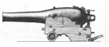

Have you turned in your Survey?

If you have not yet turned in a completed Member Survey, please do so at the March meeting. Your responses may also be mailed or emailed to Tony Roscetti using the form accompanying last month’s edition of HARDTACK.
The Survey is intended to help us better understand the interests of our members. The information you provide will not be disclosed to anyone outside our organization.

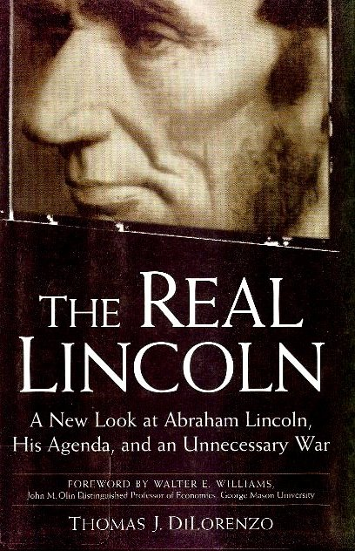
From the Bookshelf

“The Real Lincoln: A New Look at Abraham Lincoln, His Agenda, and an Unnecessary War” by Thomas J. DiLorenzo (Three Rivers Press 2002) 333 pp.

The “Real” Lincoln? Hardly.

A review by Dave Klinestiver

Looking beyond the myth, and seeking the historical “truth” of the matter, is fundamental to the task of every historian. Finding new meanings and interpretations in the events of the past, moreover, is rightfully the purview of each succeeding generation of historical commentators. There is no excuse, however, for any serious historian—and certainly not a professional scholar of academia—to claim to offer readers the “real” story of a man and his era when the writer has not bothered to master the essential facts of his subject matter.

This reviewer first became aware of Thomas DiLorenzo and “The Real Lincoln” about a year ago, when Book-tv (on C-SPAN2) aired a talk given by the author at a booksigning. When DiLorenzo began his presentation by stumbling over—and then misstating—the years in which this country was “engaged in a great civil war,” it was evident to me that the author’s scholarly authority fell well short of the demands of his subject. As I listened that evening to DiLorenzo rave on about Lincoln’s “real agenda” (in sum: to promote Northern industrialism and a federal empire by waging a bloody and “unnecessary” war to economically and politically subjugate the South), it was clear to me that the person with the real agenda was Mr. DiLorenzo.

The book itself only confirms those initial impressions. Rather than presenting his readers with a balanced, scholarly analysis of Lincoln’s political/social/economic principles and beliefs and how those views informed and influenced his decisions as president, DiLorenzo seems more intent on recasting Lincoln’s mythic image as the Great Emancipator to that of the Great Instigator of all Evils of post-Civil War America and, by doing so, to further his own Jeffersonian interpretation of American political-economic history.

DiLorenzo paints Lincoln as a conniving, power-hungry politician and economic “mercantilist” (even worse, in the author’s opinion, than a capitalist!) who was morally indifferent to slavery, and who merely used the issue to bolster his own political ambitions and objectives. By ignoring context and the full historical record, by using selected facts to draw conclusions that are as outrageous as they are fallacious, and by imbuing Lincoln with a prescience of future events and consequences surpassing that of Nostradamus, DiLorenzo manages to construct a character that is utterly unrecognizable to anyone familiar with the man, however complex and enigmatic, that emerges from a wealth of primary source material—beginning with Lincoln’s own writings—as well as innumerable studies over many decades that DiLorenzo chooses to dismiss as whitewashed mythologizing.

As a professor of economics at the School of Business and Management at Maryland’s Loyola College (not to be confused with Loyola University in Chicago) specializing in political history and political economy, DiLorenzo is certainly entitled—and presumably qualified—to champion his own views on the subject of United States economic history. In examining his book, however, it is clear that DiLorenzo has not bothered to undertake anything close to a scholarly investigation into Lincoln’s evolving views on slavery, economic development or the role of the federal government. DiLorenzo also lacks an appreciation for the times and political/social culture in which Lincoln lived and which imposed (as Lincoln himself well understood) significant constraints on what he could effectively accomplish. Whatever period of history it is in which DiLorenzo qualifies as a “specialist,” it is clearly not the Civil War and antebellum eras of this country.

One need only look at the book’s bibliography to see the shortcomings of DiLorenzo’s scholarship. Beyond the paucity of references to leading works in the Lincoln canon (which one would expect to find in any academic work, whatever its ideological bent), DiLorenzo actually cites Gore Vidal’s Lincoln, a pseudo-biographical work of fiction no less, as one of his background sources! (the book itself is not mentioned in DiLorenzo’s text). It is not surprising that no leading Civil War or Lincoln historian has endorsed this book, particularly since DiLorenzo manages to denigrate most of them by name. It is also telling that DiLorenzo’s two “anonymous peer reviewers” apparently asked that they not be identified in his acknowledgments.

Every year brings dozens of new books about Lincoln on top of the thousands of titles published over the preceding 140 years. Some are very good and a few are outstanding; others are mediocre—or worse. What is particularly unfortunate about this book is that, as a work with the imprimatur of authorship by an academician, less informed “mainstream” readers—not just the die-hard “states’ righters” who are predisposed to this sort of thing—may actually buy-in to the misrepresentations and contrarian claptrap espoused by DiLorenzo as historical truth.

If you want to read a libertarian rant on the evils wrought by the Republican Party and the federal government during and after the Civil War, you will undoubtedly enjoy DiLorenzo’s book. If, however, you are in search of a fair and balanced view of the “real” Abraham Lincoln, you will not find him here.

Twp ICWRT Member-Authors Are Critiqued in DiLorenzo’s “The Real Lincoln”

By Nikki Schofield

The views of two members of The Indianapolis Civil War Round Table, Alan T. Nolan and Lloyd A. Hunter, are critically assessed in Thomas DiLorenzo’s book, “The Real Lincoln,” which is subtitled “A New Look at Abraham Lincoln, His Agenda, and an Unnecessary War.”

In reference to “The Myth Of The Lost Cause And Civil War History,” co-edited by Nolan and Gary W. Gallagher, DiLorenzo writes that: “The book’s premise is that the doctrine of states’ rights had no real history but was fabricated after the war by disgruntled former Confederates to rationalize the secession of 1861” (p. 262). DiLorenzo specifically cites Nolan’s assertion that slavery—not the right of secession—was the fundamental cause of the War. DiLorenzo disagrees, accusing the authors of “spreading untruths and distorting history” and even “shoddy scholarship” (p. 263).

DiLorenzo also disputes Lloyd Hunter’s assertion that Confederate mythmakers “fabricated another supposed falsehood—“that the Constitution of 1787 had been a compact among equally sovereign states.” DeLorenzo argues that the Constitution was indeed a compact among thirteen sovereign states, several of which reserved their right to withdraw (p. 262).

According to DiLorenzo, “Lincoln and the Republicans certainly had a cause: the cause of centralized government and the pursuit of empire” (p. 263). DiLorenzo describes Lincoln as a rhetorically gifted, fence-straddling politician who wanted to favor and also to oppose racial equality. He defended the natural rights of all races, but opposed the right of blacks to vote, to serve as jurors, and other rights then limited to white male citizens. (p. 13). DiLorenzo also characterizes Lincoln as a defender of slaveowners (pp. 12, 15), a wartime dictator who “led the way in subverting constitutional government in America” (p. 6) and, at least by implication, an unindicted “war criminal” (p. 198).

Although DiLorenzo’s text does contain end notes that list sources, many of his statements are not cited to any specific authority. As a result, the reader is left to wonder as to the basis for many of the author’s bold and highly controversial assertions.

Revealing The Real Lincoln

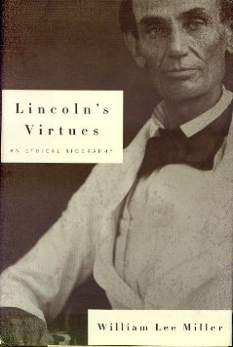
Anyone looking for the “real” Abraham Lincoln would do well to read Lincoln’s Virtues: An Ethical Biography by William Lee Miller (Alfred A. Knopf 2002) 515 pp. Published the same year as DiLorenzo’s “The Real Lincoln,” Miller’s study stands in stark contrast to DiLorenzo’s “slash and burn” exposition, distinguished in terms of both the depth and breadth of the author’s preparatory research as well as the intelligent insights and conclusions he draws from the material.

Like DiLorenzo, Miller is an academic but not a professional historian. Trained as a social ethicist who has taught at Yale University, Indiana University and the University of Virginia, Professor Miller is nevertheless well-versed in American antebellum history and politics. His earlier study of the turbulent congressional debates over the peculiar institution, Arguing About Slavery (1996), was widely praised by historians as well as critics for its well-researched and highly readable approach to its subject. In Lincoln’s Virtues, Miller offers an original and fresh perspective on the familiar facts of Lincoln’s life which (in contrast to DiLorenzo) the author has clearly mastered along with the rich historiography of Lincoln biography.

Following a generally chronological path, Miller examines Lincoln’s experiences, motivations and evolving beliefs and values over the course of his life, particularly during the pre-presidential years. Relying extensively on Lincoln’s own words, both public and private, Miller—as effectively as any other Lincoln scholar—is able to “get inside the head” of his subject to analyze and persuasively explain the rationale behind many of Lincoln’s decisions and actions.

Despite a title that may suggest otherwise, this book is not an uncritical, laudatory tome to the Lincoln Myth. To the contrary, Miller strives to look behind the Lincoln of popular legend to the flesh-and-blood man—and ambitious politician—in the context of his times. Miller does not paper-over Lincoln’s contradictions and shortcomings; he does, however, convincingly reveal how Lincoln’s awesome intelligence, commitment to principle and inherent desire to do what is right in the confines of a deeply prejudiced society—all contributed to the genuine greatness of the man who became the mythic icon.

Indiana Historical Society Opens The Faces of Lincoln Exhibition

On February 12th, the Indiana Historical Society opened its new permanent exhibition entitled The Faces of Lincoln. Drawing on documents and images from three significant collections acquired in 2003, the IHS plans to have revolving displays of original materials tied to various themes relating to Lincoln and his era.

Initially, the exhibition will focus on Lincoln and Politics, featuring political cartoons, lithographs, patriotic envelopes and other period ephemera, as well as images of Lincoln and members of his cabinet. Future themes include Lincoln in Photographs and Lincoln and Family.

The IHS has completed the scanning of some 840 images from its Lincoln collection. Digital images can be viewed through the Historical Society’s website at www.indianahistory.org.

Andy Jacobs Speaks On Lincoln at Presidents’ Day Program

On the evening of February 21st—Presidents’ Day—a large audience gathered at the Glendale Mall branch library for a program entitled, "Honoring Lincoln: Why We Remember Our 16th President.” Former Congressman Andy Jacobs, Jr. was the featured speaker for the event, which was co-sponsored by The Lincoln Group of Indiana and the Indianapolis-Marion County Public Library.

Congressman Jacobs is one of 15 members of the Abraham Lincoln Bicentennial Commission, a body created by Congress to promote the celebration of the 200th anniversary of Lincoln’s birth in 2009. In addition to enjoying Mr. Jacob’s appreciation of the 16th president, the audience had an opportunity to speak with 19th century residents of Freetown Village as well as Civil War era “living historians”—including our own Nikki Schofield (in the guise of condemned Booth co-conspirator, Mary Surratt) and Norris Darrall (wearing the uniform of an Indiana soldier of the Veteran Reserve Corps serving at Camp Morton).

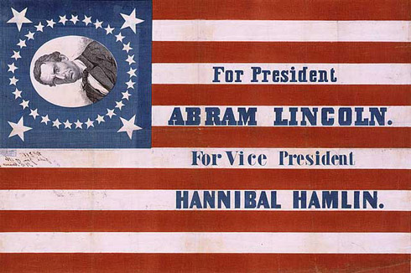
A number of other ICWRT members were also in attendance, including Alan Nolan, whose scholarship and contributions to Civil War history were recognized by Mr. Jacobs in his remarks.

Angie Gilmer, President of the Abraham Lincoln Group of Indiana, introduced the program. The Group (formerly known as the Abraham Lincoln Association) is a non-political “round table” of individuals dedicated to learning about the life and contributions of Lincoln.

The Abraham Lincoln Group meets six times a year at the Nora branch library. Their next meeting will be Thursday, April 14, 2005—the 140th anniversary of Lincoln’s assassination. For more information about the organization and membership, contact Angie Gilmer at 253-8857 or aeg123@sbcglobal.net.

HARDTACK, the newsletter of The Indianapolis Civil War Round Table, is published monthly, September through June, each year. In addition to information about upcoming programs, HARDTACK features articles, news, reviews and a calendar of Civil War-related events. HARDTACK is distributed by mail or email to all ICWRT members.

If you have a short article, book review or some other item that may be of interest to our members, we invite you to submit it for consideration. Please send your material via email to the editor at: HardtackEditor@comcast.net. Please include a telephone number and email address where we may contact you.

Visit the website of The Indianapolis Civil War Round Table: http://indianapoliscwrt.org/

“On To Richmond!”
The Annual Trip of The Indianapolis Civil War Round Table
June 18-24, 2005

Conducted by Nikki Schofield
Home phone: 317-328-8782
Email: Nikki1942@sbcglobal.net

The Capital of the Confederacy is our destination this year!

- Saturday, June 18, meet the bus at 7:30 a.m. in the parking lot of the Ramada Limited East, 7050 East 21st Street, phone 317-352-0481. The bus, owned by Star of America (formerly Star of Indiana), will have our favorite driver, Noah Young, at the wheel. You will need to sign a release for the motel, saying that you do not hold them responsible for your car. In previous years, you had to bring a copy of the signed release with you, but this year, you can just sign it when you arrive. Try to car pool, as space is limited. We will depart from Indianapolis at 8:00 a.m. If you have not been on a trip with us before, and therefore need a map showing our departure location, please ask me.

Our first stop on Saturday, about 10:00 a.m., will be the Freedom Center (Underground Railroad Museum) overlooking the Ohio River. We will eat lunch here, before heading south. Saturday night, we will stay in the Comfort Inn, Charleston, W.Va. phone 800-798-7886.

- Sunday, June 19, we will drive to Lexington, Virginia, where we will tour the historic town, cemetery, and Stonewall Jackson House.

In Richmond, we are staying four nights in the Hampton Inn, 800 Research Road, phone 804-897-6099. At 7:30, our evening speaker is Sam Craghead of the Richmond CWRT, speaking on Drewry’s Bluff.

- Monday morning, June 20, we will tour Hollywood Cemetery with guides. We will lunch at the Museum of the Confederacy, where we will have two guides. The White House of the Confederacy tour and a seminar will be included. In the evening, Bob Krick, National Park Historian for Richmond Battlefield Park, will be our speaker at 7:00 p.m.

- Tuesday, Petersburg will be our destination. We will visit Pamplin Park, where we will see the Breakthrough, and have lunch in the museum cafe. In the afternoon, we will visit The Crater at the Petersburg National Battlefield Park, and see Drewry’s Bluff on our way back to the motel. Our dinner of Southern Comfort Chicken, a specialty of the house, will be at the historic Jefferson Hotel, on their mezzanine at 7:00.

- Wednesday, we will tour Tredegar Iron Works on the James River in the morning, and the Medical Museum at the site of Chimborazo Hospital in the afternoon. The evening speakers will be Charlie Cook and Mark Gorman.

- Thursday will be a day of driving. As you know, time on the bus is never wasted. We will have videos to watch, Civil War music to listen to, and Civil War enthusiasts with whom too talk. We also have an open microphone, so you can share your favorite trip, CW personality, book review, or thoughts on the trip, with your fellow travelers. We will stay in the Comfort Inn, Barboursville, West Virginia that evening. Their phone number is 304-733-2122.

- Friday, June 24, we will drive to Lexington, Kentucky and visit the John Hunt Morgan House and Civil War Museum, before arriving back in Indianapolis in the late afternoon. I estimate arriving about 5:00 p.m., but there are no guarantees for ETA.

What you do not need -- You do not need to be a member of a Civil War Round Table in order to go on this trip. Nor do you need any prior knowledge of places or events in Richmond. Our guides and speakers will fill you to overflowing with knowledge about that important city during the Civil War. You do not need to submit a form, just your check with name, address and phone number. You do not need a parking release, because those will be available when you arrive at the Ramada Limited East.

COSTS:

Star of America bus $130.00
Comfort Inn, Charleston, W.Va. 46.00
Hampton Inn, Richmond, Va. 209.00
Comfort Inn, Barboursville, W.Va. 40.00
Freedom Center 10.00
Box lunch in Lexington, Va. 10.00
Stonewall Jackson House 5.00
Hollywood Cemetery 7.00
Pamplin Park 12.00
Tredegar Iron Works free
Petersburg National Park 3.00
Museum of the Confederacy
(including box lunch) 28.00
Jefferson Hotel chicken dinner 40.00
John Hunt Morgan House 5.00
Mail, phone, postage 5.00
Total: $550.00

This price is based on two people per room. If you want a private room, the cost will be higher. If you need a roommate, I will try to pair you up with someone, upon mutual agreement.

Down payment -- Please make a down payment of $100.00 as soon as you know that you can go, and the remaining $450.00 by May 18, 2005.

Cut-Off Date – May 18 is the cut-off date, because I have to give final numbers to motels and the places we will visit, one month before we leave.

We would be happy to welcome first-timers on our trip.

My new email address is: Nikki1942@sbcglobal.net.

Now, it’s ON TO RICHMOND!

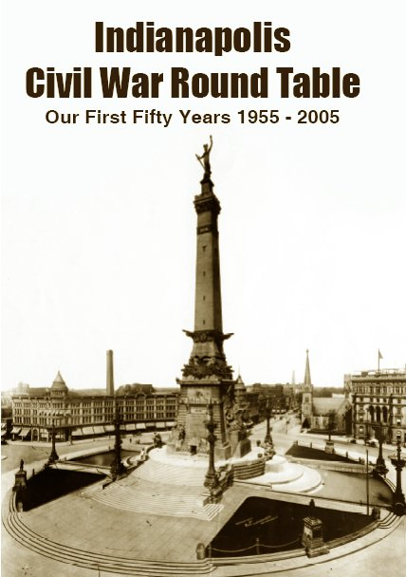

ORDER FORM

Indianapolis Civil War Round Table: Our First Fifty Years 1955-2005
by Thomas Krasean
112 pages with index. Size 6 x 9 inches (Authorhouse Press 2005)

Order before March 16, 2005 for delivery at the April ICWRT meeting—
Our 50th Anniversary Celebration!!

Complete and return this order form together with your payment to Doug Wagner, 5245 Kathcart Way, Indianapolis, Indiana 46254. Please make your check payable to: The Indianapolis Civil War Round Table. If you prefer to have your order mailed to you, please add $3.00 per volume for shipping & handling.

Hardbound copies: $20.00 each: ____ copy(ies) x $20.00 = $___________
Paperback copies: $10.00 each: ____ copy(ies) x $10.00 = $ ___________
Shipping & Handling (if applicable): $ ___________ TOTAL ENCLOSED: $ ___________
Name: ________________________________________
Address (for mailed orders): _______________________________________________________

